SuiteScript

Student Guide



©2000 - 2014 NetSuite Inc.

Any reproduction or distribution of any part of this document without the prior written permission of

NetSuite Inc. is strictly prohibited.

The information included in this document is confidential and proprietary information of NetSuite Inc.

First printing: May 2014

Second printing: October 2014

NetSuite Inc.

2955 Campus Drive, Suite 100

San Mateo, CA. 99403-2511



**Table of Contents**

Module i

Overview

Module 01

Module 02

Module 03

Module 04

Module 05

Module 06

Module 07

Module 08

Module 09

Module 10

Module 11

Module 12

Module 13

Module 14

Module 15

Module 16

Module 17

Optional

Prepare to Develop Scripts

Introduction to Scripting

Introduction to SuiteScript API

Investigating Client Event Functions*

Record Level Client Scripts*

Scripting Sublists on Client*

Introduction to Objects

Introduction to User Event Scripts*

Manipulating Record Objects

Scripting Sublists on Server*

Scripting Searches

Scheduled Scripts and Search Results*

Script Parameters

Workflow Action Scripts*

Front End Suitelets*

Back End Suitelets*

Best Practices and Review

Portlet Scripts

Page i

©2000 - 2014 NetSuite Inc

Duplication is prohibited



Page ii

©2000 - 2014 NetSuite Inc

Duplication is prohibited



SuiteScript

Module i: Overview

Course Audience

Developers who need to customize and automate their NetSuite

application.

Module i: Overview

2

Module i: Overview - 1



SuiteScript

Course Objectives

Upon completion of this course, you should be able to:

Automate forms through client, user event, and Suitelet scripts

Incorporate a foundational set of SuiteScript functions in your scripts

Manipulate sublists

Integrate searches with scripts

Implement batch processing through scheduled scripts

Create custom actions that extend workflows (SuiteFlow)

Make use of back‐end Suitelets

Customize your dashboard through portlet scripts

Test and debug scripts through client and server‐side debugging tools

Develop scripts that incorporate a variety of best practices

Module i: Overview

3

Agenda: Day One

Prepare to Develop Scripts

Introduction to Scripting

Introduction to SuiteScript API

Investigating Client Event Functions

Day

1

2

3

4

5

Module i: Overview

4

Module i: Overview - 2



SuiteScript

Agenda: Day Two

Record Level Client Scripts

Scripting Sublists on Client

Introduction to Objects

Introduction to User Event Scripts

Day

1

2

3

4

5

Module i: Overview

5

Agenda: Day Three

Manipulating Record Objects

Scripting Sublists on Server

Scripting Searches

Day

1

2

3

4

5

Module i: Overview

6

Module i: Overview - 3



SuiteScript

Agenda: Day Four

Scheduled Scripts and Search Results

Script Parameters

Workflow Action Scripts

Day

1

2

3

4

5

Module i: Overview

7

Agenda: Day Five

Front‐End Suitelets

Back‐End Suitelets

Best Practices and Review

Optional Module: Portlet Scripts

Day

1

2

3

4

5

Module i: Overview

8

Module i: Overview - 4



SuiteScript

Using WebEx

To ask a question:

•

•

Raise hand

Type in Chat

(send to All Participants)

To mute/unmute your audio:

Click the Mute button

•

Chat

Module i: Overview

9

Activity: Let’s get to know each other!

Grab a space using your pointer. Using the Text tool, write down your nickname, NetSuite role &

experience and your programming experience. Once you’re done, put up an emoticon on how you feel!

Think about what you want get out of this training and how you’re going to use it. Be specific!

Module i: Overview

10

Module i: Overview - 5

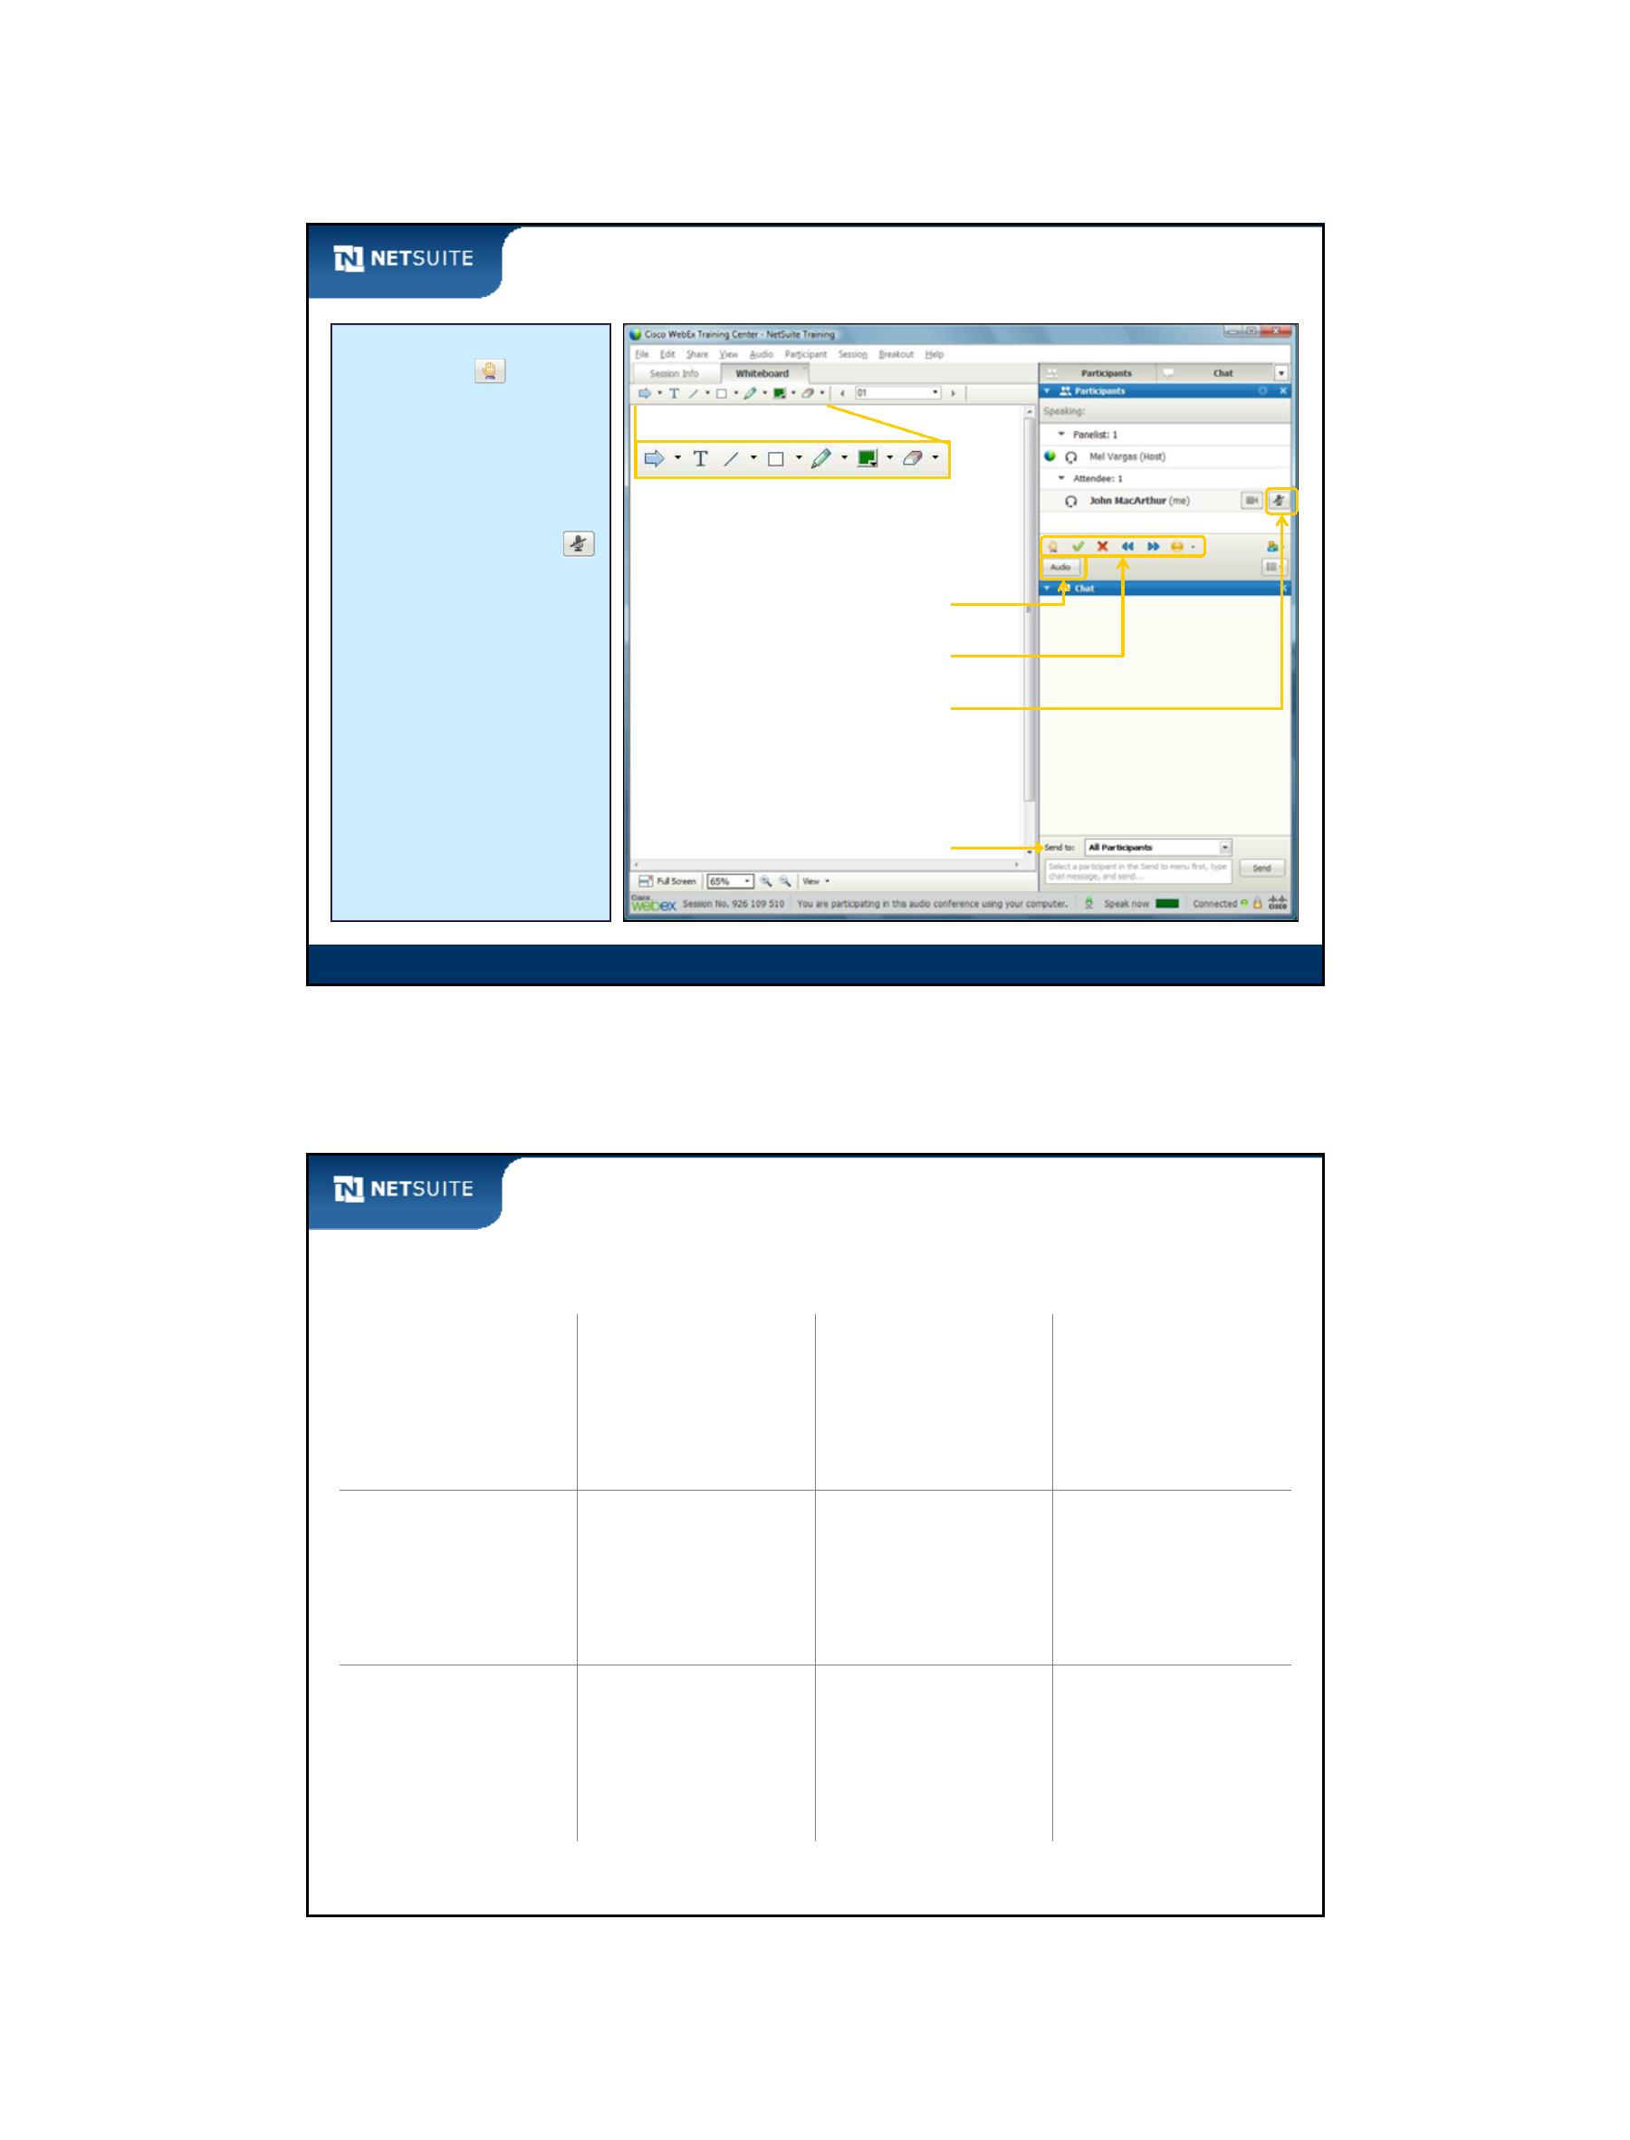

SuiteScript

Classroom This and That!

Class participation:

Parking Lot questions

Interactive exercises (Activity)

Logistics:

Lunch and breaks

Course materials:

Exercise Guide, Student Guide

Training Account: SuiteDreams

SuiteCloud (Eclipse) IDE

Resources:

NetSuite User Group

NetSuite Help Center

Module i: Overview

11

Any Questions?

This module provided an introduction to:

Course objectives

Course agenda

Before we get started, …

Can you hear my voice?

Can everyone see the screen?

Are there any issues with the computer stations?

Does everyone have the appropriate course materials?

Module i: Overview

12

Module i: Overview - 6

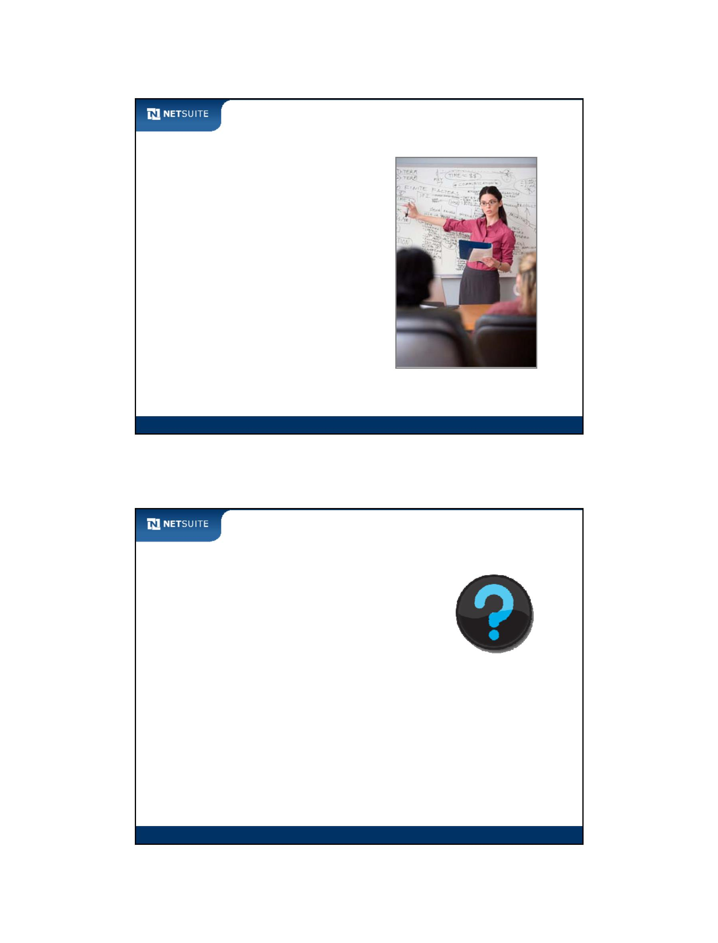

SuiteScript

Module 1: Prepare to Develop Scripts

Objectives

Upon completing this module, you should be able to:

Log into your NetSuite training account

Navigate the NetSuite application

Define the NetSuite data model

Define the overall NetSuite web architecture

Summarize the different SuiteScript script types

Module 1: Prepare To Develop Scripts

2

Module 1: Prepare To Develop Scripts - 1



SuiteScript

Activity: Review Navigation

1. How do you view a list of vendors?

2. How can you make sure you are viewing all vendors?

3. Edit a vendor. How do you view tasks related to a specific vendor?

4. How do you re‐open the same vendor from #3 without returning to a

list of vendors?

5. How can you open a list of partners in a new tab?

Module 1: Prepare To Develop Scripts

3

SaaS

What is SaaS?

SaaS = Software as a service

Application hosted over the internet

No on‐premise deployment

Servers not maintained by customers

Configurable and customizable

Module 1: Prepare To Develop Scripts

4

Module 1: Prepare To Develop Scripts - 2



SuiteScript

JavaScript

What is JavaScript?

Originally developed by Netscape

Typically interpreted in the Web Browser

Can be used as a server‐side programming language

No relationship to Java, other than a few syntax similarities

Module 1: Prepare To Develop Scripts

5

NetSuite Data Model

Standard Data Types

Data types and menu selections

Record type analogous to file cabinet

Record type analogous to table

Terminology

Module 1: Prepare To Develop Scripts

6

Module 1: Prepare To Develop Scripts - 3



SuiteScript

NetSuite Record Groups

Entities

Customers

Vendors

Purchase Orders

Tasks

Employees

Expense Reports

Phone Calls

Transactions

Sales Orders

CRM

Events

Items

Custom

Inventory Items

Item Groups

Discounts

Module 1: Prepare To Develop Scripts

7

Data types and menu selections

Entities

Customers

Transactions

Sales Orders

Module 1: Prepare To Develop Scripts

8

Module 1: Prepare To Develop Scripts - 4

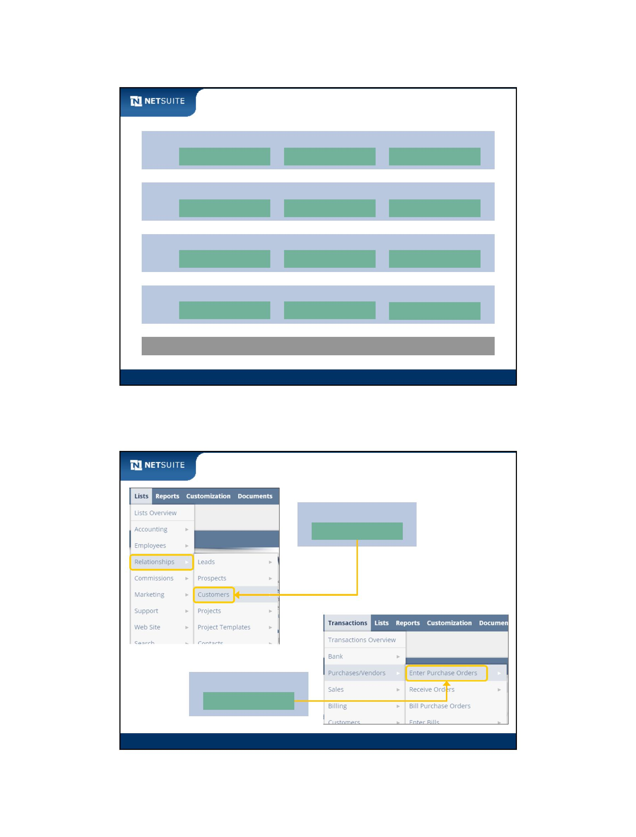

SuiteScript

Record type analogous to file cabinet

Different types of data in NetSuite are called Record Types

Employee

Record Type

Customer 1

Customer 2

Customer 3

Customer

Record Type

Module 1: Prepare To Develop Scripts

9

Record type analogous to table

Customers

1

1

Sales Order

1

*

Item

Module 1: Prepare To Develop Scripts

10

Module 1: Prepare To Develop Scripts - 5

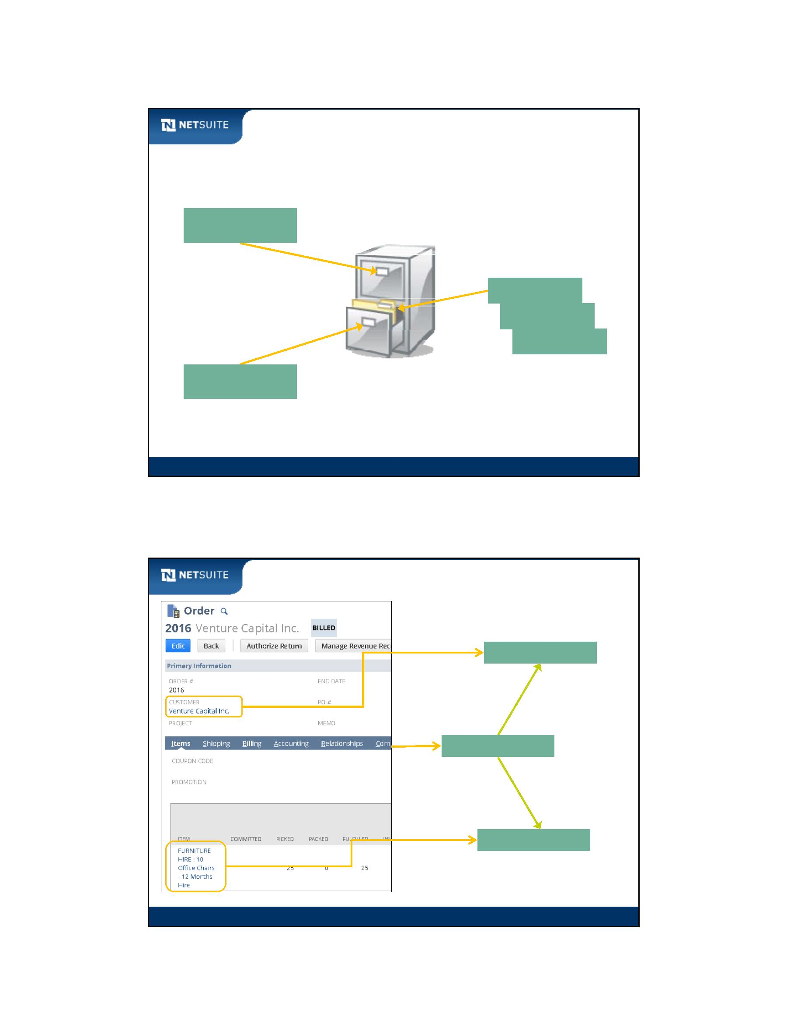

SuiteScript

Record type analogous to table continued

1

1

1

*

Module 1: Prepare To Develop Scripts

11

Terminology

Relational Database

Terminology

NetSuite Terminology

Table

Record Type

Column

Row

Field

Record

Module 1: Prepare To Develop Scripts

12

Module 1: Prepare To Develop Scripts - 6

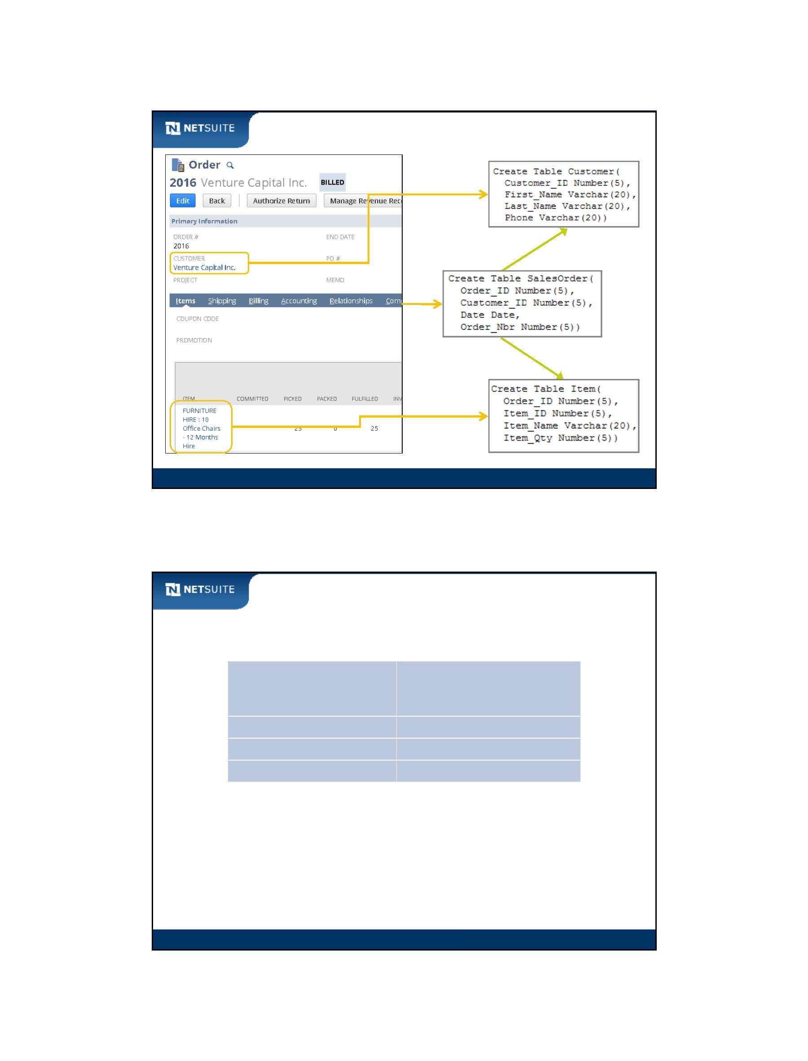

SuiteScript

Activity: Match up data concepts

Draw lines to match up an entry in the column on the left with an entry in the column on the right.

Adjust Inventory

Employee Internal Id of 104

Competitor

Joan Mencino

Entity data type

Transaction data type

Fax

Employee Internal Id of 15

Task

Has relationship to employee

Aubrey Pober

Column

Expense Report

Has relationship to support case

Module 1: Prepare To Develop Scripts

13

SuiteCloud Platform Technology Overview

Package Customizations

Standard

Customizations

Get Information

Integrations

Process Automation

Developments

Module 1: Prepare To Develop Scripts

14

Module 1: Prepare To Develop Scripts - 7

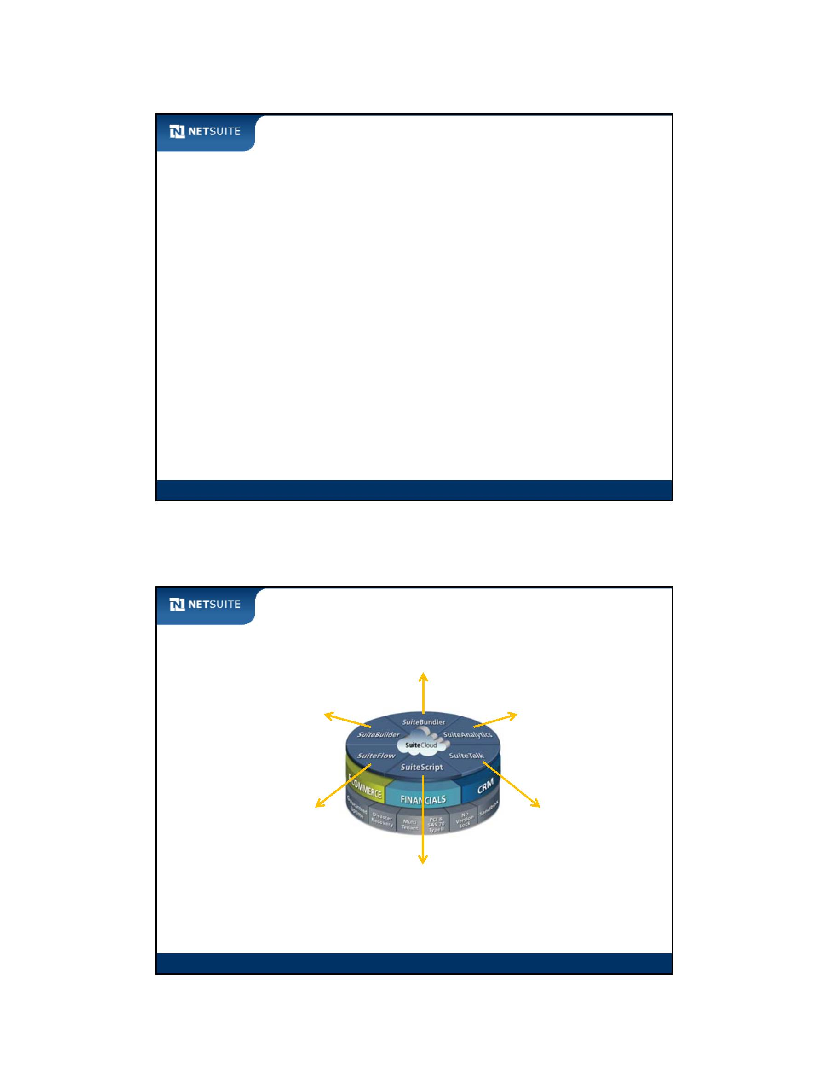

SuiteScript

Web Architecture – Typical

Client (browser)

JavaScript

http request

http response

Server

ASP, JSP, PHP, Cold Fusion

Database

SQL

Oracle, DB2,

SQL Server

Module 1: Prepare To Develop Scripts

15

Web Architecture – NetSuite

Client (browser)

JavaScript (SuiteScript)

Client‐side Scripts

http request

http response

Server

JavaScript (SuiteScript)

User Event, Scheduled, Suitelet,

RESTlet, Portlet, Workflow Action,

Mass Update, Bundle Installation

SQL

Database

Oracle

Module 1: Prepare To Develop Scripts

16

Module 1: Prepare To Develop Scripts - 8

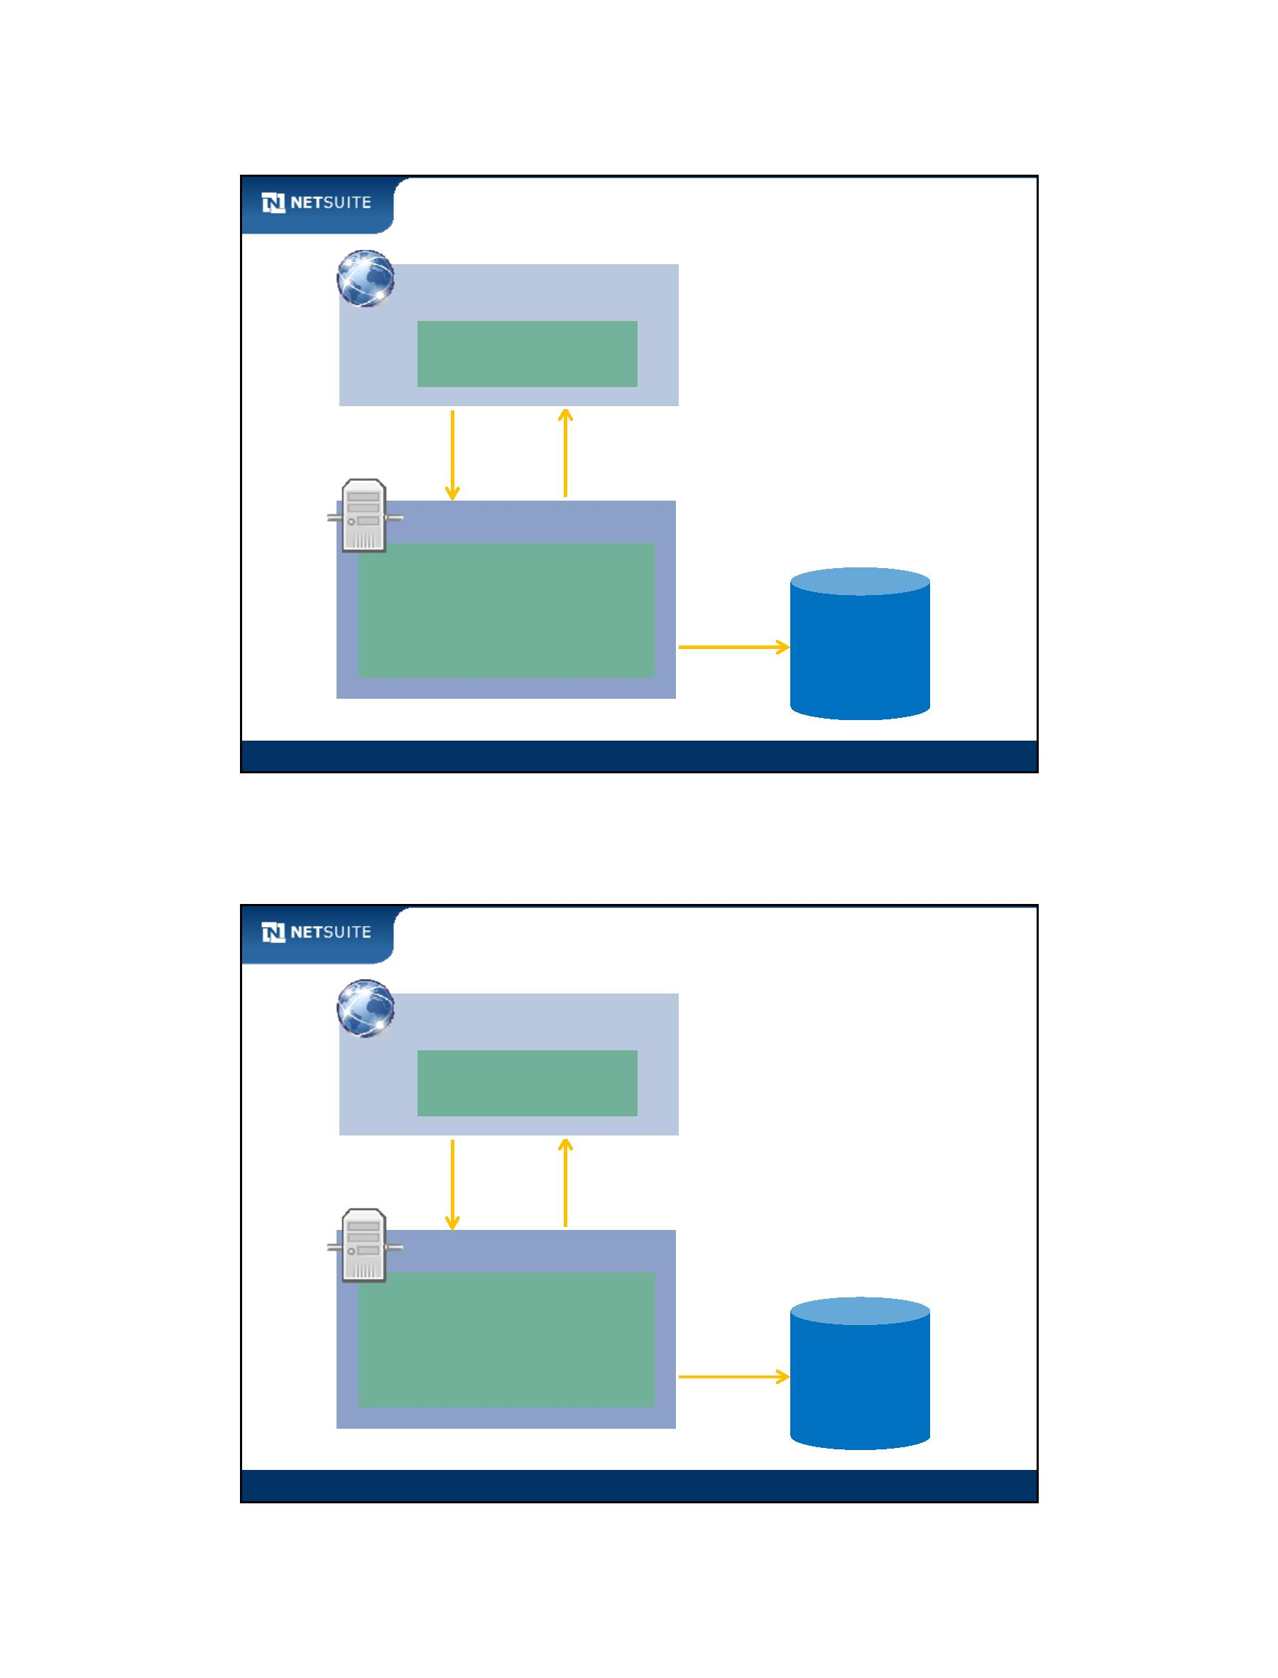

SuiteScript

Overview of SuiteScript Script Types

Client

Suitelet

User Event

RESTlet

Scheduled

Portlet

Workflow Action

Mass Update

Bundle Installation

Module 1: Prepare To Develop Scripts

17

Client

Client

Script running in

browser

Script execution

affects form field

Module 1: Prepare To Develop Scripts

18

Module 1: Prepare To Develop Scripts - 9

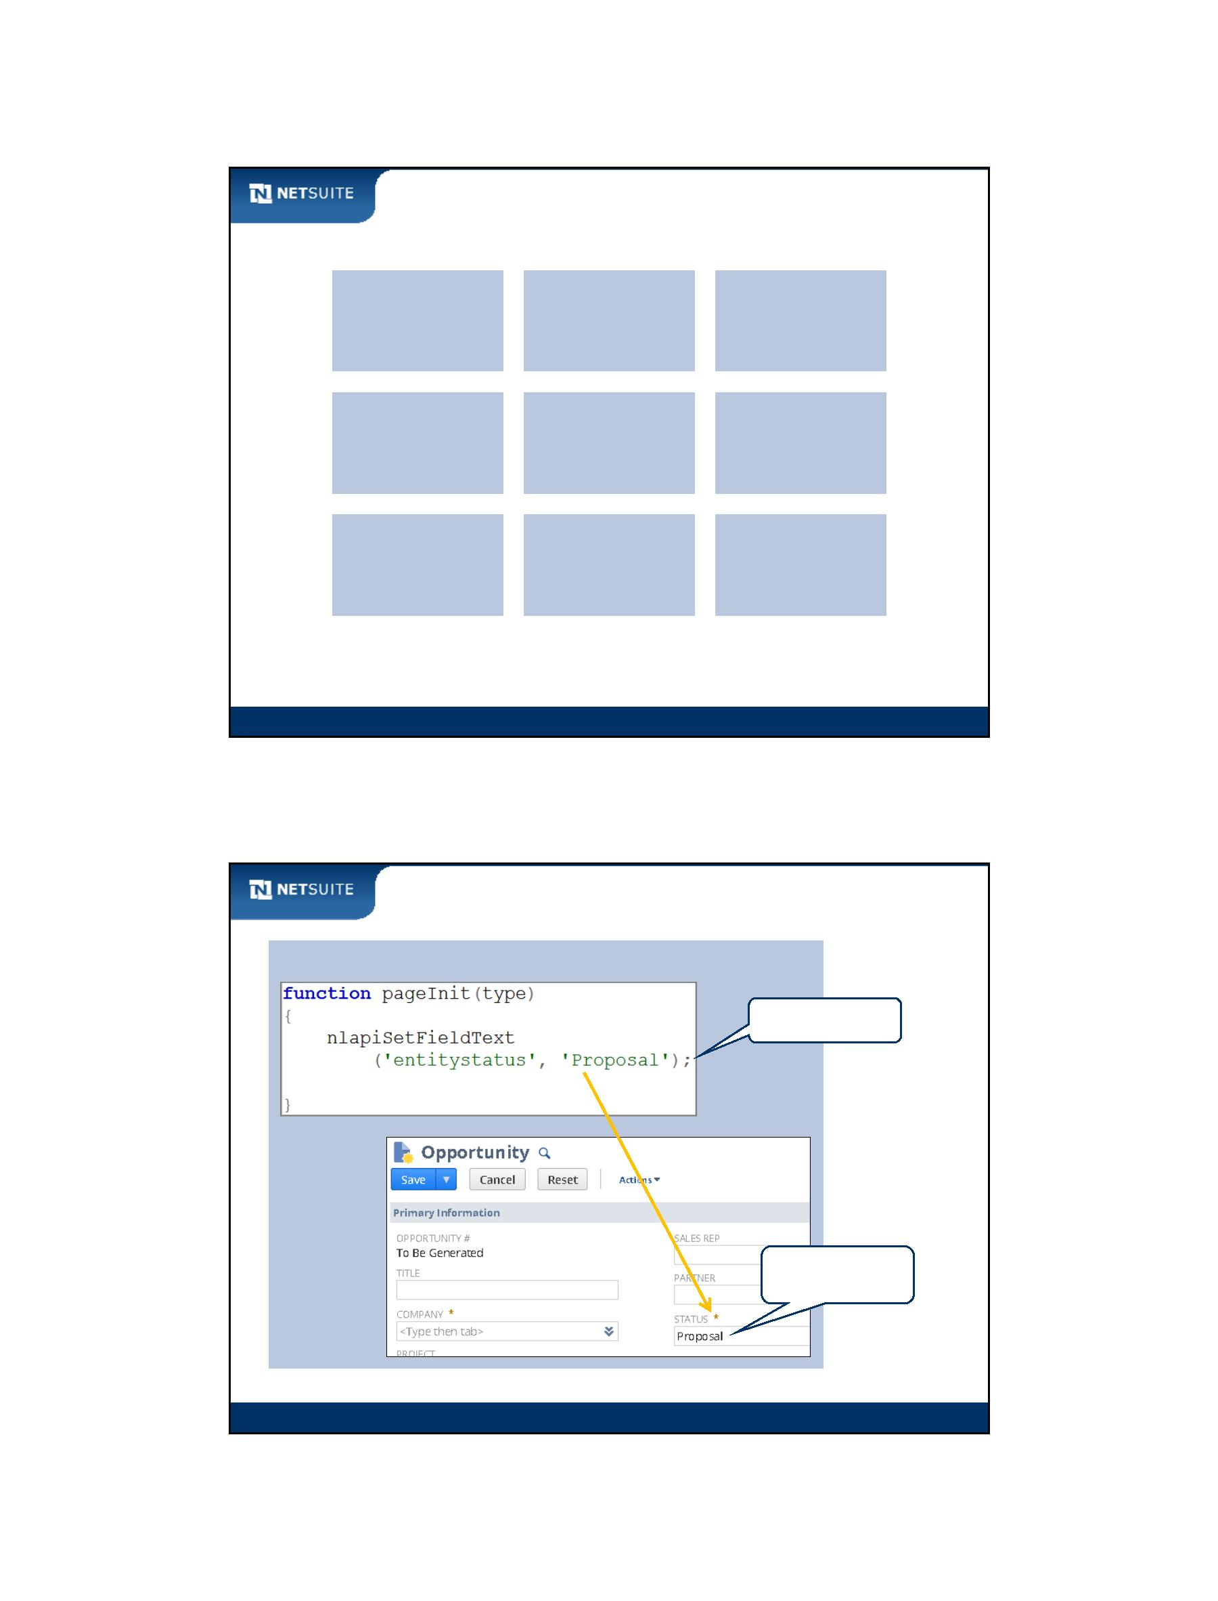

SuiteScript

User Event

Client

Client

http request

http response

Web Server

Override Title

Module 1: Prepare To Develop Scripts

19

Scheduled

Web Server

Script executes at

scheduled time

Script to return Status of

opportunity records

Module 1: Prepare To Develop Scripts

20

Module 1: Prepare To Develop Scripts - 10

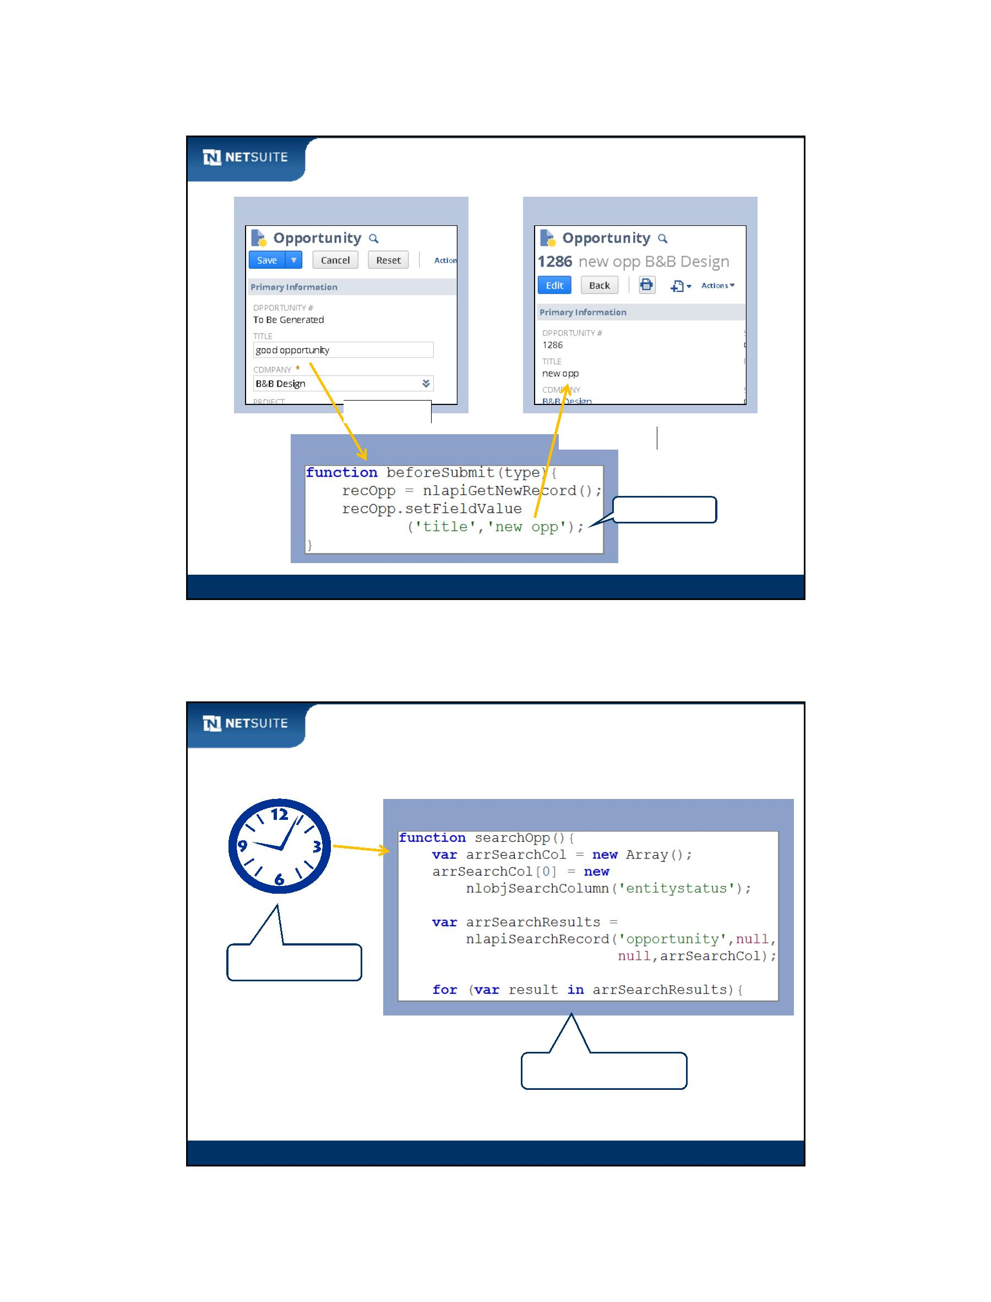

SuiteScript

Portlet

Client

Script

generating

portlet form

http response (html)

Web Server

Portlet form

on Home

Dashboard

Module 1: Prepare To Develop Scripts

21

Workflow Action

custom workflow

action executes

SuiteScript

Web Server

pass parameters from

workflow to script

Module 1: Prepare To Develop Scripts

22

Module 1: Prepare To Develop Scripts - 11

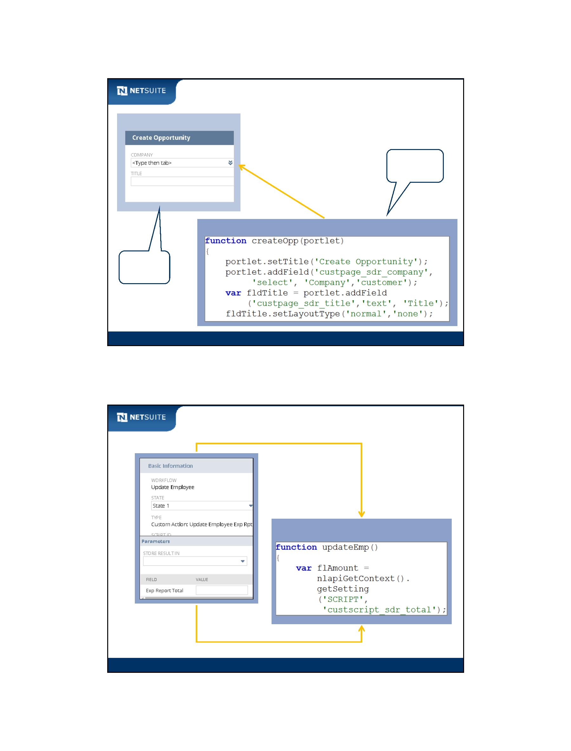

SuiteScript

Suitelet

Client

http response

(form generated)

http POST request

(form submitted)

Web Server

Module 1: Prepare To Develop Scripts

23

RESTlets

http response

(values populated)

Client

Web Server

http GET request

(request submitted)

Module 1: Prepare To Develop Scripts

24

Module 1: Prepare To Develop Scripts - 12

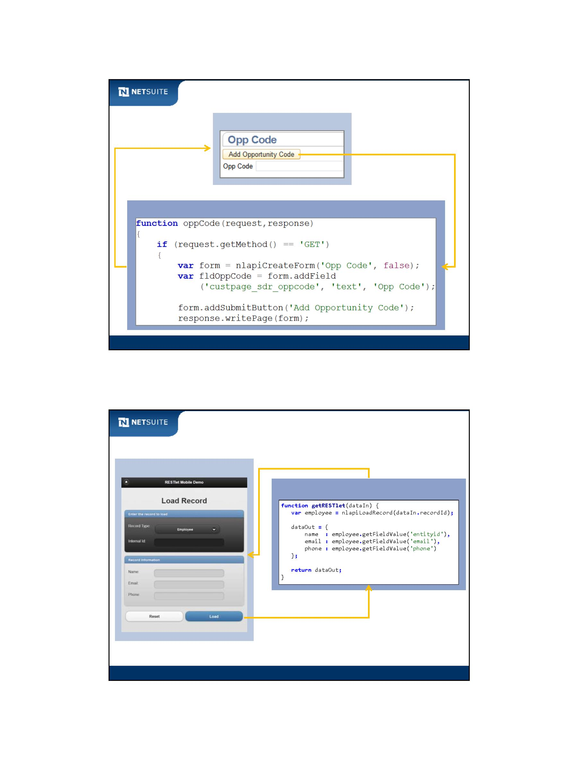

SuiteScript

Mass Update

Web Server

Script to process an

individual opportunity

record

List of records

controlled by Mass

Update process

Module 1: Prepare To Develop Scripts

25

Bundle Installation

Web Server

Triggers

Before or After

Installing the Bundle

Module 1: Prepare To Develop Scripts

26

Module 1: Prepare To Develop Scripts - 13

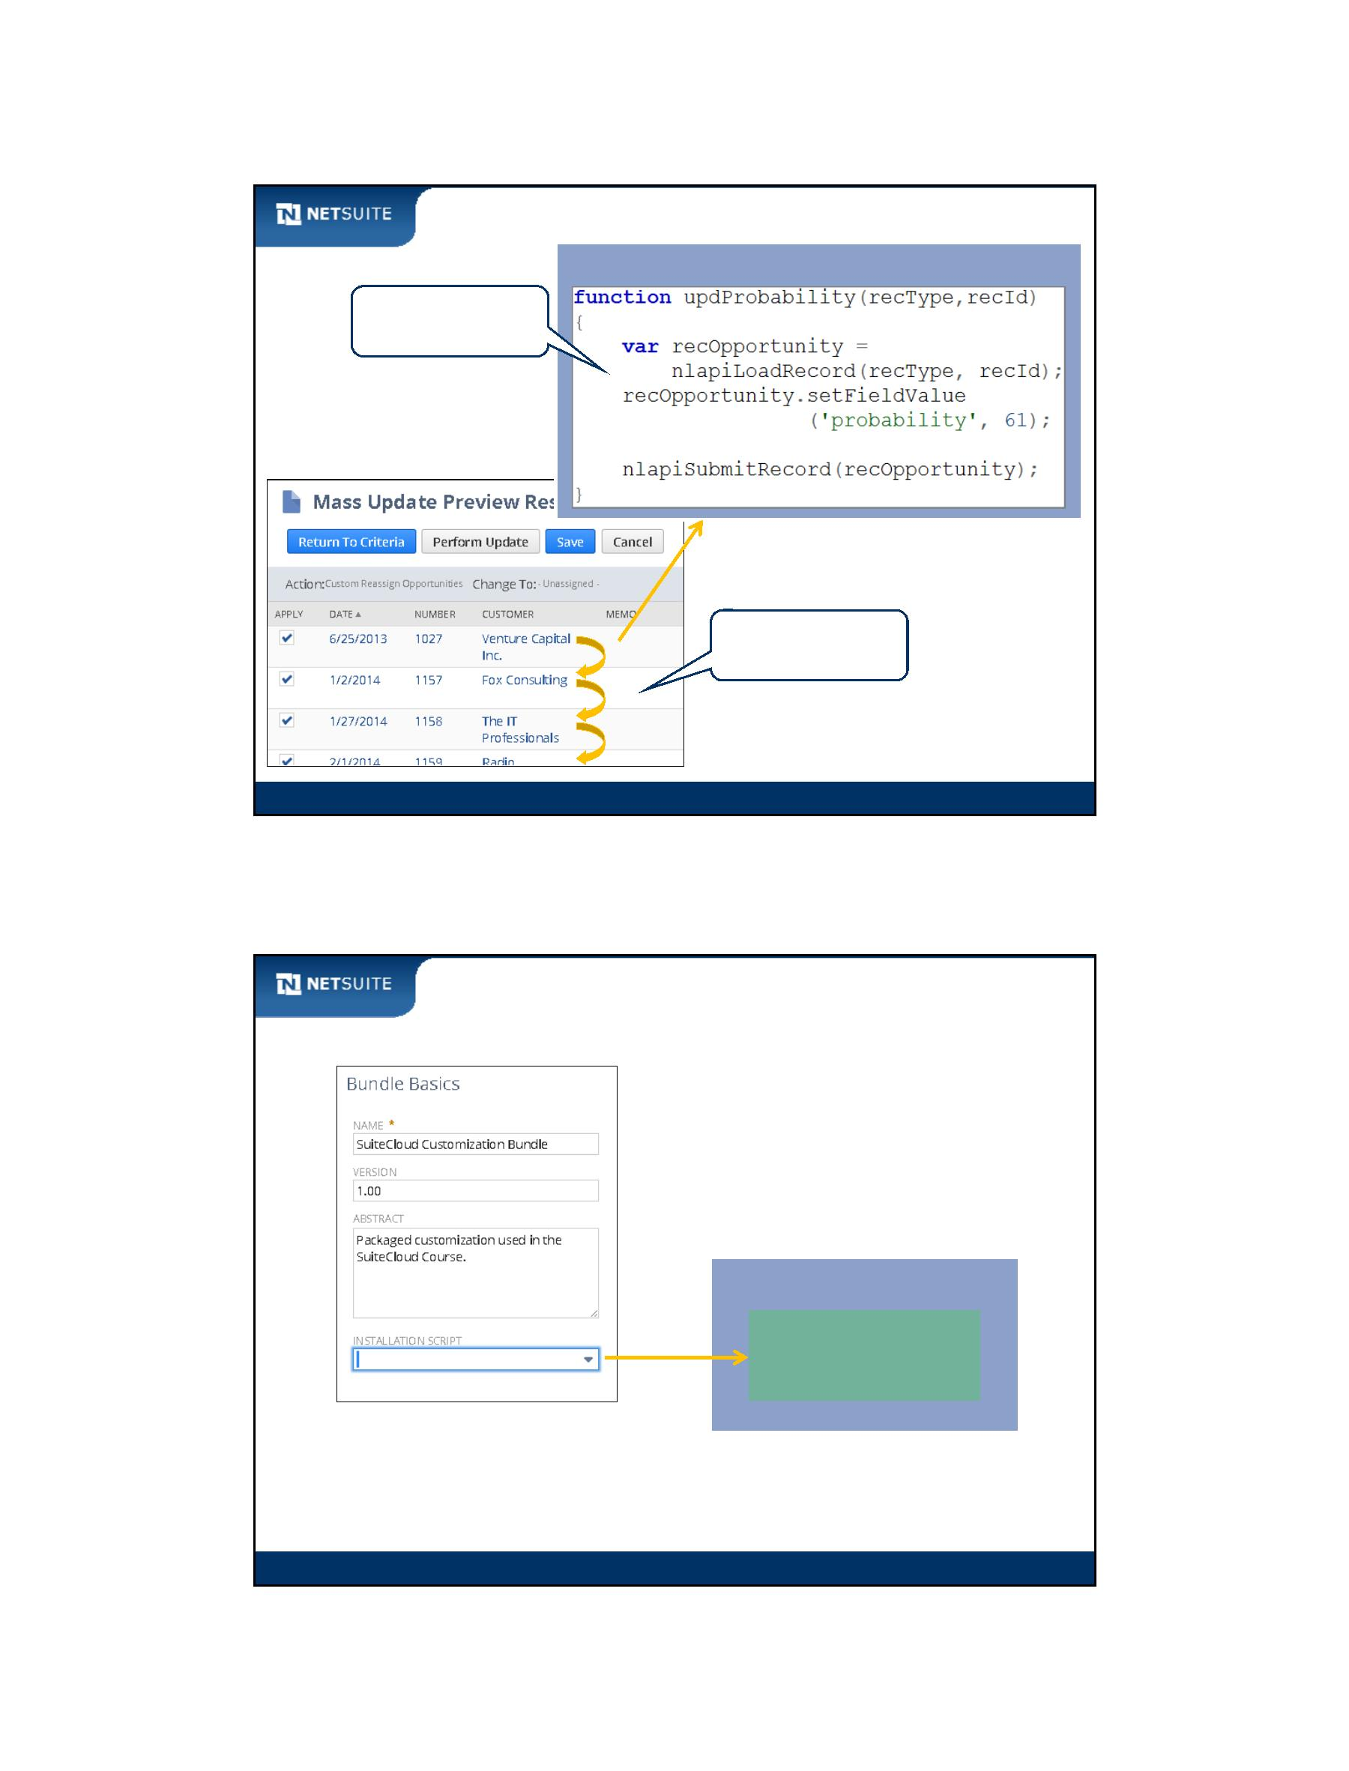

SuiteScript

Activity: Script Types Review

**User**

**Event**

**Workflow**

**Action**

**Client**

**Scheduled**

**Portlet**

**Suitelet**

□ □ □ □ □ □

□ □ □ □ □ □

□ □ □ □ □ □

□ □ □ □ □ □

□ □ □ □ □ □

Generates http

response

Processes http

request

Runs on client

Runs on server

JavaScript

technology

Module 1: Prepare To Develop Scripts

27

NetSuite Help Center

Use the NetSuite Help Center to

become proficient in scripting.

Help on SuiteCloud

technologies

Module 1: Prepare To Develop Scripts

28

Module 1: Prepare To Develop Scripts - 14

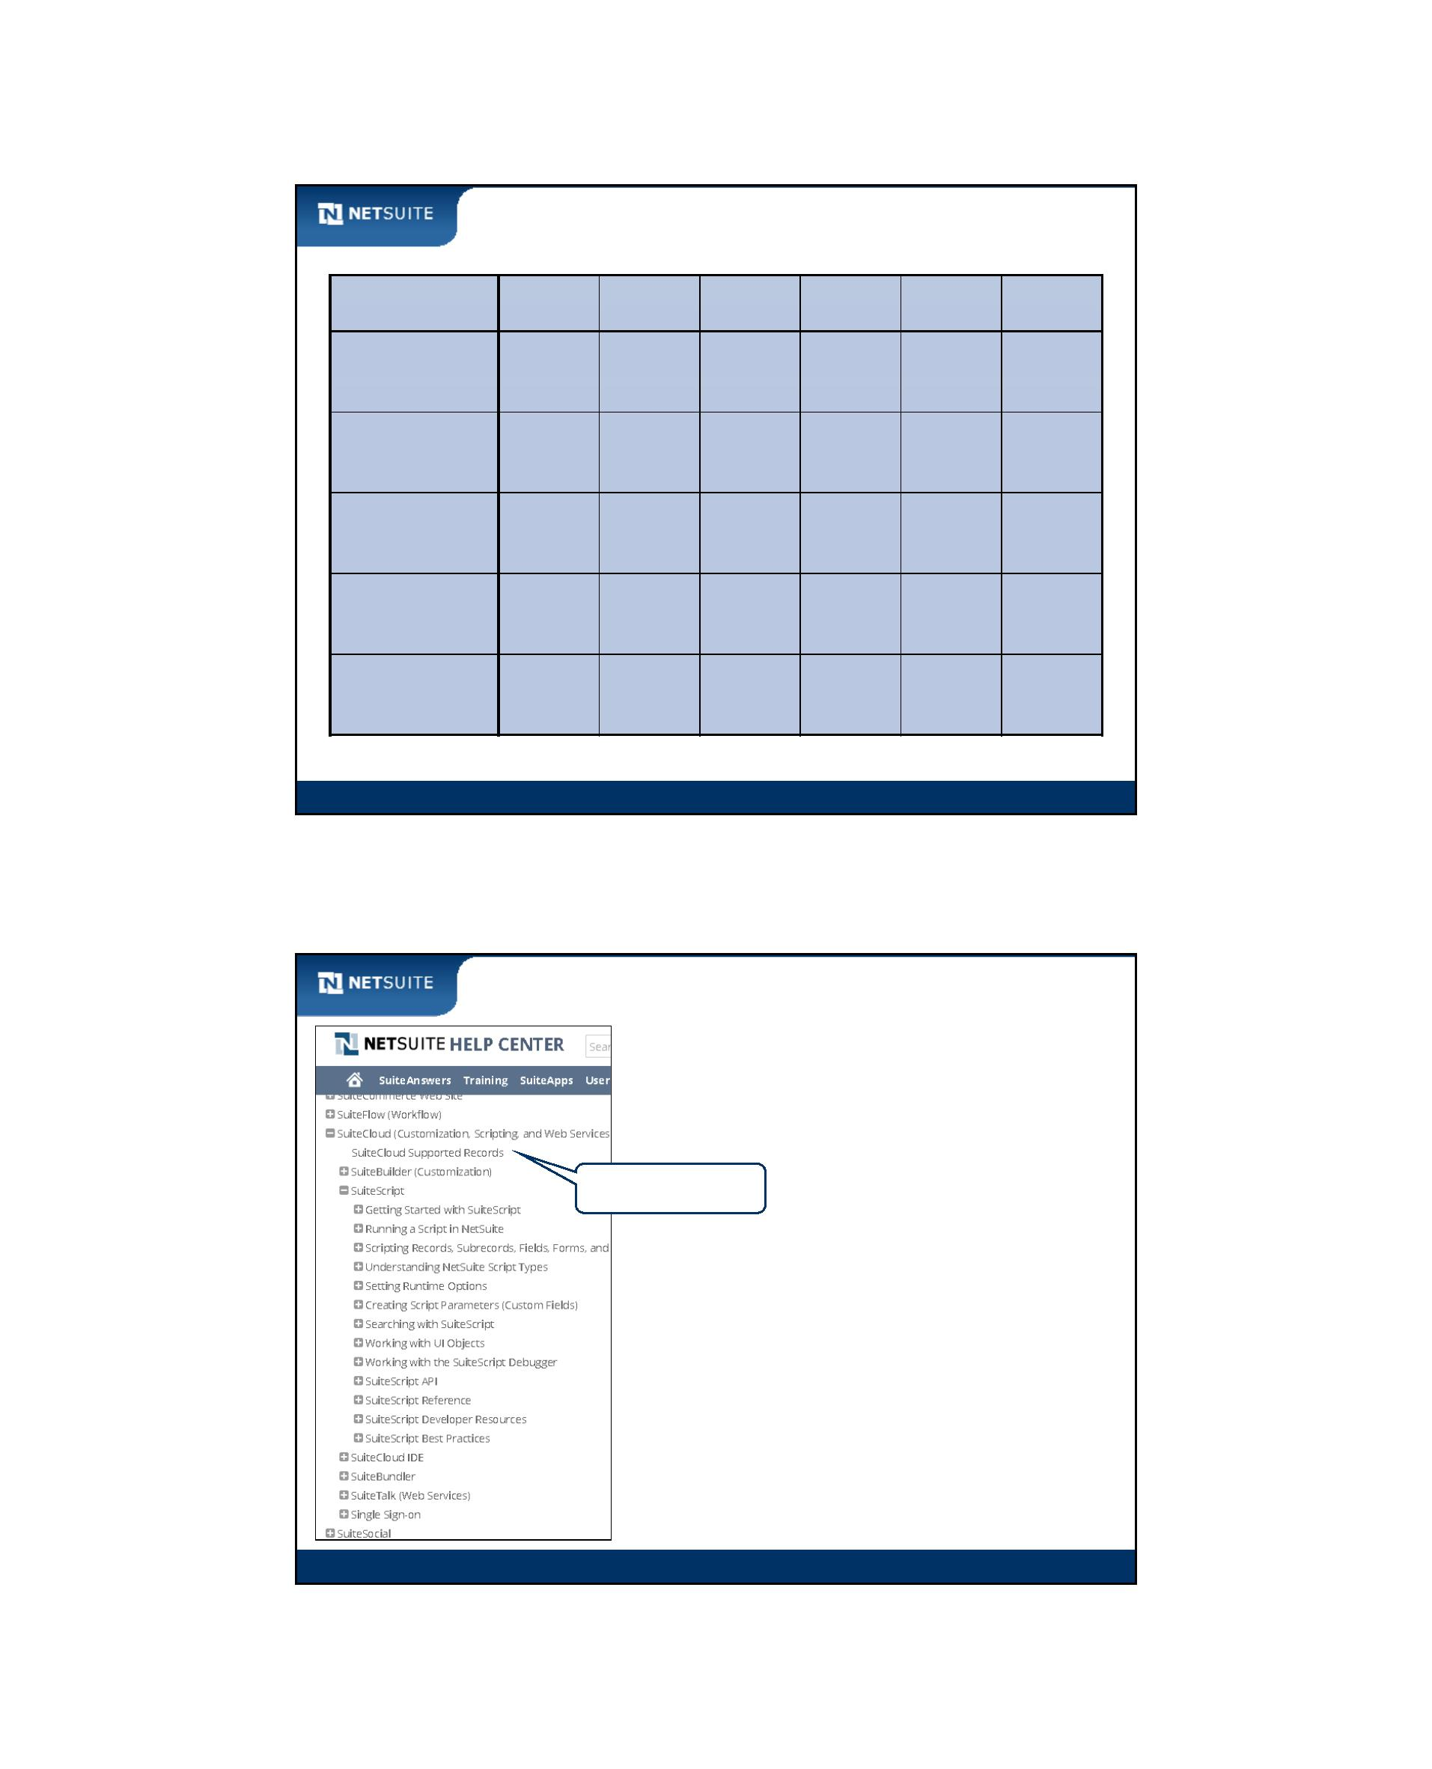

SuiteScript

Module 2: Introduction to Scripting

Objectives

Upon completing this module, you should be able to:

Create a script using the Eclipse IDE or other text editor

Create a custom form

Attach a script to a custom form

Module 2: Introduction To Scripting

2

Module 2: Introduction To Scripting - 1



SuiteScript

Walk Through: Create a Client‐side Script

Scenario:

Display a JavaScript pop‐up message upon opening an employee form

Skills Covered:

Opening Eclipse and creating a Project

Creating a JavaScript file

Creating a client SuiteScript function

Loading a script file into NetSuite

Creating a custom form

Configuring a script on the Custom Code subtab

Executing a script

Module 2: Introduction To Scripting

3

Basic JavaScript Syntax

Define function

One or more parameters

Function contents

Enclose function in

curly braces

End statements

with semicolon

Module 2: Introduction To Scripting

4

Module 2: Introduction To Scripting - 2

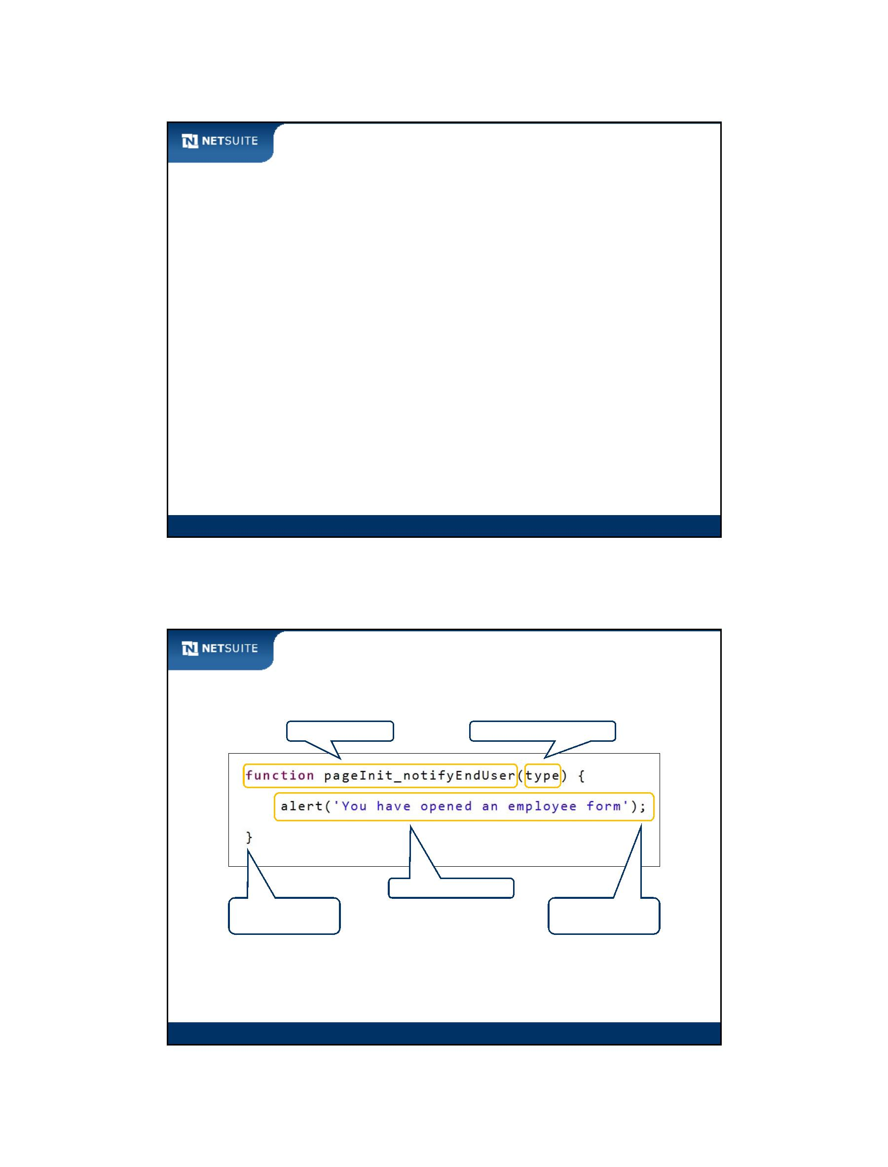

SuiteScript

Activity: Fill in Custom Code Subtab

Fill in the Custom Code subtab based on information in the top two screenshots.

Module 2: Introduction To Scripting

5

Best Practices

Make your form names unique to your organization

Naming conventions:

File Names: <companyName>_<scriptType>_<description>

Name functions after their event types on Custom Code subtab

Use alert to debug your script

o

Module 2: Introduction To Scripting

6

Module 2: Introduction To Scripting - 3

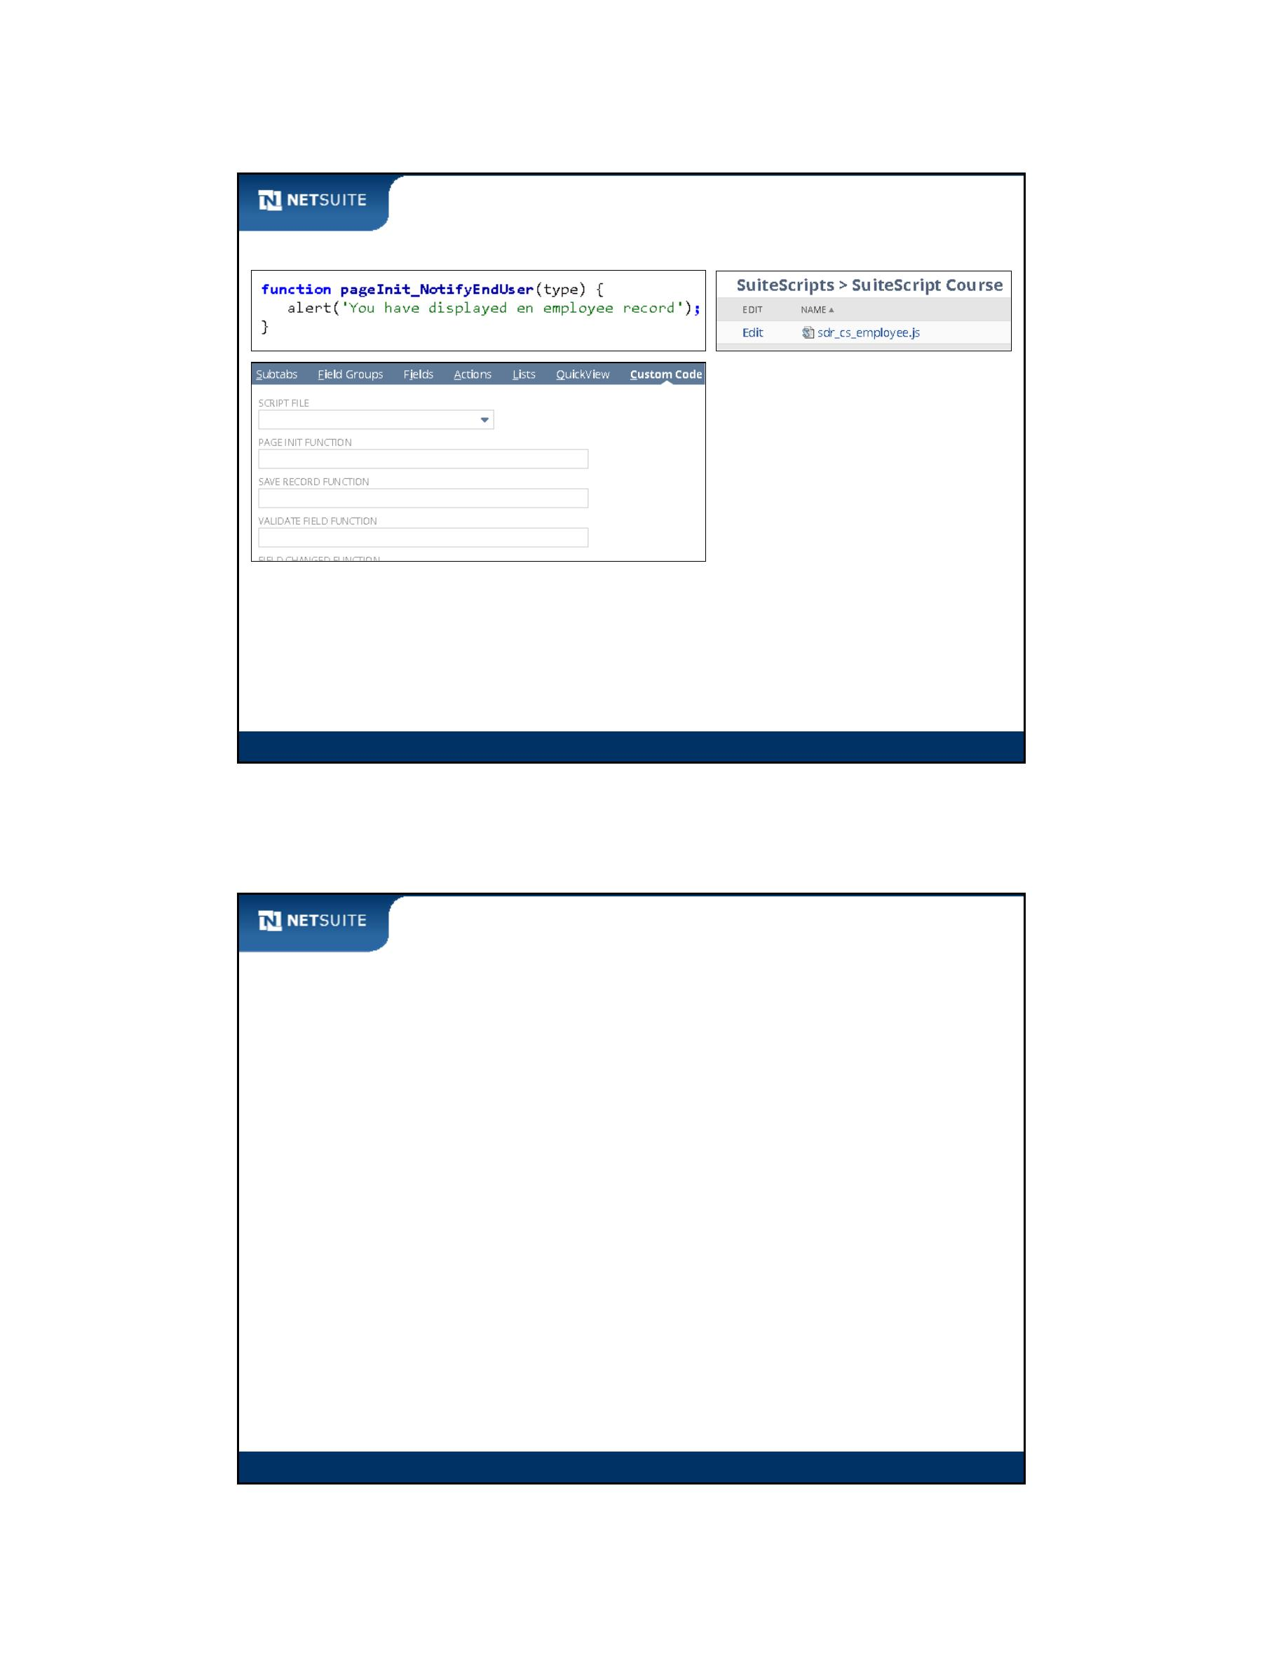

SuiteScript

Now It’s Your Turn

In the hands on exercise, you practice:

Creating a script using the SuiteCloud (Eclipse) IDE or other text editor

Creating a custom form

Attaching a script to a custom form

Module 2: Introduction To Scripting

7

Activity: Steps to Create a Client‐side Script

Module 2: Introduction To Scripting

8

Module 2: Introduction To Scripting - 4

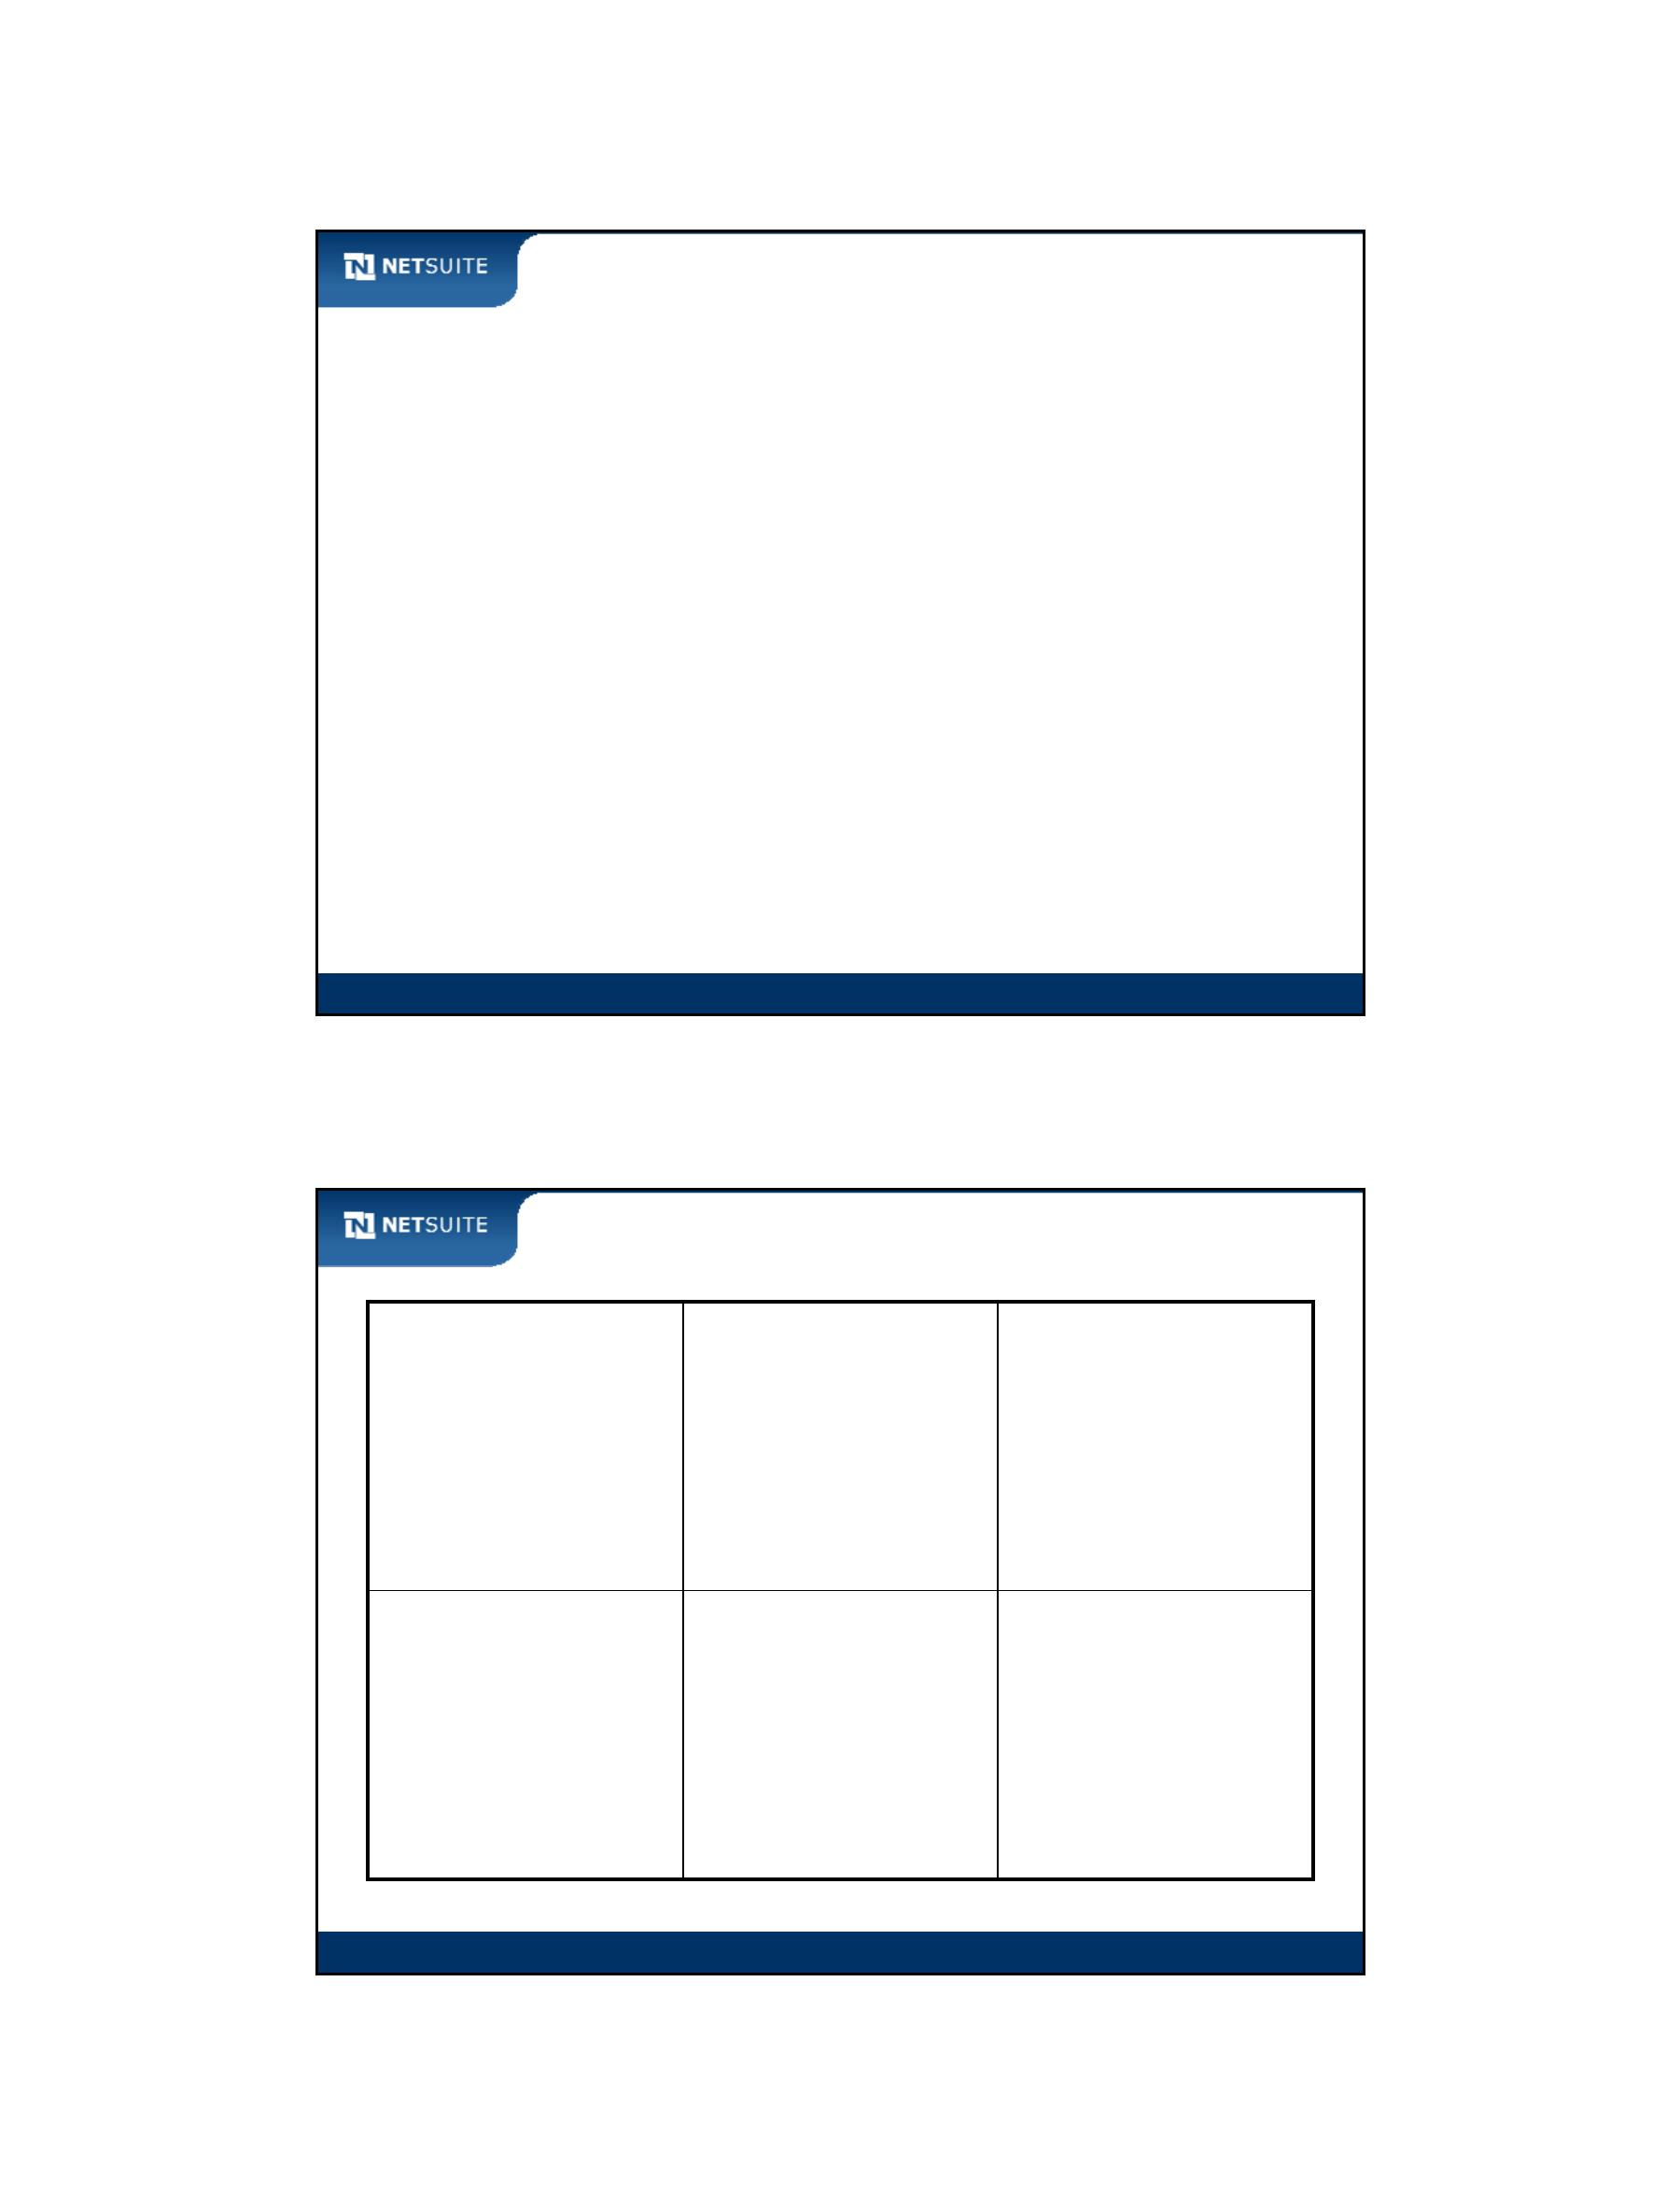

SuiteScript

Module 3: Introduction to SuiteScript API

Objectives

Upon completing this module, you should be able to:

Use the SuiteScript API to get and set values in fields

Use the SuiteScript API to enable and disable fields

Understand the relationship between the DOM and client‐side

SuiteScript API functions

Use browser‐based script debuggers to troubleshoot client‐side scripts

Module 3: Introduction to SuiteScript

2

Module 3: Introduction To SuiteScript API - 1



SuiteScript

Activity: Identify UI Elements

Module 3: Introduction to SuiteScript

3

Walk Through: Scripting a Custom Entity Field

Scenario:

Create a custom field called Employee Code

Default a value to Employee Code upon page load

Display the text and id of the Supervisor in an alert message

Skills Covered:

Creating a custom field

Using several SuiteScript API functions:

nlapiSetFieldValue, nlapiGetFieldValue, nlapiGetFieldText

Module 3: Introduction to SuiteScript

4

Module 3: Introduction To SuiteScript API - 2

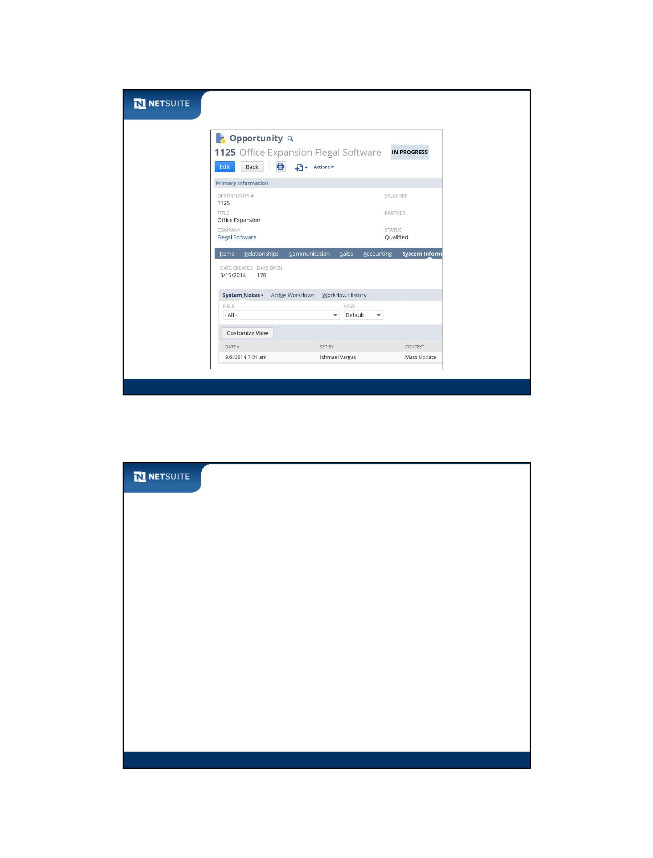

SuiteScript

Activity: Configure CRM Field

Configure a check box CRM field to display in the main (body) area of a phone call form.

Give the Label the value Followup.

Module 3: Introduction to SuiteScript

5

Activity: Enter Function Format to Disable a field

Enter function format to disable the Special Amount

transaction body field using nlapiDisableField.

Tip: Use the NetSuite Help Center.

Module 3: Introduction to SuiteScript

6

Module 3: Introduction To SuiteScript API - 3

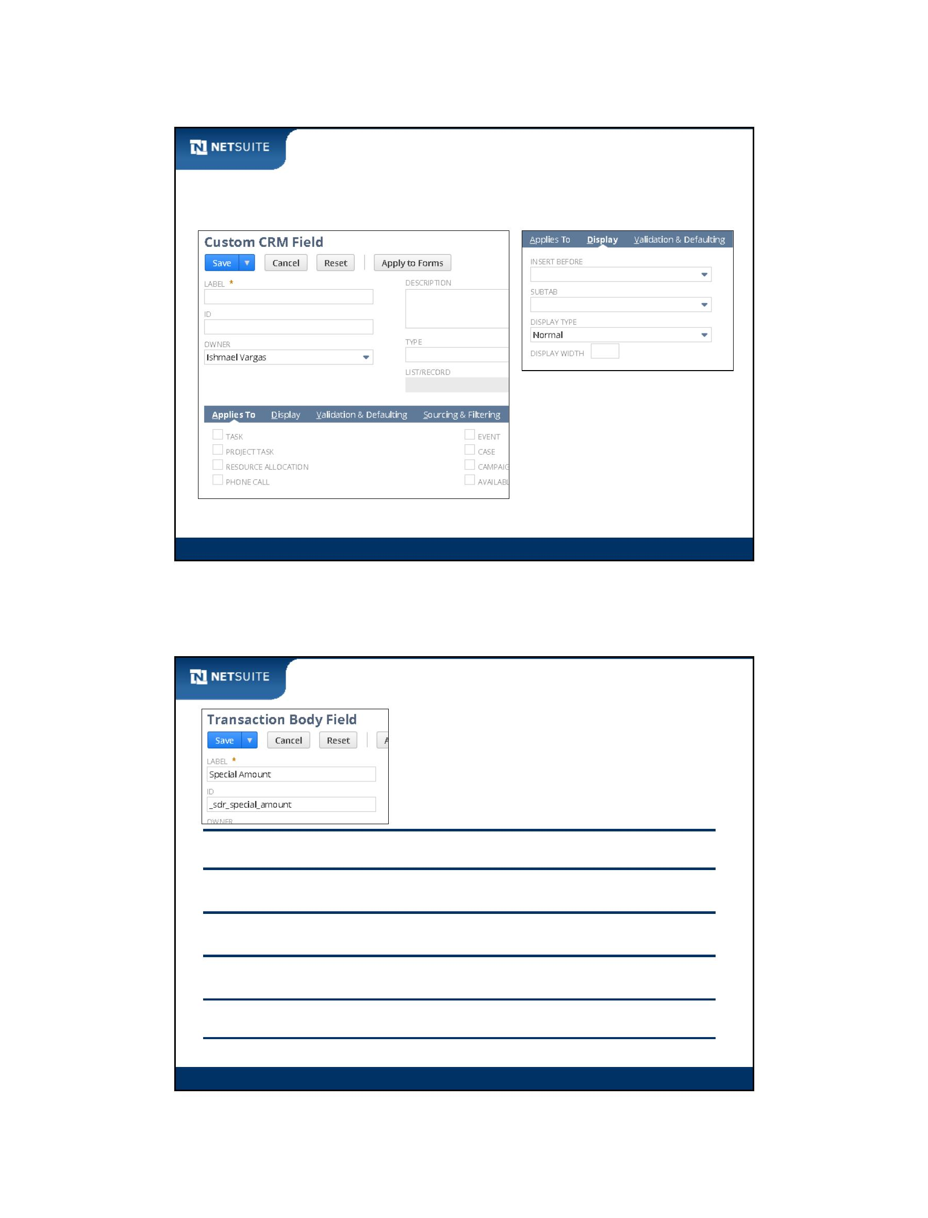

SuiteScript

DOM and SuiteScript API

DOM function format to get/set field:

Example of DOM function to set phone field:

Equivalent SuiteScript API function to set phone field:

Module 3: Introduction to SuiteScript

7

DOM and SuiteScript API continued

window

document

formA

nlapiSetFieldValue

field1

field2

nlapiGetFieldValue

nlapiSetFieldText

nlapiGetFieldText

nlapiDisableField

formB

field3

window.document.formB.field3 = ‘abc’

Module 3: Introduction to SuiteScript

8

Module 3: Introduction To SuiteScript API - 4

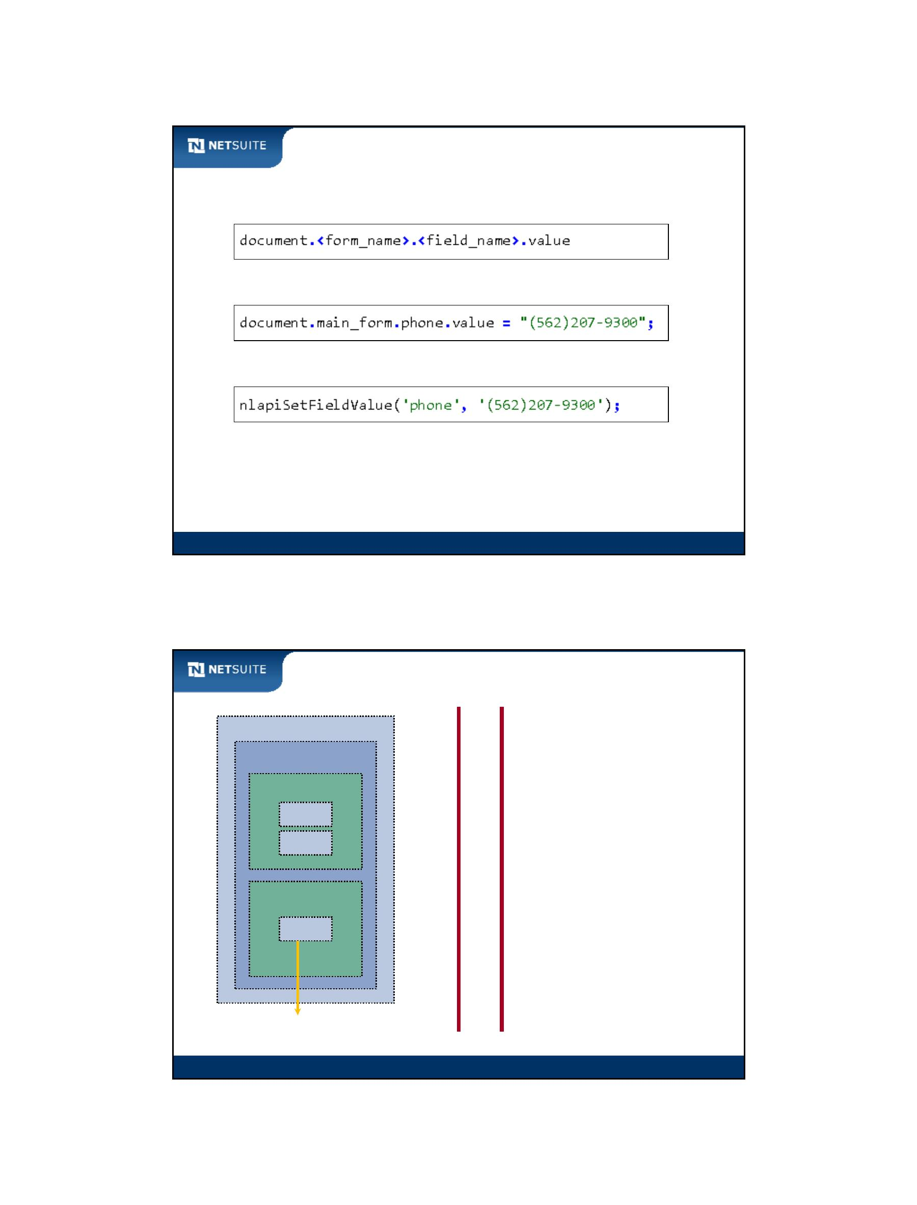

SuiteScript

Why DOM Access is not Recommended

Definition of nlapiSetFieldValue

Lots happening in the

implementation

Module 3: Introduction to SuiteScript

9

Walk Through: Client‐side Debugging

Scenario:

Debug the Page Init function as if an issue needs troubleshooting

Skills Covered:

Debugging client‐side script

General debugging concepts of setting breakpoints and stepping

through code

Finding the script file in which to set a breakpoint

Module 3: Introduction to SuiteScript

10

Module 3: Introduction To SuiteScript API - 5

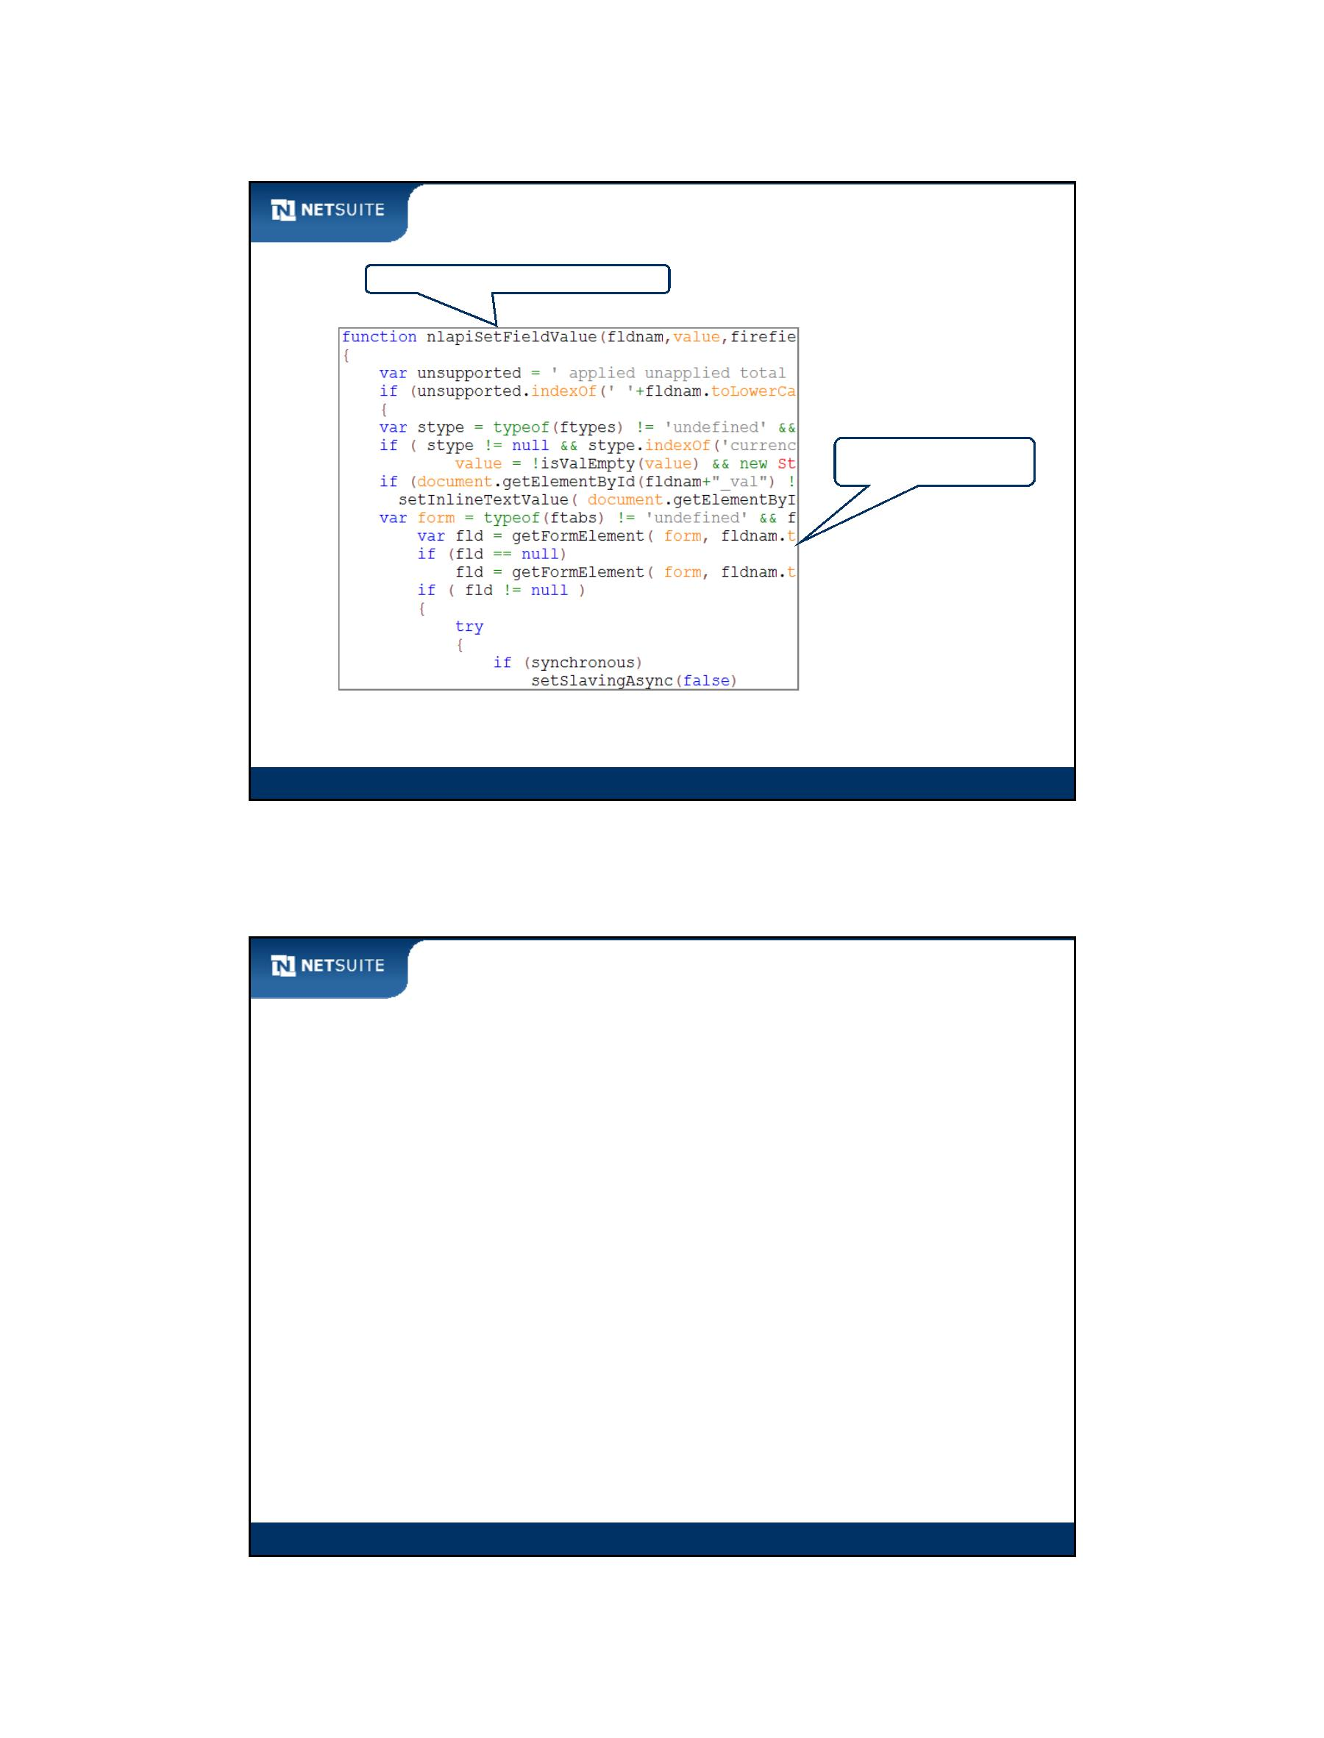

SuiteScript

Activity: T/F on Debugging

1

2

3

4

Step Into debugs the source code of a function that is being

called

Step Out returns from a called function into the calling function

Step Over skips the execution of a line of script

Continue stops execution at the next breakpoint, or completes

execution when there is no breakpoint

5

A script file named SuiteDreams_CS_Vendor can be located by the same name in the

debugger

Module 3: Introduction to SuiteScript

11

Tips & Best Practices

Naming conventions:

NetSuite IDs: _<company_abbrv>_<description>

o

Do not access the DOM directly!

Be mindful of case sensitivity. Function names, variable names,

and JavaScript keywords are all case sensitive.

When testing client side scripts; you often need to clear browser

cache in order for NetSuite to recognize the updated script. In

some browsers you can refresh a record and clear cache at the

same time by pressing CTRL + F5.

Module 3: Introduction to SuiteScript

12

Module 3: Introduction To SuiteScript API - 6

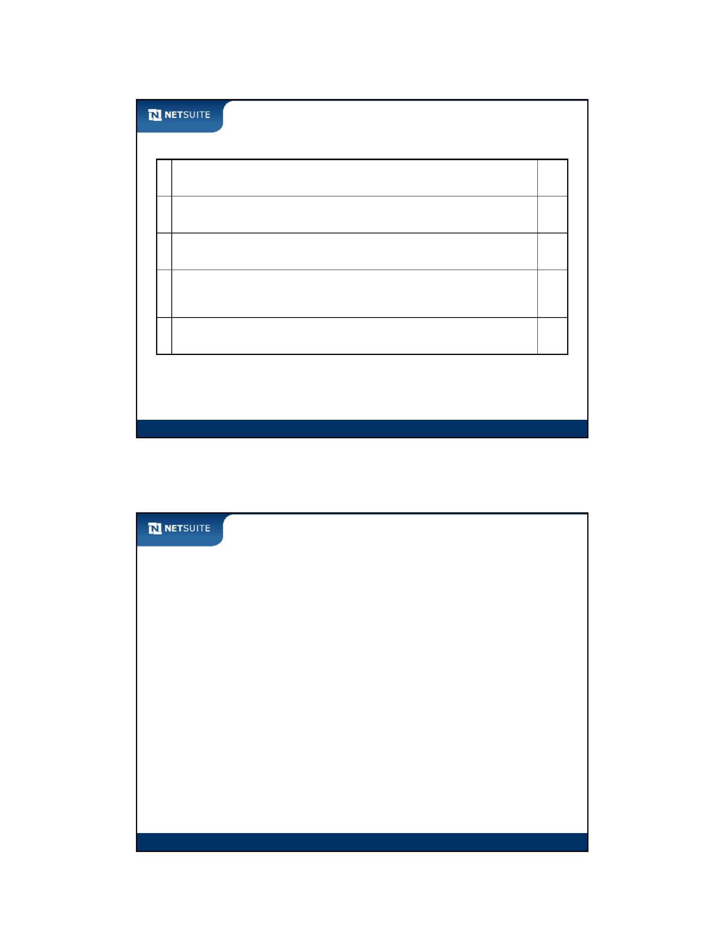

SuiteScript

Additional Resources

See SuiteCloud > SuiteScript > SuiteScript API > SuiteScript Functions >

Field APIs in the NetSuite Help Center for details about SuiteScript

functions used in this and upcoming modules

Module 3: Introduction to SuiteScript

13

Now It’s Your Turn

In these hands on exercises, you practice:

Creating custom fields for the purposes of scripting them

Using SuiteScript API functions to get and set field values

Using SuiteScript API functions to enable and disable fields

Using the browser‐based debuggers to troubleshoot your script

Note: Exercise instructions do not include use of debuggers, but try it

out if you have one installed in your browser.

Module 3: Introduction to SuiteScript

14

Module 3: Introduction To SuiteScript API - 7



SuiteScript

Module 4: Investigating Client Event Functions

Objectives

Upon completing this module, you should be able to:

Execute scripts in a variety of client event functions

Module 4: Investigating Client Event Functions

2

Module 4: Investigating Client Event Functions - 1



SuiteScript

NetSuite Functions and Client‐Side Events

End User Function

NetSuite Client Event

Function

JavaScript

Client‐side Event

Opening form

Page Init Function

onLoad

Changing a field

Changing a field

Submitting form

Changing a field

Validate Field Function

Field Changed Function

Save Record Function

Post Sourcing

onBlur

onChange

onSubmit

onChange

(plus wait time)

Module 4: Investigating Client Event Functions

3

Activity: Build Field Changed Function

Refer to SuiteCloud > SuiteScript > Understanding NetSuite Script Types > Client Scripts >

Client Event Types in NetSuite Help Center

Module 4: Investigating Client Event Functions

4

Module 4: Investigating Client Event Functions - 2

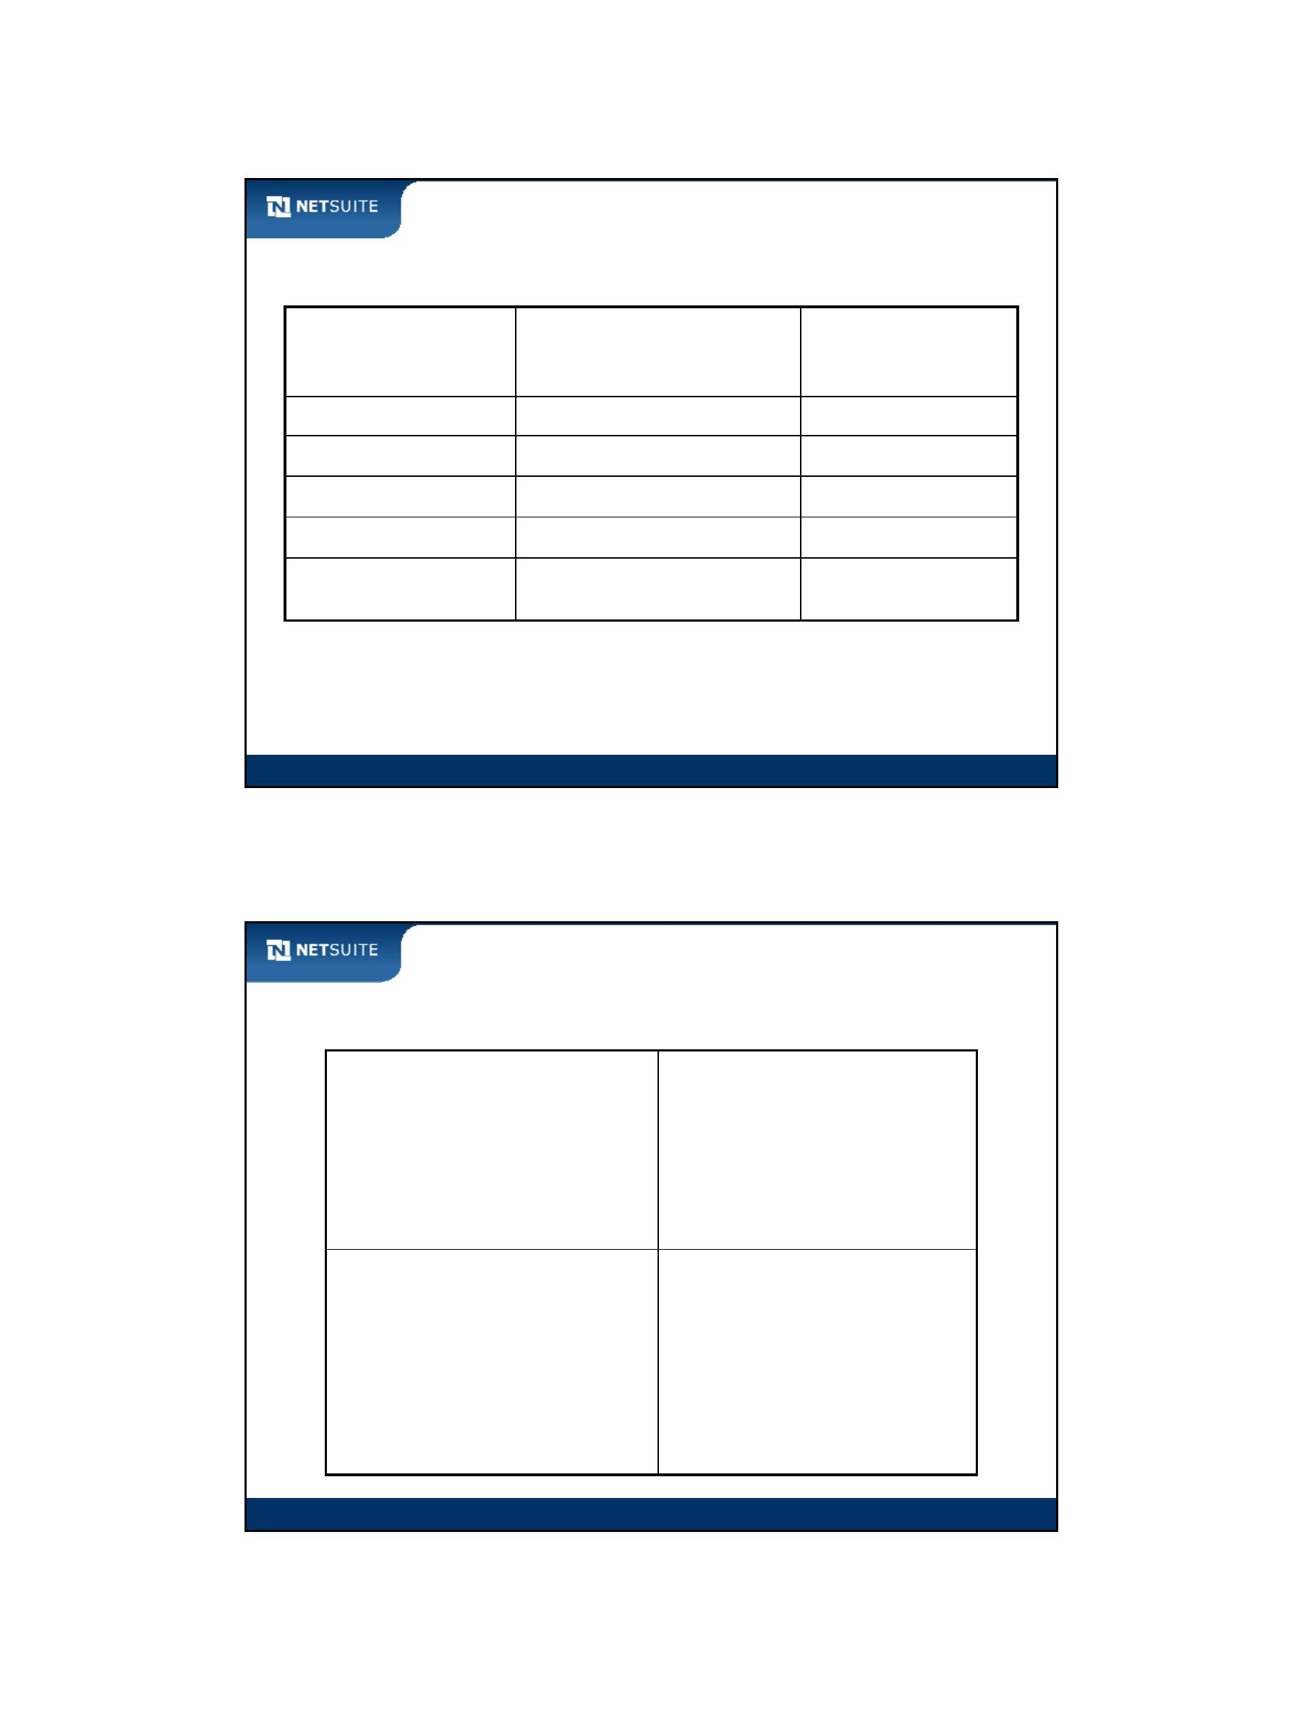

SuiteScript

Walk Through: Scripting across Client Event Functions

Scenario:

Set the value of Phone into Fax whenever Phone is changed

Validate Employee Code upon save

Validate Employee Code at the time it is changed

Skills Covered:

Work with other client event functions

– Field Changed

– Save Record

– Validate Field

Module 4: Investigating Client Event Functions

5

Client Event Function Execution Path

User changes ‘phone’ field

NetSuite Internal JavaScript

name = ‘phone’

function fieldChanged (type, name)

{

…

}

Module 4: Investigating Client Event Functions

6

Module 4: Investigating Client Event Functions - 3

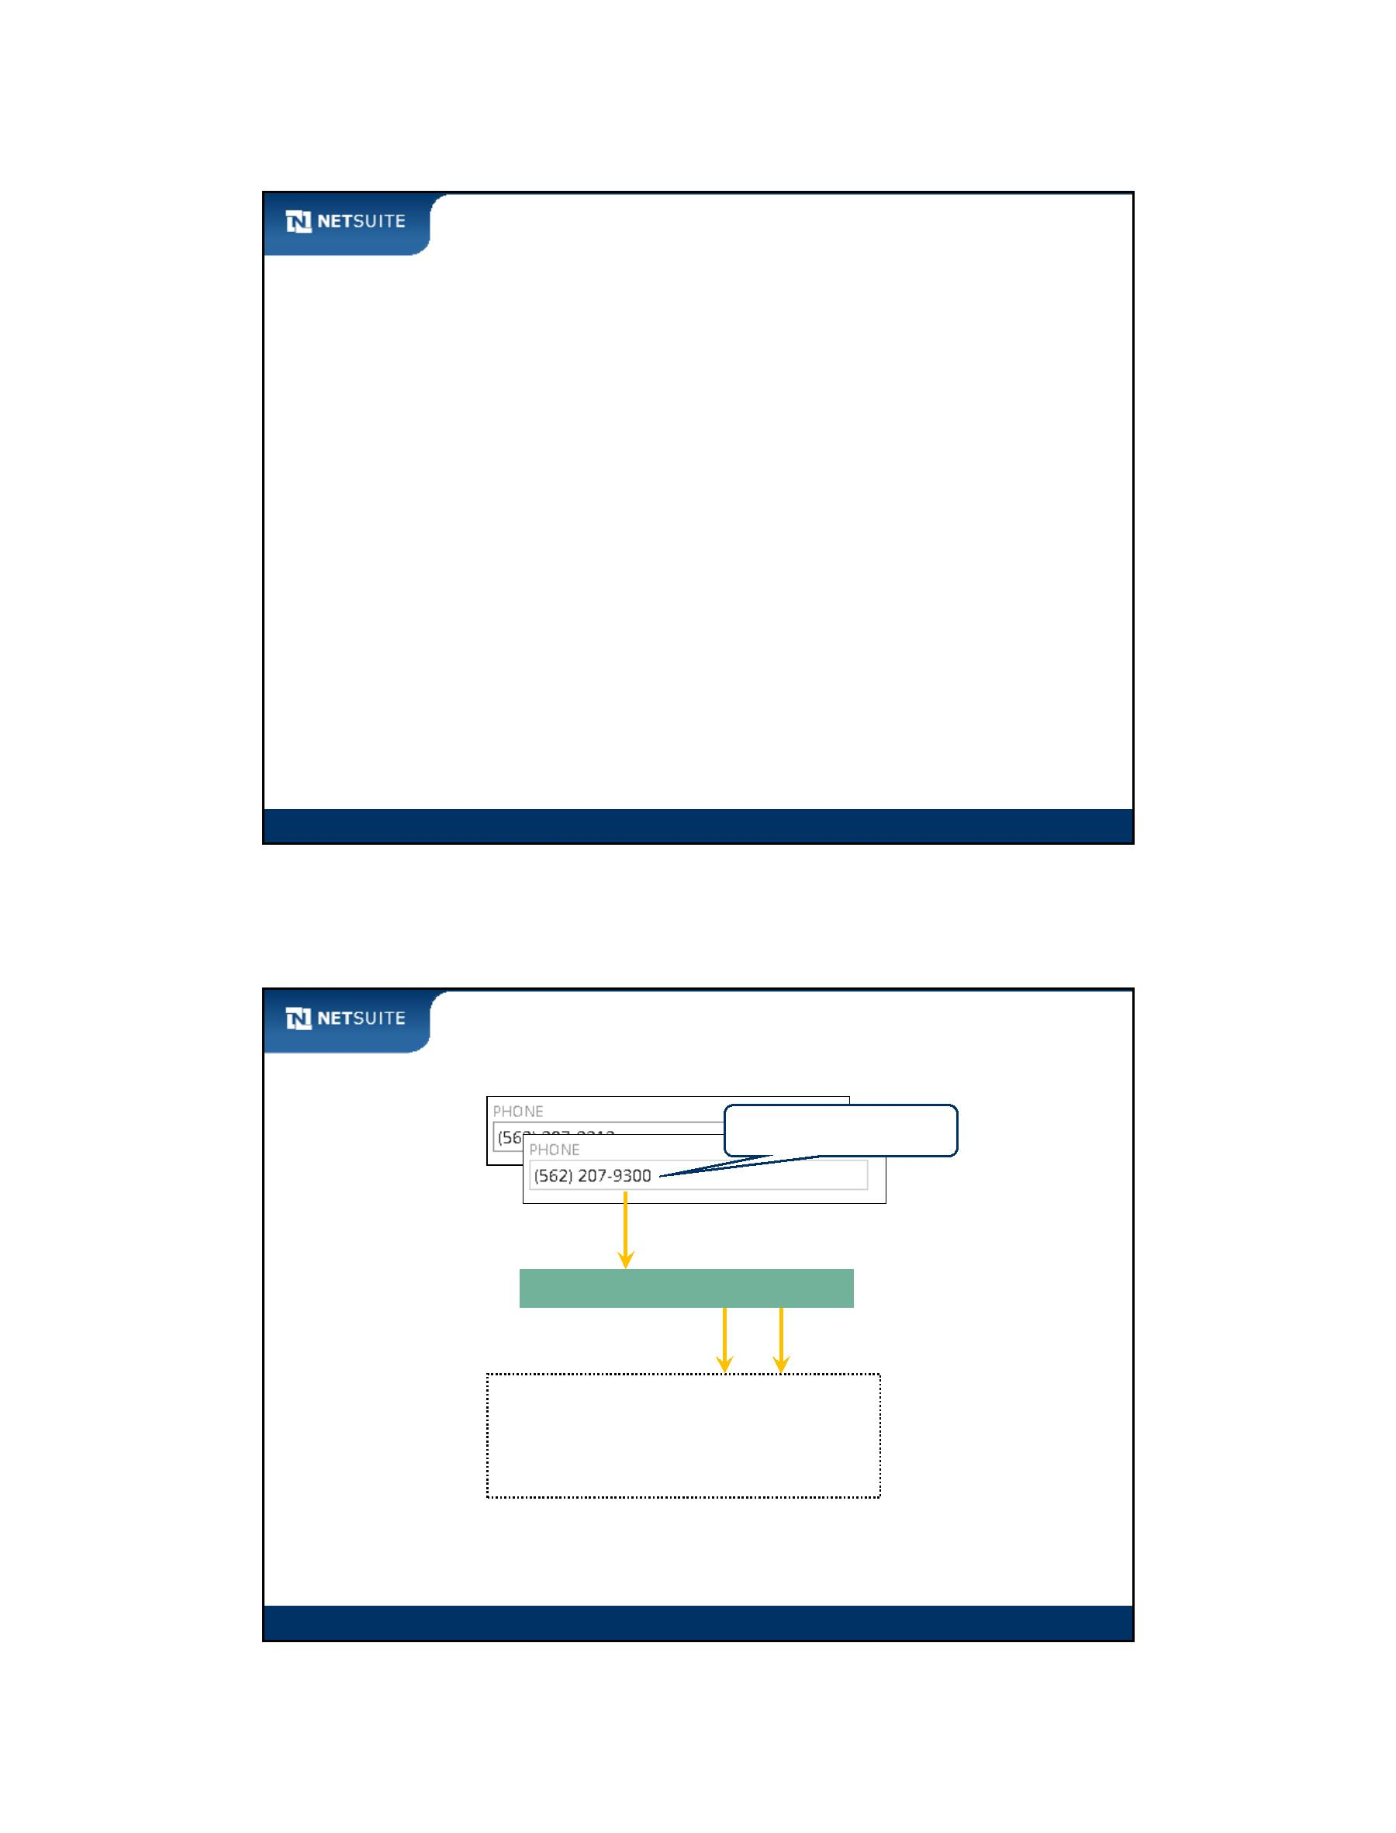

SuiteScript

Activity: Identify Client Event Functions

Identify the client event functions that take place at the indicated areas and buttons

Validate several fields

when Save is clicked

Default Purpose as

the form loads into

the browser

Must not be in the

past. Validate as soon

as date is entered

Alert on the value of

Subsidiary when its

value is populated,

which doesn’t occur

until an Employee is

selected

Module 4: Investigating Client Event Functions

7

Activity: Best Practices from This Module

Module 4: Investigating Client Event Functions

8

Module 4: Investigating Client Event Functions - 4

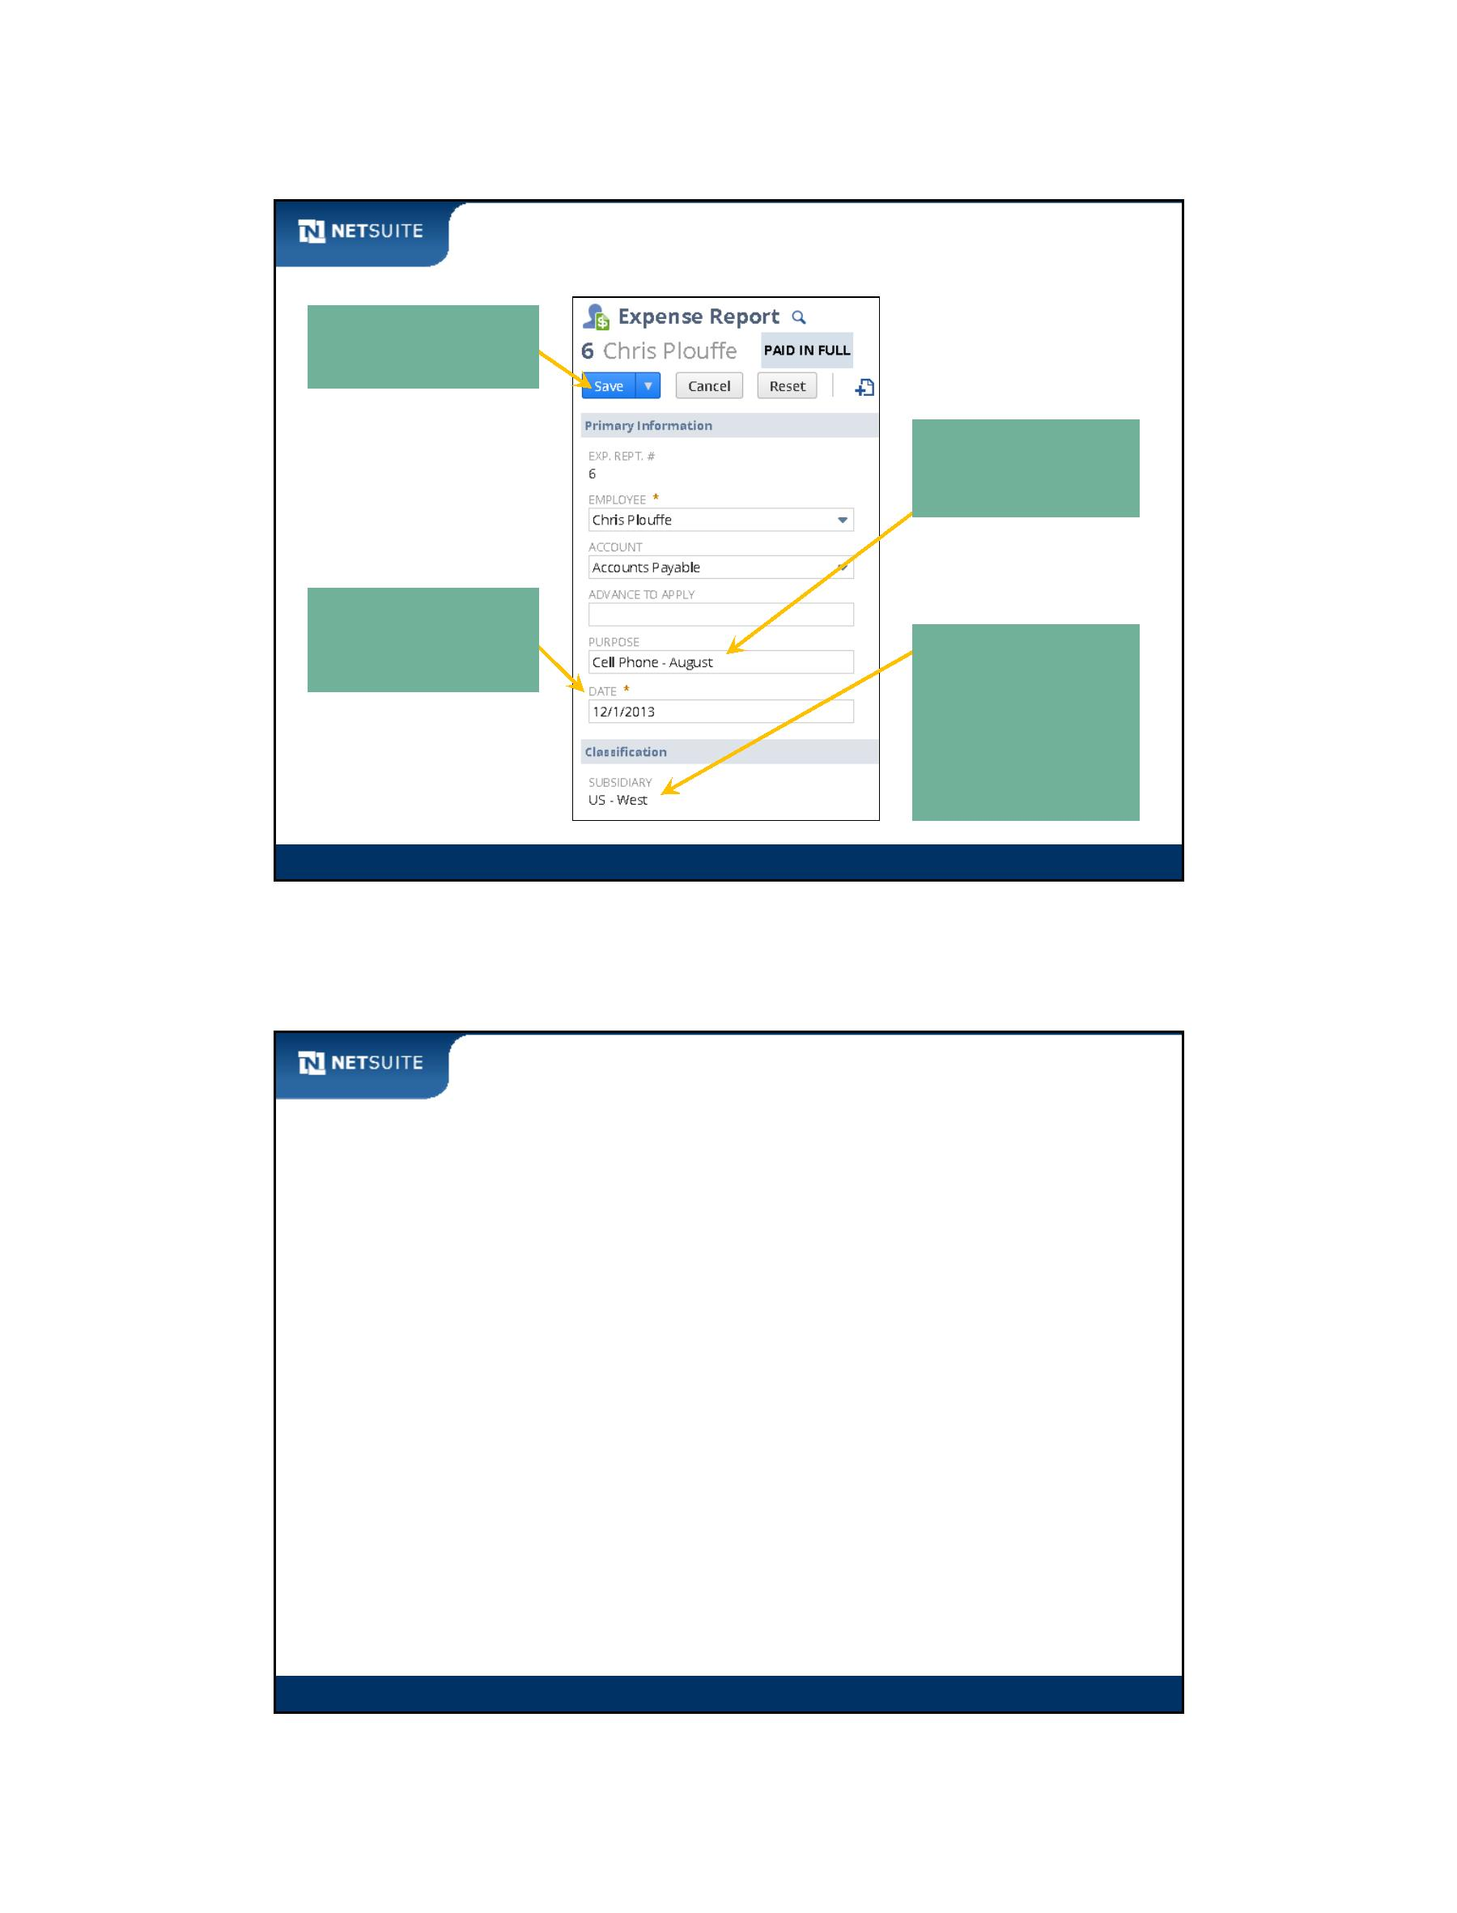

SuiteScript

Additional Resources

See SuiteCloud > SuiteScript > Understanding NetSuite Script Types >

Client Scripts > Client Event Types in the NetSuite Help Center for

details about the different client event functions.

Module 4: Investigating Client Event Functions

9

Now It’s Your Turn

In these hands on exercises, you practice:

Executing scripts in a variety of client event functions

Module 4: Investigating Client Event Functions

10

Module 4: Investigating Client Event Functions - 5



SuiteScript

Module 5: Record Level Client Scripts

Objectives

Upon completing this module, you should be able to:

Create a client‐side script that is deployed to one or more records

Log data from the script and view the logs in the UI

Filter scripts to execute on a specific record type

Module 5: Record Level Client Scripts

2

Module 5: Record Level Client Scripts - 1



SuiteScript

What are Record‐level Scripts?

Customer

Applies to the whole record

Standard

Customer Form

Sales

Customer Form

SuiteDreams

Customer Form

Accounting

Customer Form

Module 5: Record Level Client Scripts

3

Flow of script execution

Record‐level scripts

execute 2nd

**[2]**

var intX = 0;

…

**[1]**

Form‐level

scripts

execute first

Standard

Employee Form Employee Form

SuiteDreams

SuiteDreams

Partner Form

SuiteDreams

Partner Form

Employee Record Type

Partner Record Type

Module 5: Record Level Client Scripts

4

Module 5: Record Level Client Scripts - 2

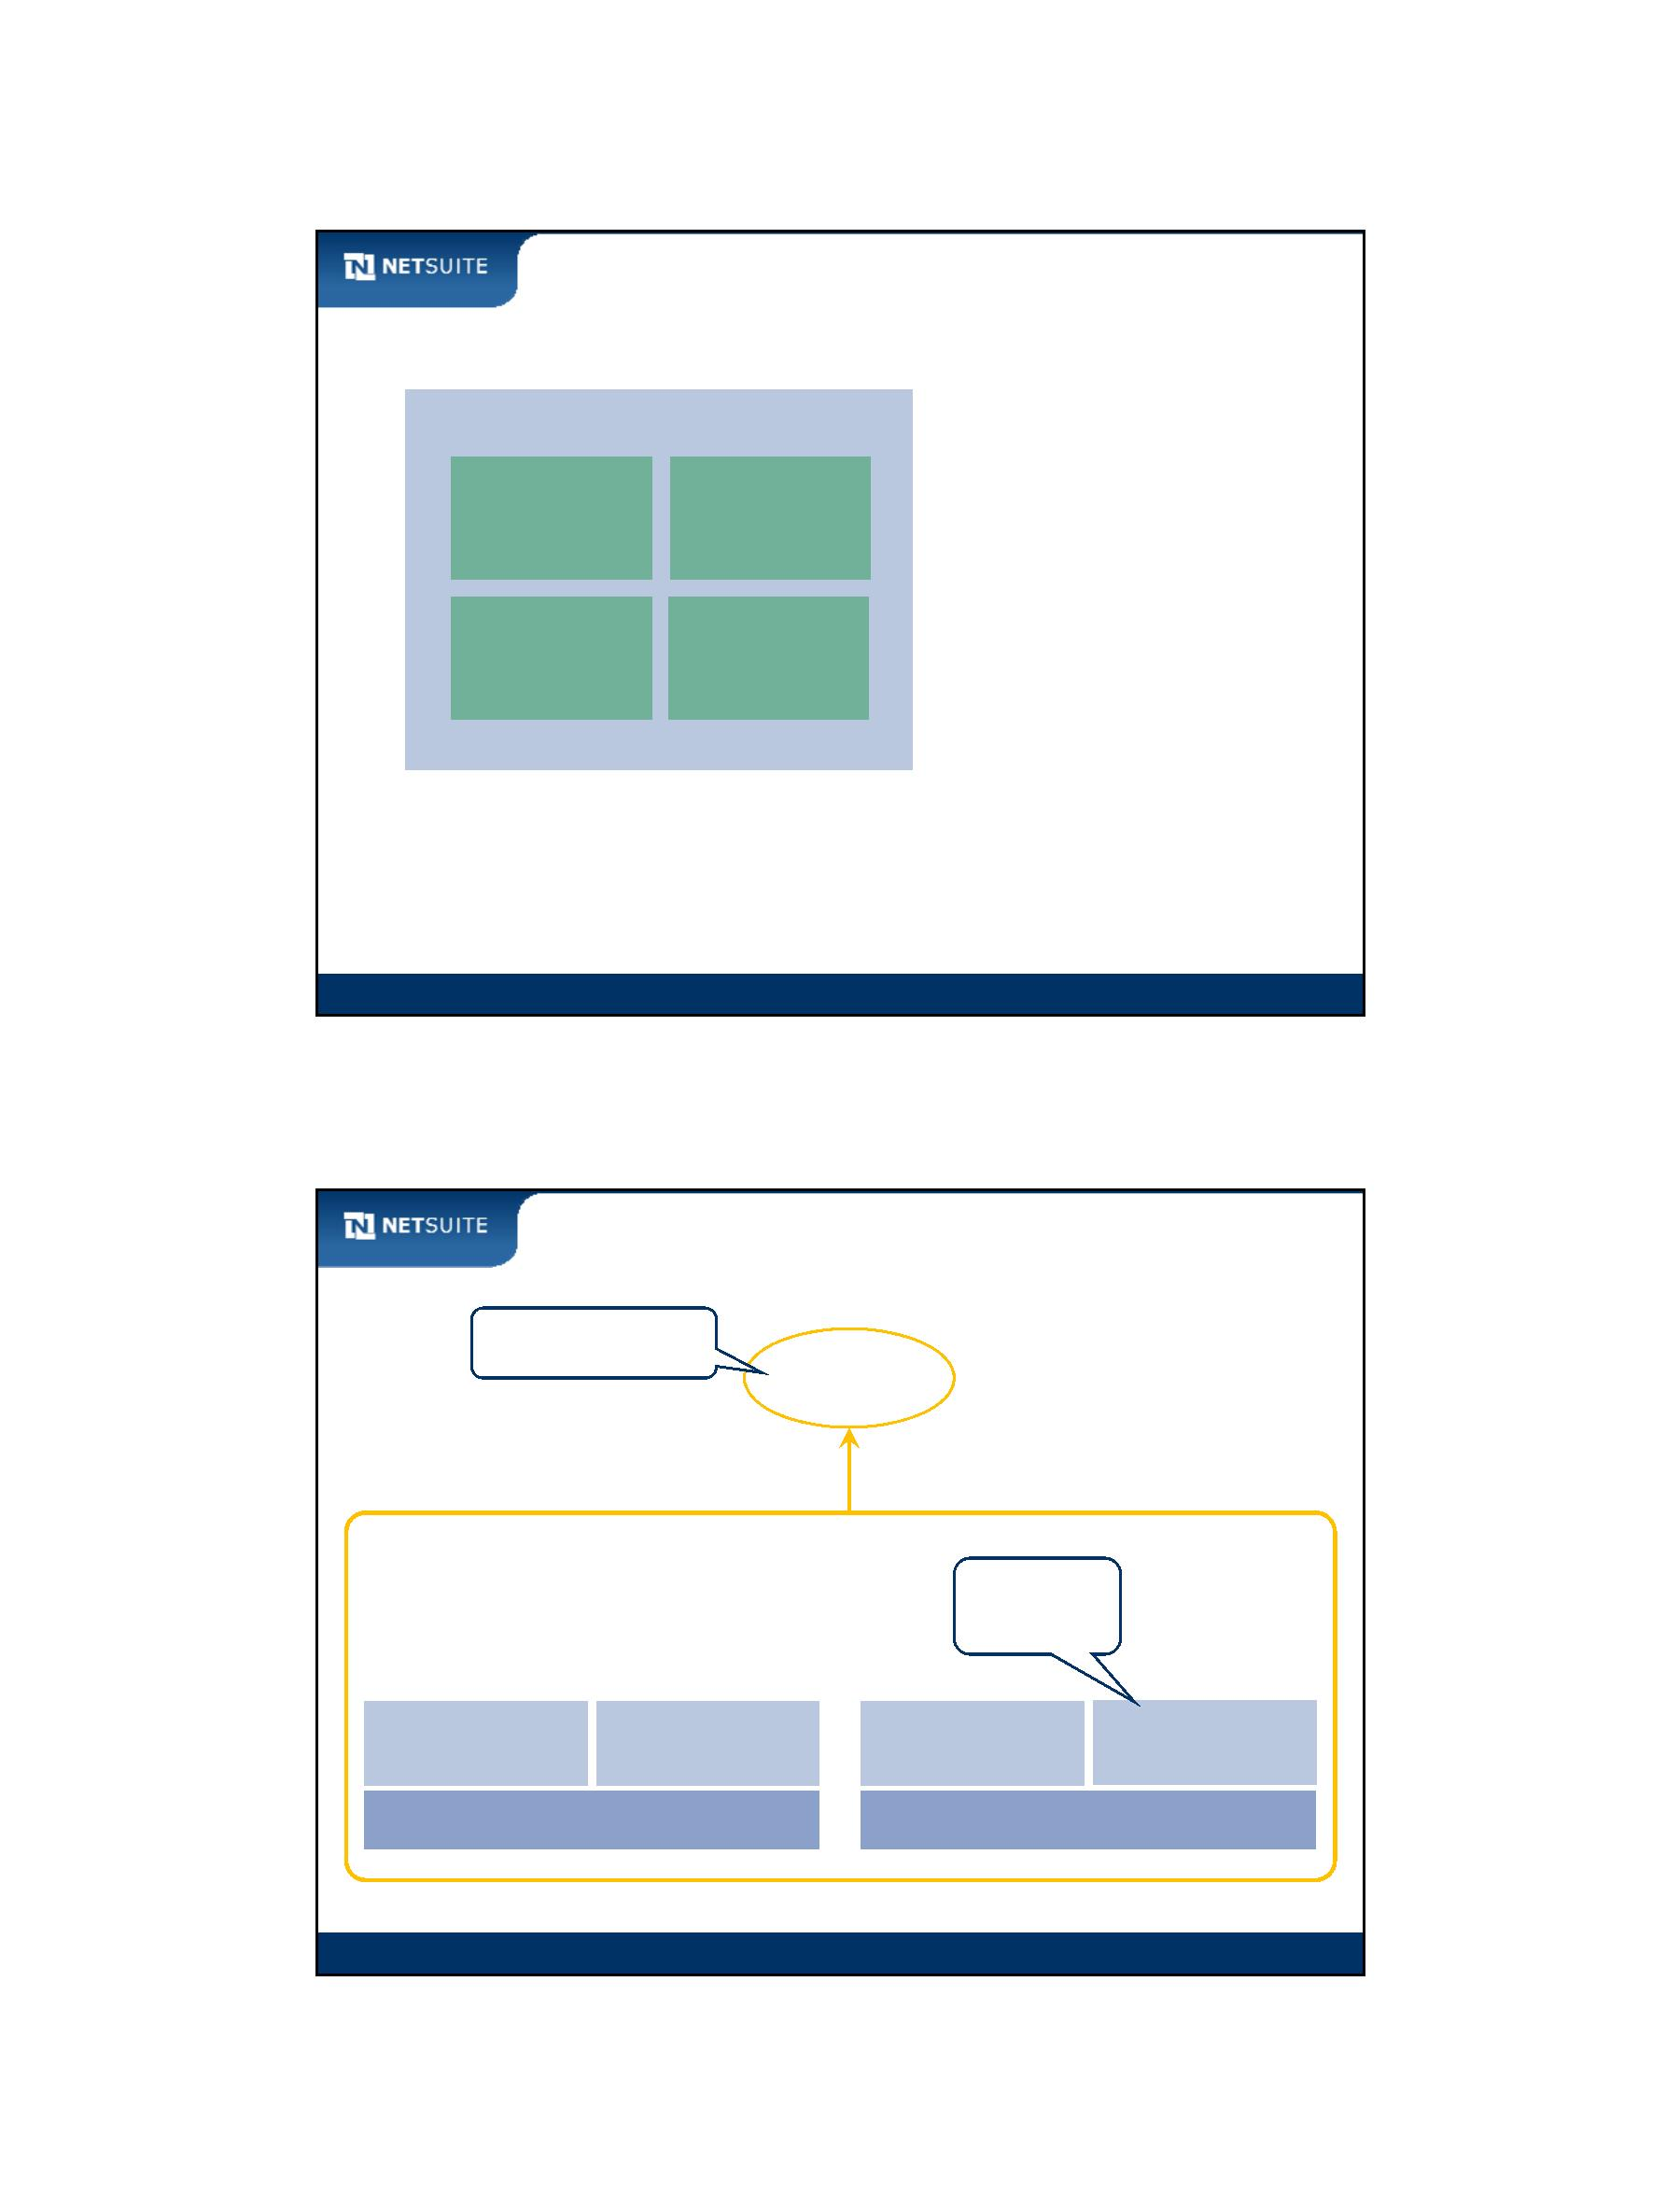

SuiteScript

Client event function naming conflicts

**X**

**Record Level Script**

HTML

**Form Level Script**

Functions loaded

into same web page,

causing conflict

Module 5: Record Level Client Scripts

5

Client event function naming conflicts continued

**Record Level Script**

HTML

**Form Level Script**

No conflict since

functions have

different names.

Module 5: Record Level Client Scripts

6

Module 5: Record Level Client Scripts - 3

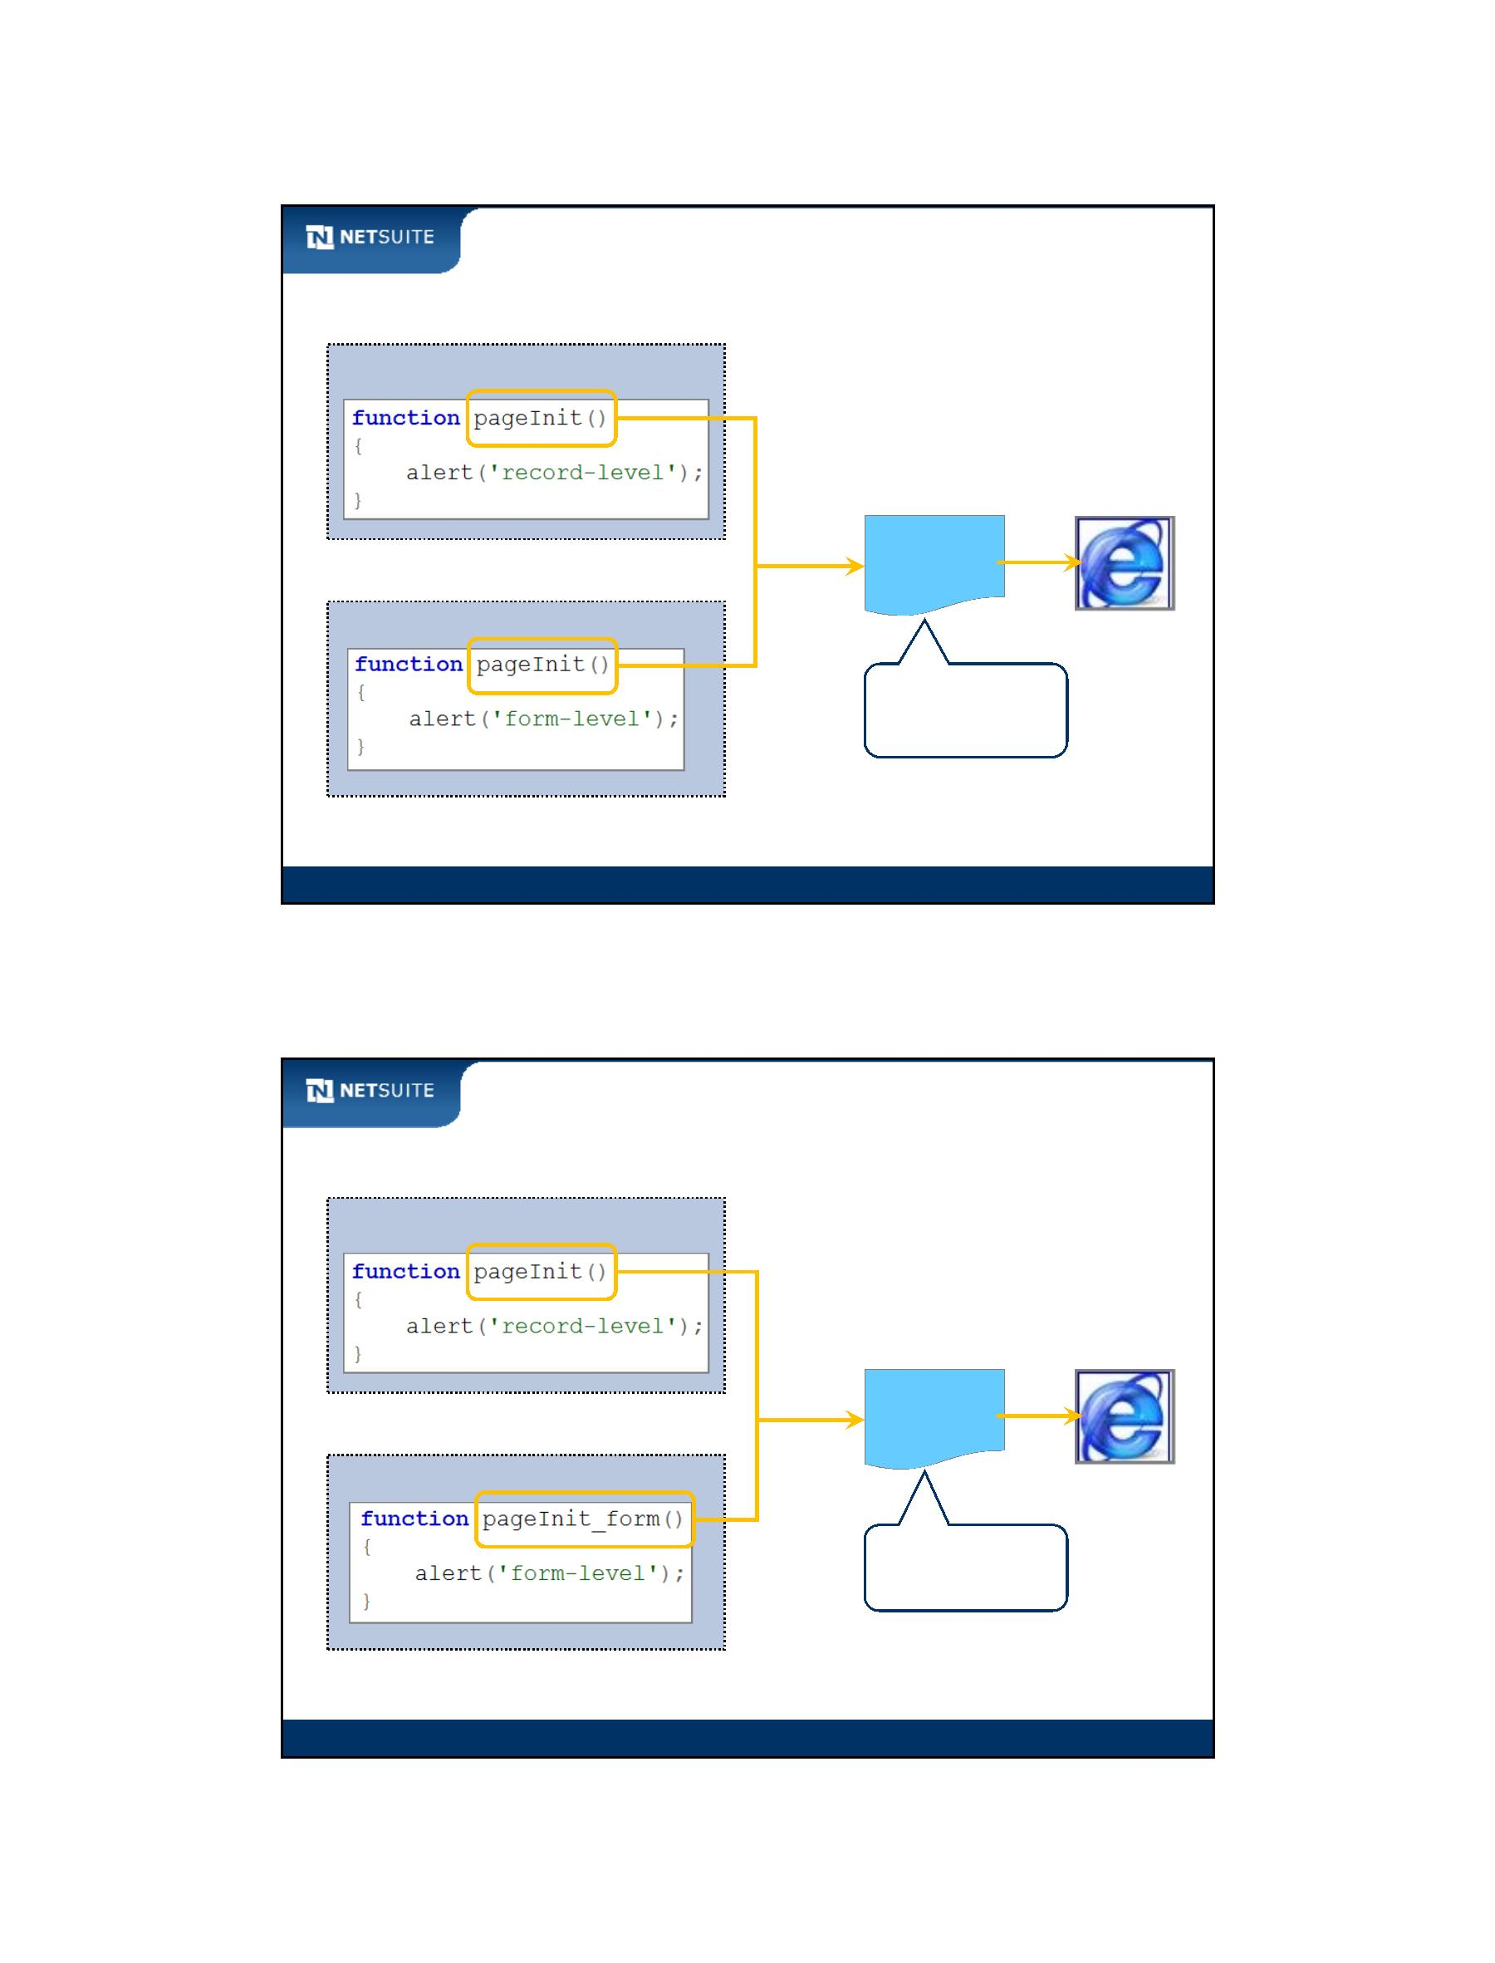

SuiteScript

Activity: Build Record‐Level Save Record Function for Employee

Existing form‐level client side script

associated with custom employee form

Module 5: Record Level Client Scripts

7

Walk Through: Record‐level Client Scripts

Scenario:

Alert the user that the system is ready for them to modify the form

Skills Covered:

Creating a record level client script

Script record

Script deployments

Module 5: Record Level Client Scripts

8

Module 5: Record Level Client Scripts - 4

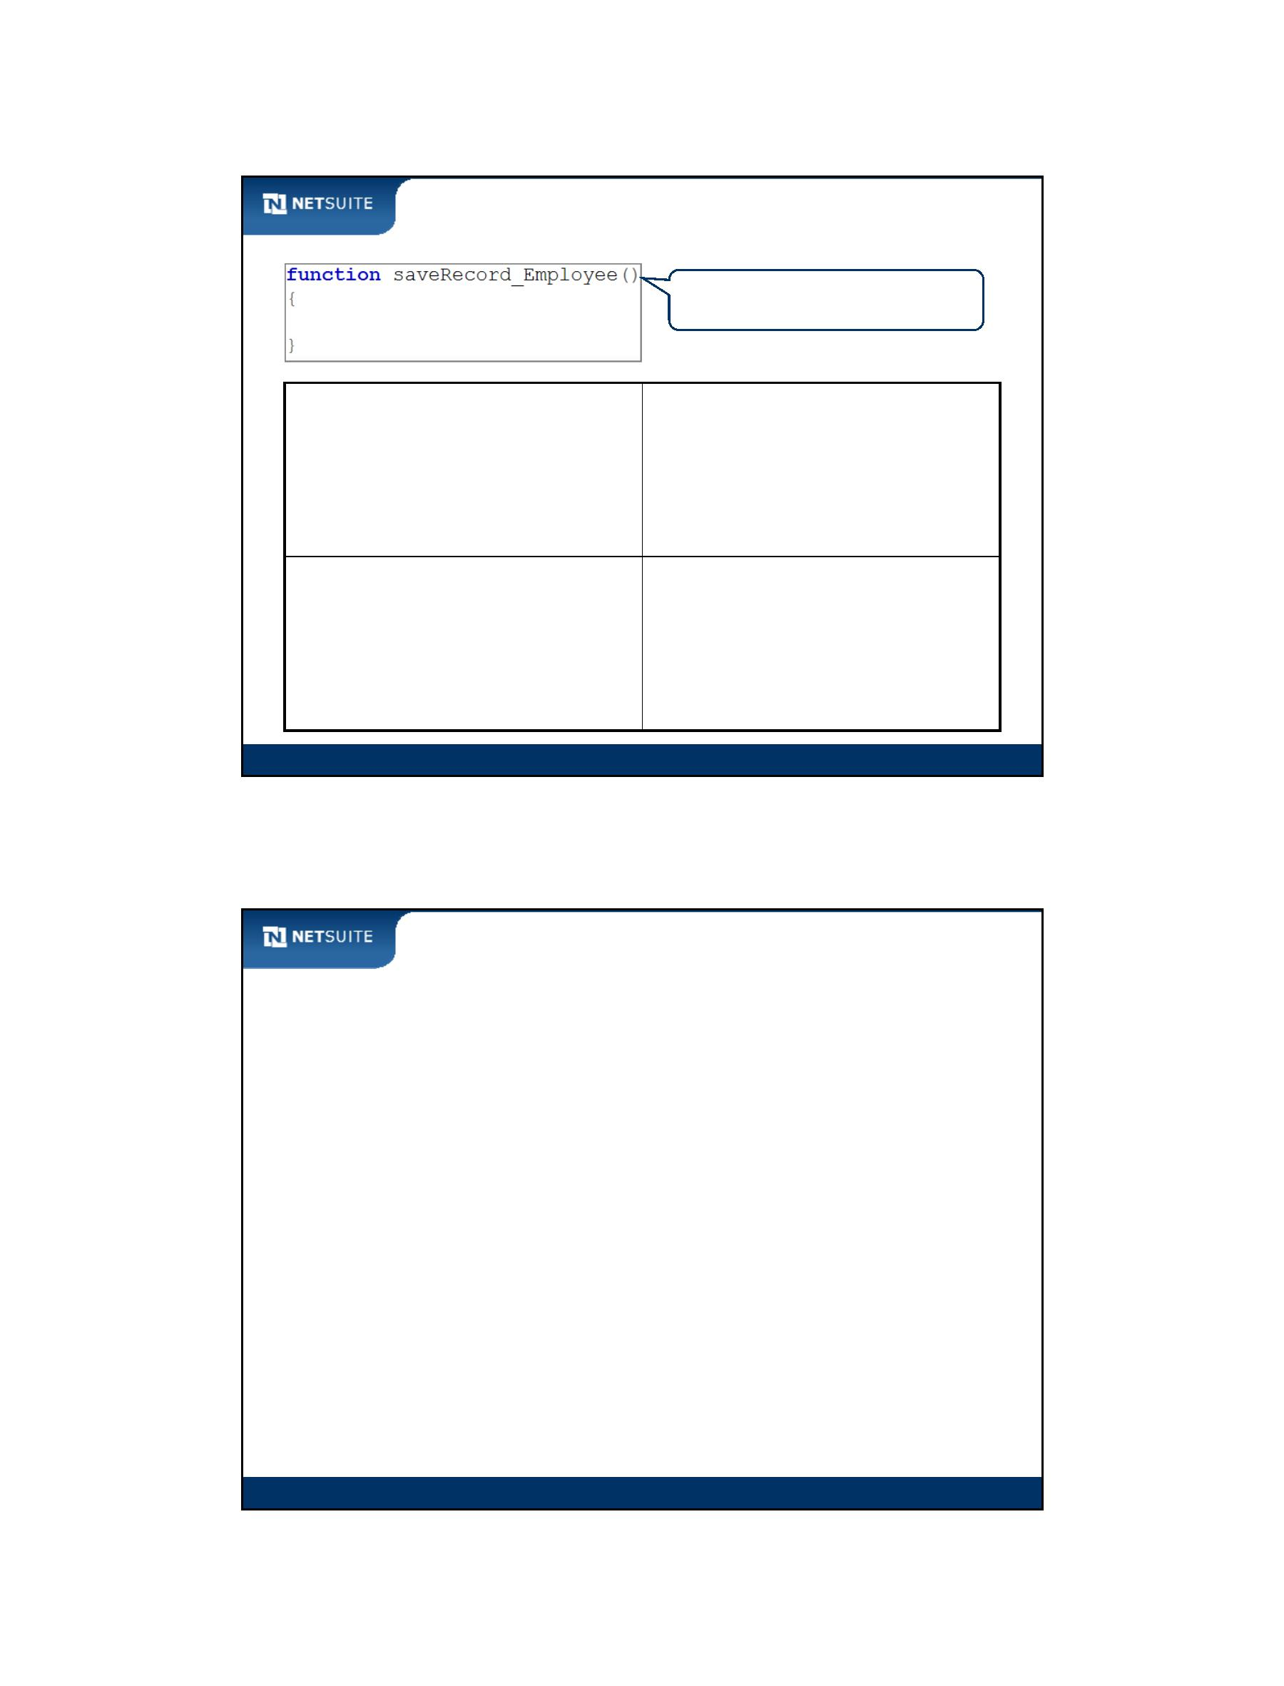

SuiteScript

Activity: Steps to Create a Record‐level Client Side Script

1. Create script file

1. Create script file

1. Create script file

1. Create script file

1. Create script file

1. Create script file

Module 5: Record Level Client Scripts

9

Walk Through: Logging Data

Scenario:

Log the record type of the current record

Skills Covered:

Getting the current record type

Logging data using the nlapiLogExecution function

Module 5: Record Level Client Scripts

10

Module 5: Record Level Client Scripts - 5



SuiteScript

Tips & Best Practices

You can have a maximum of 10 record level client scripts deployed

to the same record type

Prefer record level client scripts over form level

Use different names for functions across form and record‐level

client scripts loaded into the same form

Remember that form level scripts execute before record level

scripts

Module 5: Record Level Client Scripts

11

Now It’s Your Turn

In these hands on exercises, you practice:

Creating and executing a record‐level client‐side script

Module 5: Record Level Client Scripts

12

Module 5: Record Level Client Scripts - 6



SuiteScript

Module 6: Scripting Sublists on Client

Objectives

Upon completing this module, you should be able to:

Script standard sublists in client‐side scripts

Script custom child record sublists in client‐side scripts

Module 6: Scripting Sublists On Client

2

Module 6: Scripting Sublists On Client - 1



SuiteScript

Sublist Terminology

line item

Module 6: Scripting Sublists On Client

3

Sublist Architecture

Form X

Sublist B

Sublist A

Line 1

Line 2

Line 3

Line 4

Line 5

Field A Field B Field C

Line 1

Line 2

Line 3

Line 4

Line 5

Field A Field B Field C

Field A Field B Field C

Field A Field B Field C

Field A Field B Field C

Field A Field B Field C

Field A Field B Field C

Field A Field B Field C

Field A Field B Field C

Field A Field B Field C

Module 6: Scripting Sublists On Client

4

Module 6: Scripting Sublists On Client - 2

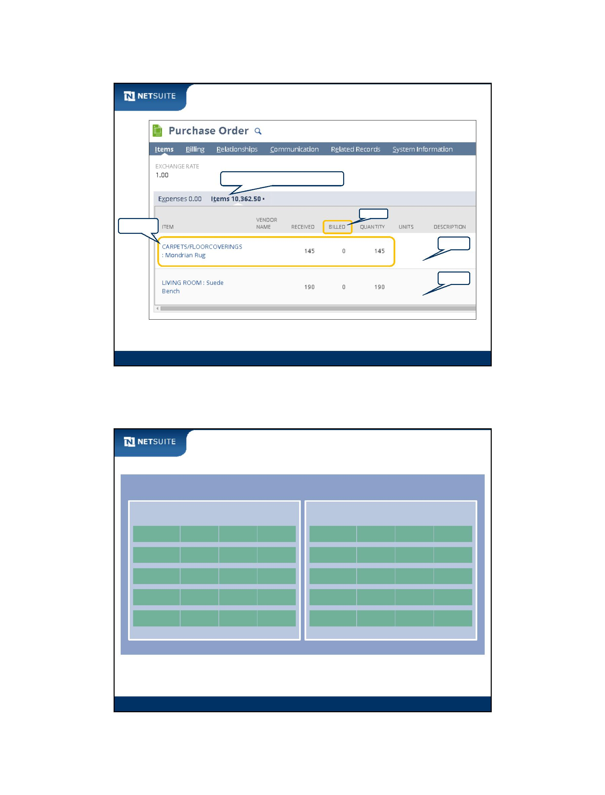

SuiteScript

How to get Sublist related IDs?

use this ID in script

to identify sublist

field IDs for each field

in the sublist

Search for Working with the SuiteScript Records Browser.

Module 6: Scripting Sublists On Client

5

Activity: Scripting a Sublist

What might you need to specify in a

SuiteScript function in order to

update the Amount for the Parking

expense?

Module 6: Scripting Sublists On Client

6

Module 6: Scripting Sublists On Client - 3

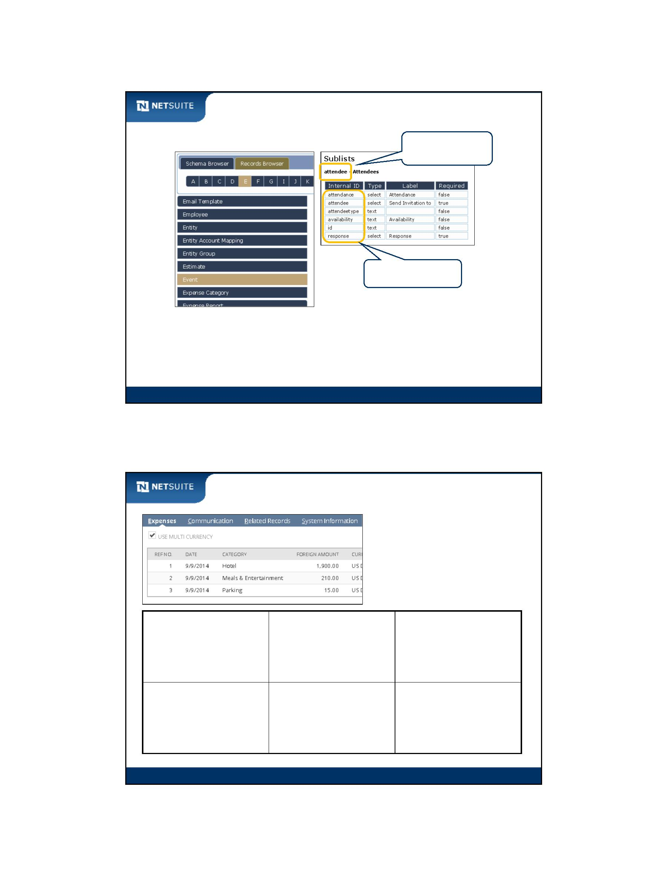

SuiteScript

Activity: Writing a Sublist Function

Using the NetSuite Help Center;

configure nlapiSetLineItemValue to

update the Amount for the Parking

expense to 17.75?

Find the definition of this function by

entering it into the Search box in the

NetSuite Help Center.

Module 6: Scripting Sublists On Client

7

Custom Child Record Sublists

Form X of some Record Type

Custom Sublist

Record

type as

sublist

Sublist A

Line 1

Field A Field B

Line 1

Line 2

Field A Field B

Field A Field B

Line 2

Field A Field B

Custom Record Type

Field A

Field B

Field on record type

as column in sublist

Module 6: Scripting Sublists On Client

8

Module 6: Scripting Sublists On Client - 4

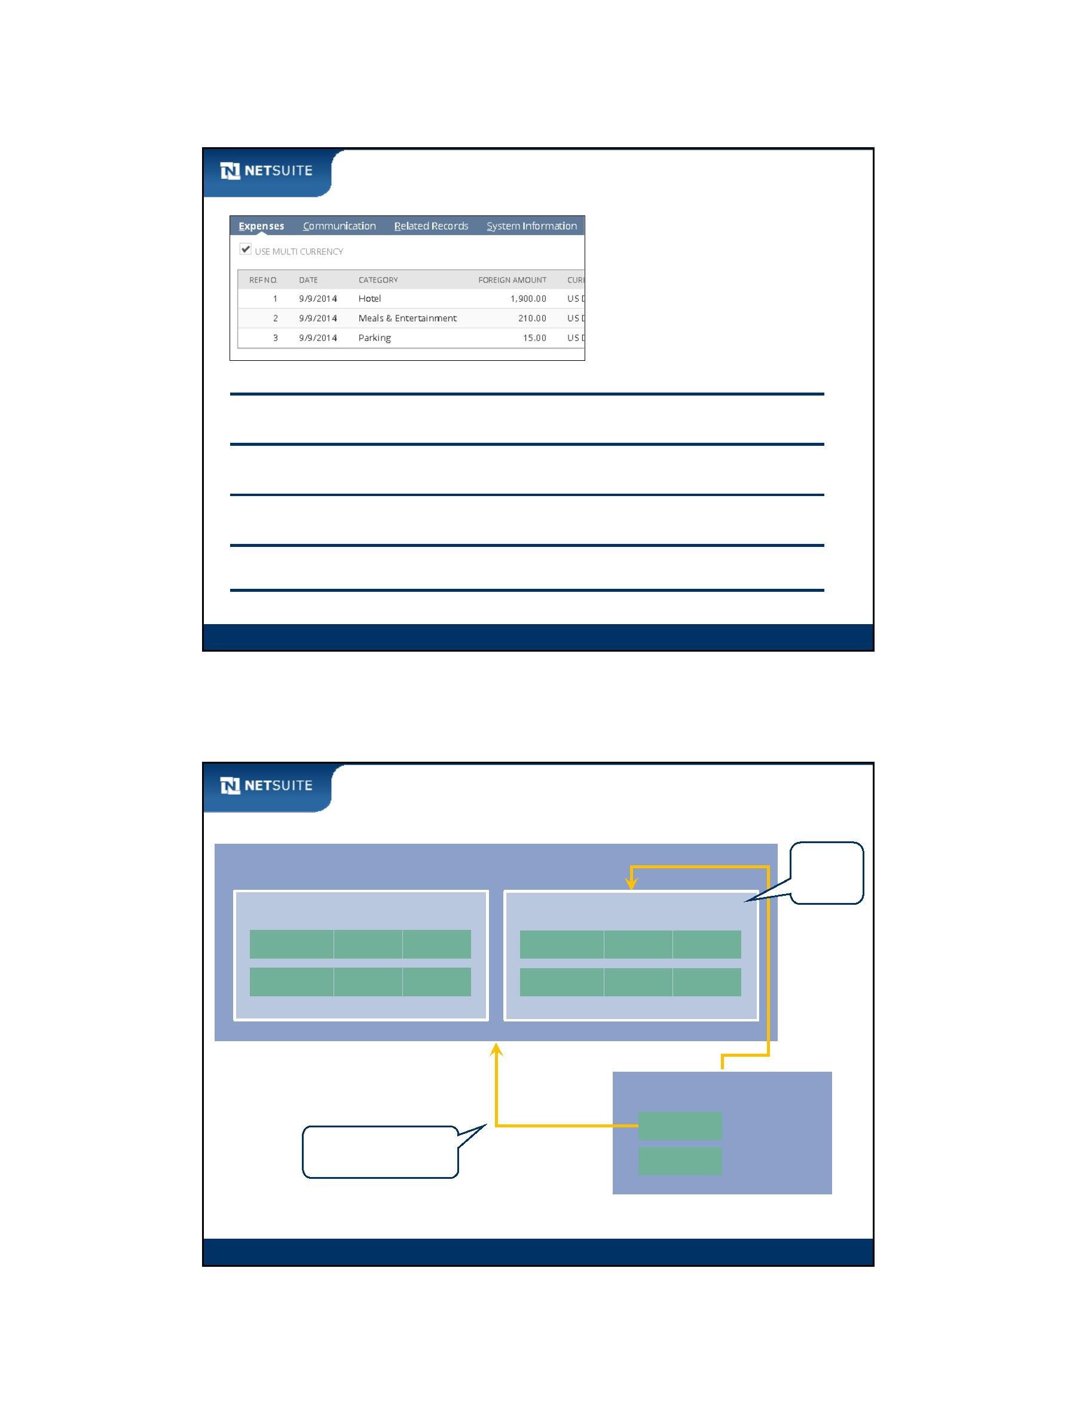

SuiteScript

Walk Through: Create Custom Child Record Sublist

Scenario:

A custom record type named Performance Review is used to keep

track of employee performance reviews

Performance review data should be editable from the related

employee record

Skills Covered:

Creating a custom record type

Defining a custom child record sublist

Module 6: Scripting Sublists On Client

9

Script Id for Custom Child Record Sublist

List/Record field making

parent/child relationship

**+**

recmach

Script id

recmachcustrecord_sdr_perf_subordinate

Module 6: Scripting Sublists On Client

10

Module 6: Scripting Sublists On Client - 5

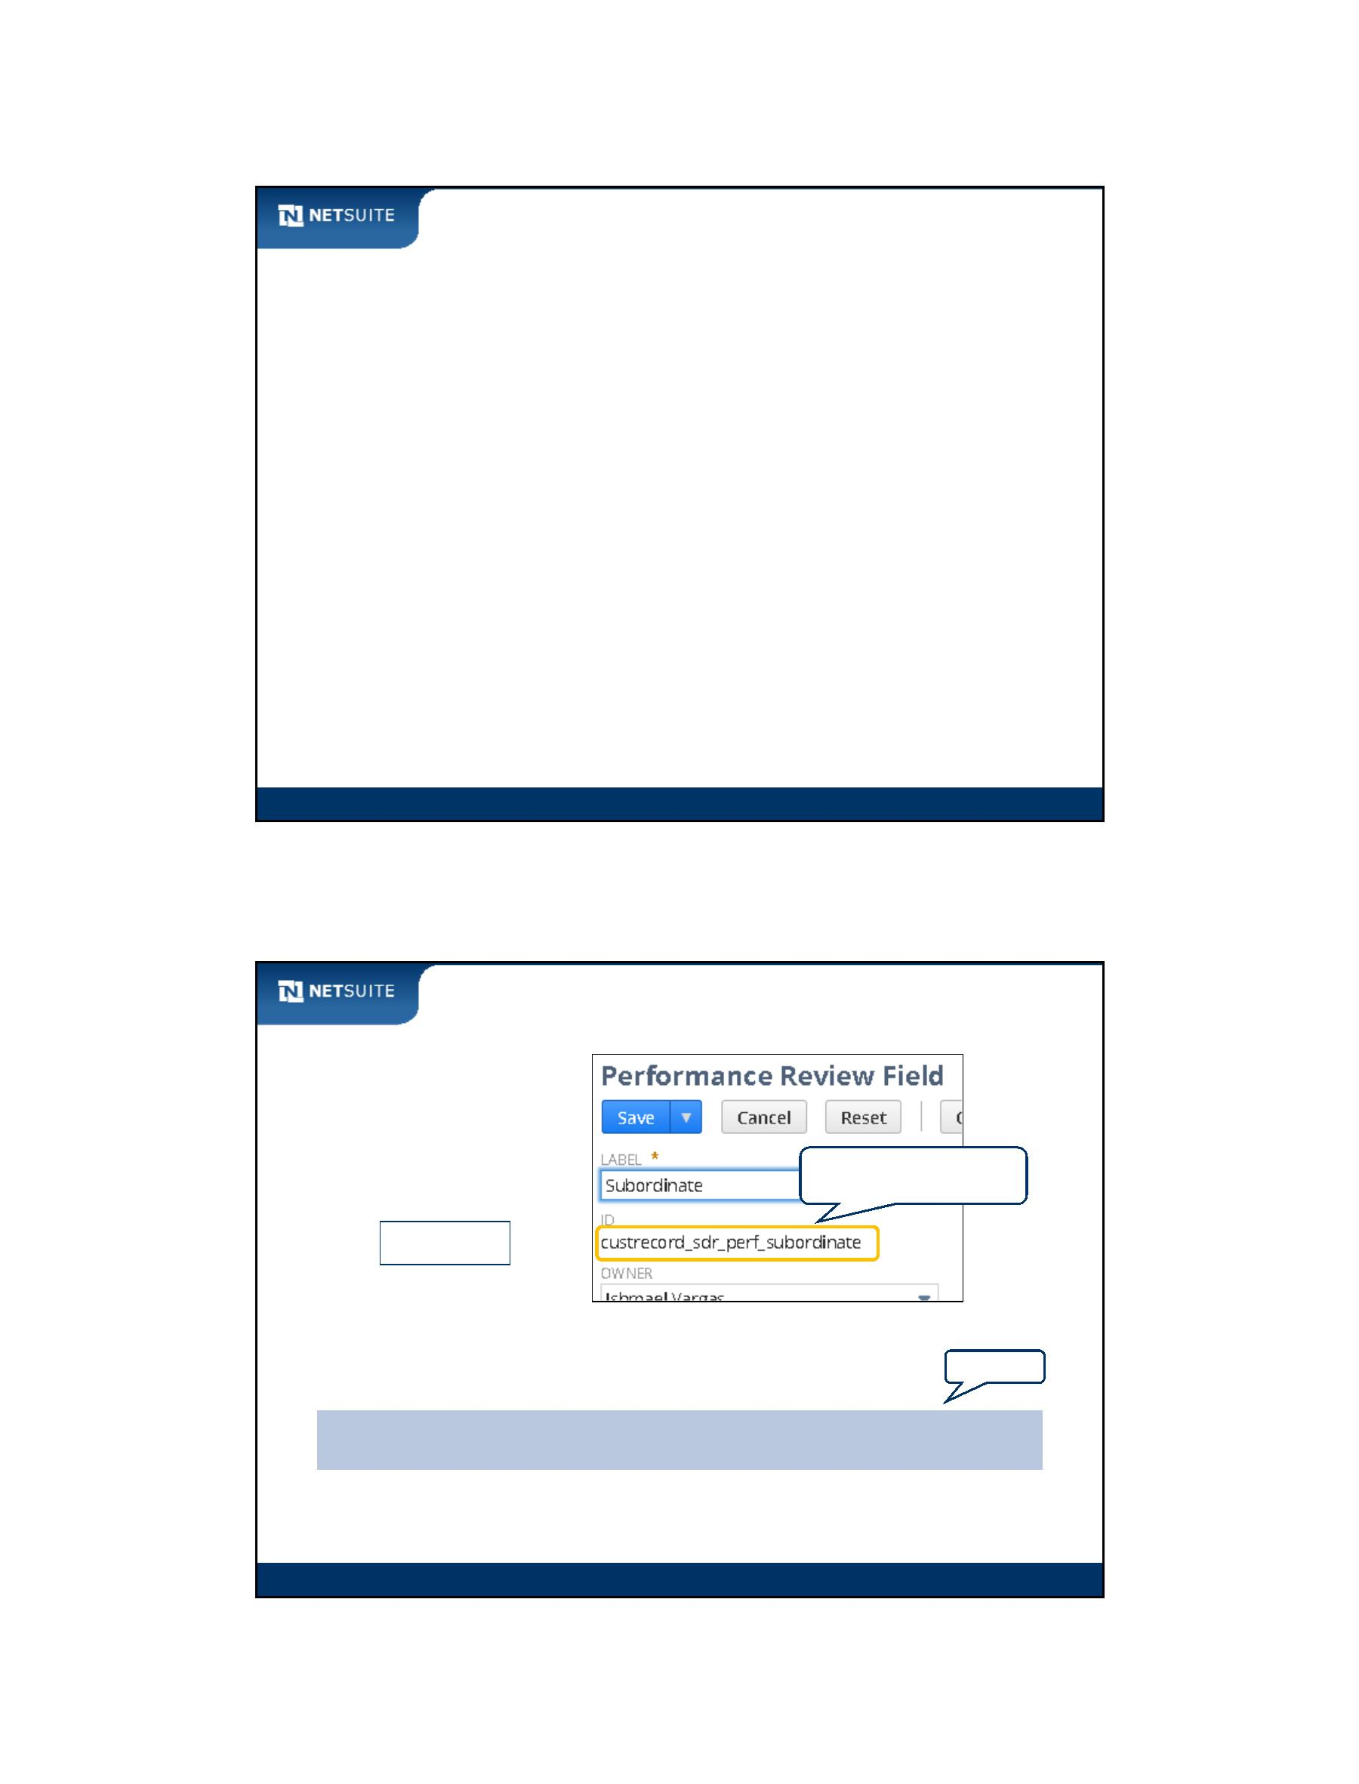

SuiteScript

Walk Through: Script Custom Child Record Sublist

Scenario:

Get the count of existing performance reviews and alert end user as they

are opening the employee form

Check upon page load if there are any performance reviews where

Rating Code = F. Alert the end user if this is the case.

Default the Review Type for new performance reviews to Salary Change

Salary Increase Amount cannot be greater than 5,000

Skills Covered:

Scripting sublists

Using Line Init and Validate Line client event functions

Module 6: Scripting Sublists On Client

11

Activity: Steps to Create a Custom Child Record

Sublist and Allow it to be Scripted

1. Create custom record type 1. Create custom record type 1. Create custom record type

1. Create custom record type 1. Create custom record type 1. Create custom record type

Module 6: Scripting Sublists On Client

12

Module 6: Scripting Sublists On Client - 6

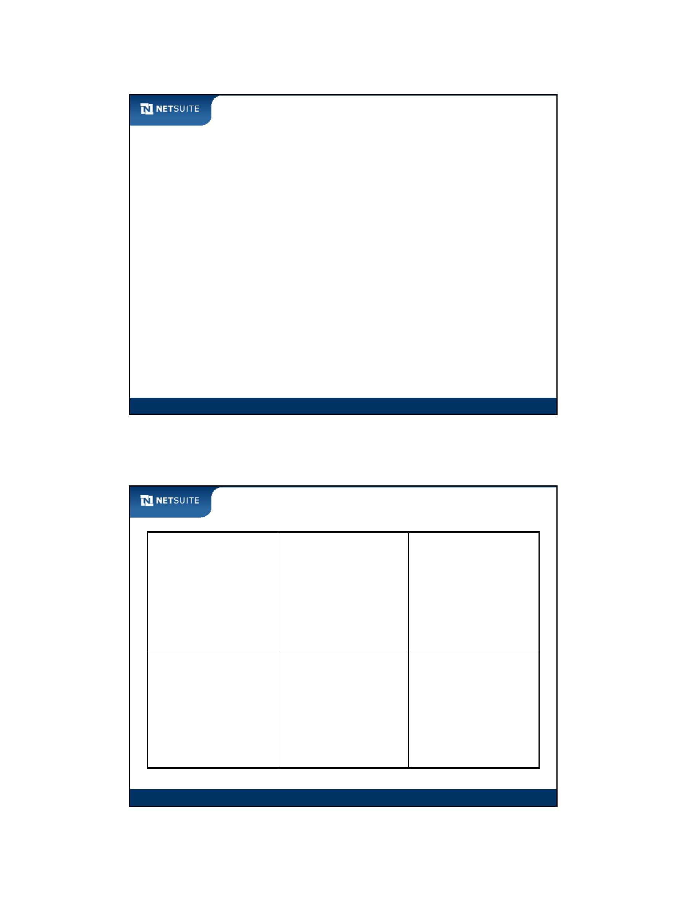

SuiteScript

Tips & Best Practices

Use the SuiteScript Records Browser to find sublist and field IDs for

standard sublists

Always check the Scriptable Sublists section in the

NetSuite Help Center for standard sublists that are scriptable

Some standard sublists may only be scriptable in certain contexts

(e.g. client or server). Click on the sublist name in the

Scriptable Sublists section of help to check for any notes

Module 6: Scripting Sublists On Client

13

Tips & Best Practices

Always filter your script against the Type parameter on Line Init

and Validate Line functions

Wrap numeric field values in parseInt or parseFloat functions in

order to compute or evaluate numerically. All SuiteScript API

functions that get field values or sublist field values return the data

as strings

Module 6: Scripting Sublists On Client

14

Module 6: Scripting Sublists On Client - 7



SuiteScript

Now It’s Your Turn

In these hands on exercises, you practice:

Creating a custom record type to generate a custom child record sublist

Creating client‐side scripts that manipulate sublists

Module 6: Scripting Sublists On Client

15

Module 6: Scripting Sublists On Client - 8



SuiteScript

Module 7: Introduction to Objects

Objectives

Upon completing this module, you should be able to:

Determine the differences between simple variable types and objects

Script objects using standard “dot” notation

Research SuiteScript API objects and methods in the NetSuite

Help Center to build scripts

Module 7: Introduction To Objects

2

Module 7: Introduction To Objects - 1



SuiteScript

Variables and Objects

Simple Types

Objects

Simple Types ‐ SuiteScript

Objects ‐ SuiteScript

Objects versus Simple Types

Module 7: Introduction To Objects

3

Simple Types

Variables describing a fruit:

variable name

variable type

variable value

fruitType

String

String

Integer

‘apple’

‘green’

7

fruitColor

fruitSweetness

fruitForCooking Boolean

true

Module 7: Introduction To Objects

4

Module 7: Introduction To Objects - 2

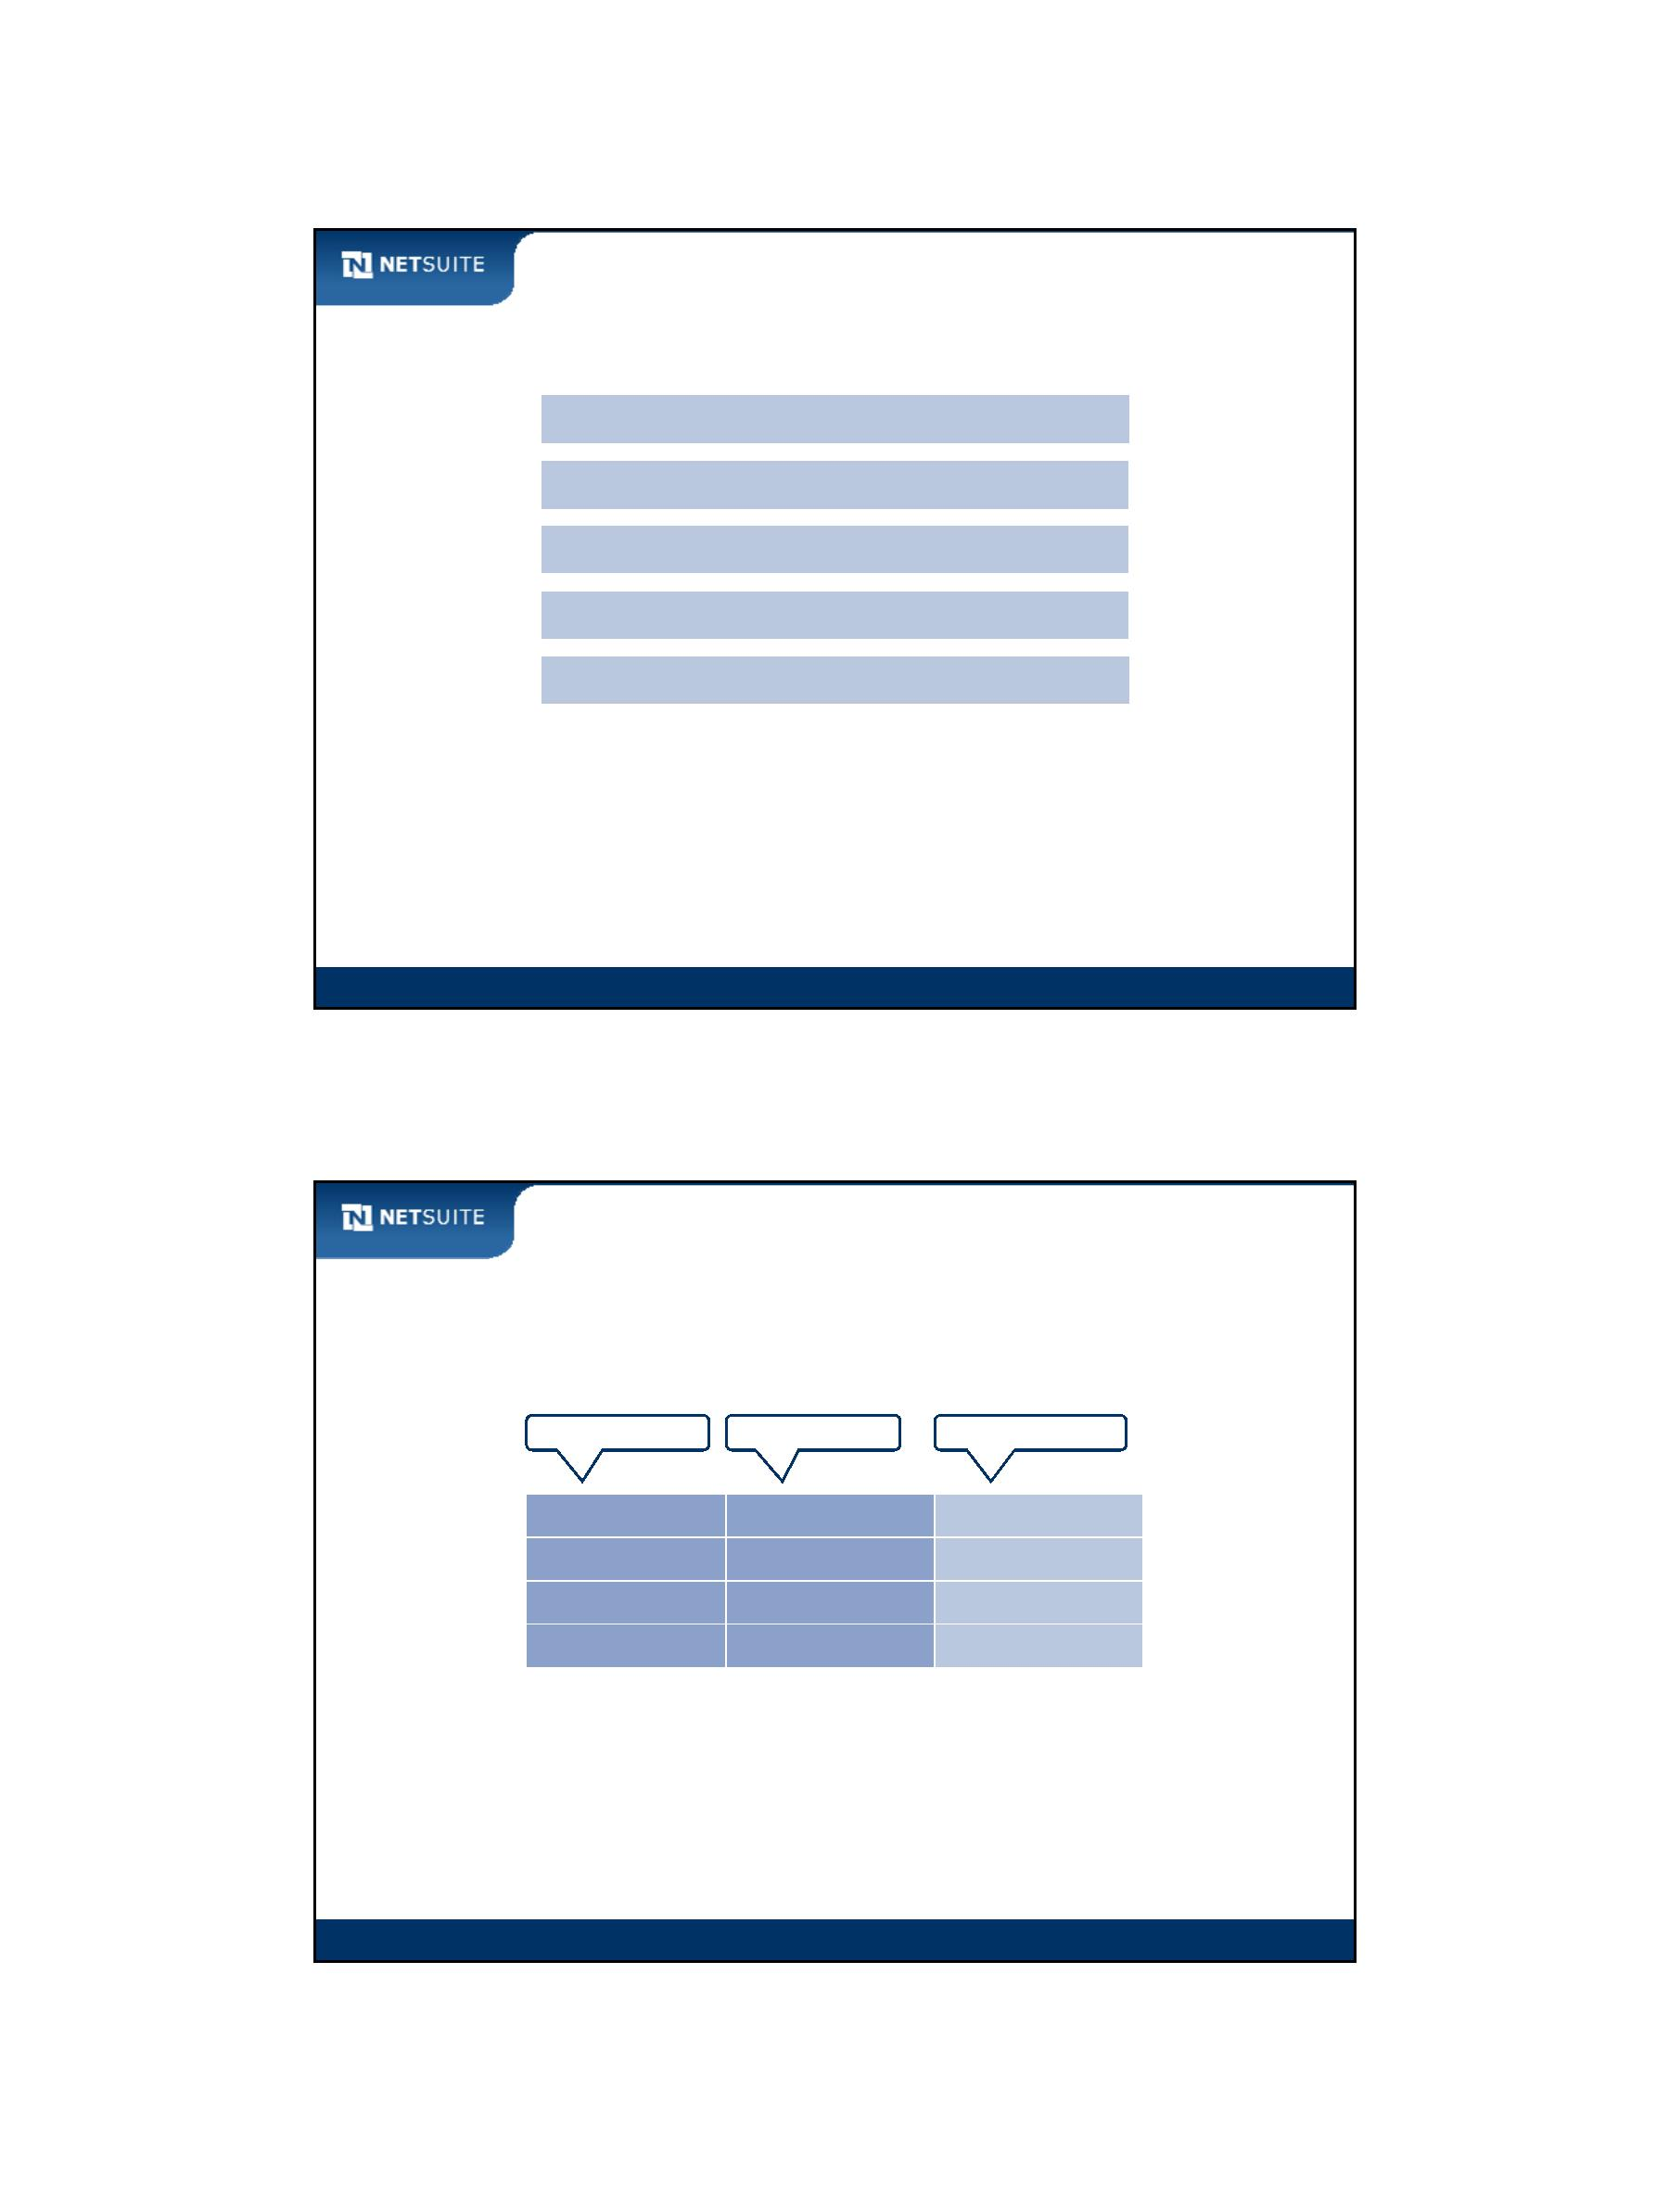

SuiteScript

Objects

Object describing a fruit:

object name

object type

myFruit

**Fruit**

object

fruitType

fruitColor

String

‘apple’

String

‘green’

7

properties

fruitSweetness

Integer

Boolean

fruitForCooking

true

getFruitType()

getFruitColor()

methods

setFruitSweetness()

setFruitForCooking()

Module 7: Introduction To Objects

5

Objects continued

Object notation:

var type = myFruit.getFruitType();

var color = myFruit.getFruitColor();

myFruit.setFruitSweetness(5);

myFruit.setFruitForCooking(false);

object variable

dot

method

method parameters

Module 7: Introduction To Objects

6

Module 7: Introduction To Objects - 3

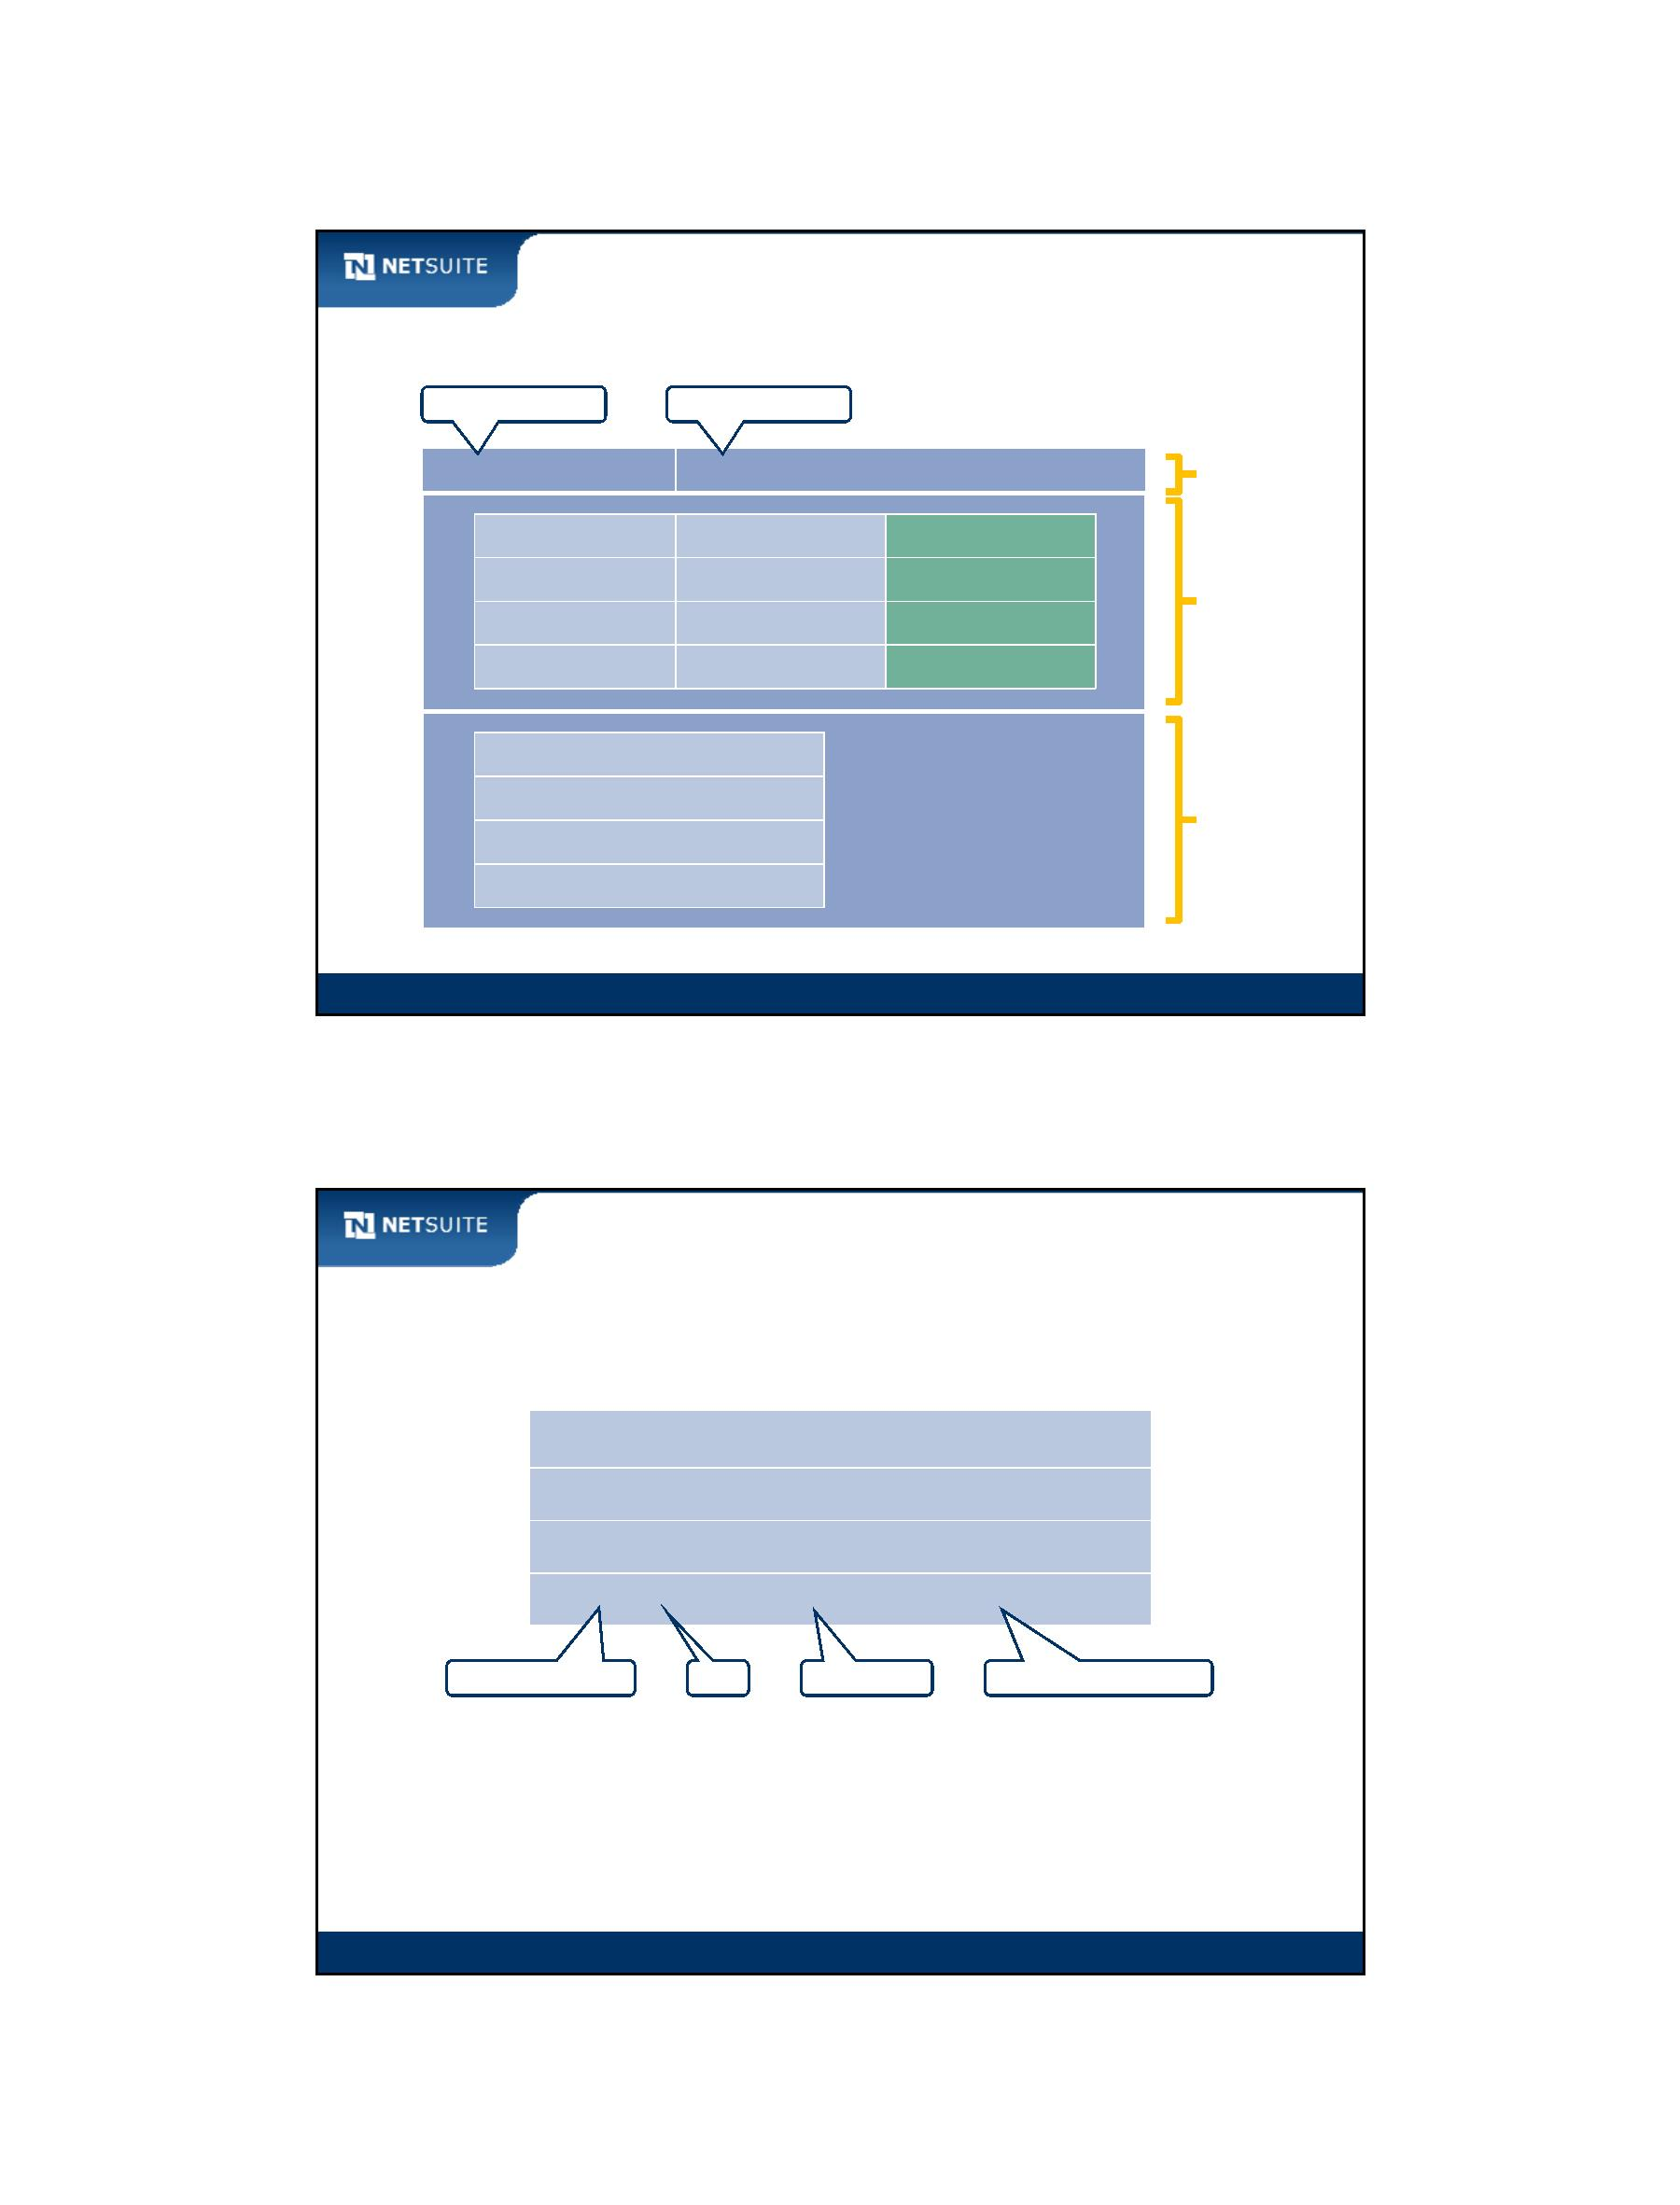

SuiteScript

Simple Types ‐ SuiteScript

Variables describing an employee:

SuiteScript API

function

variable name

variable type

employeePhone String

employeeFax String

employeeEmail String

employeeDept String

nlapiGetFieldValue(‘phone’)

nlapiGetFieldValue(‘fax’)

nlapiGetFieldValue(‘email’)

nlapiGetFieldText(‘department’)

Module 7: Introduction To Objects

7

Objects ‐ SuiteScript

Object describing an employee record:

object name

object type

recEmployee

nlobjRecord

object

properties

getFieldValue(‘phone’)

getFieldValue(‘fax’)

methods

setFieldValue(‘email’)

setFieldText(‘department’)

Module 7: Introduction To Objects

8

Module 7: Introduction To Objects - 4

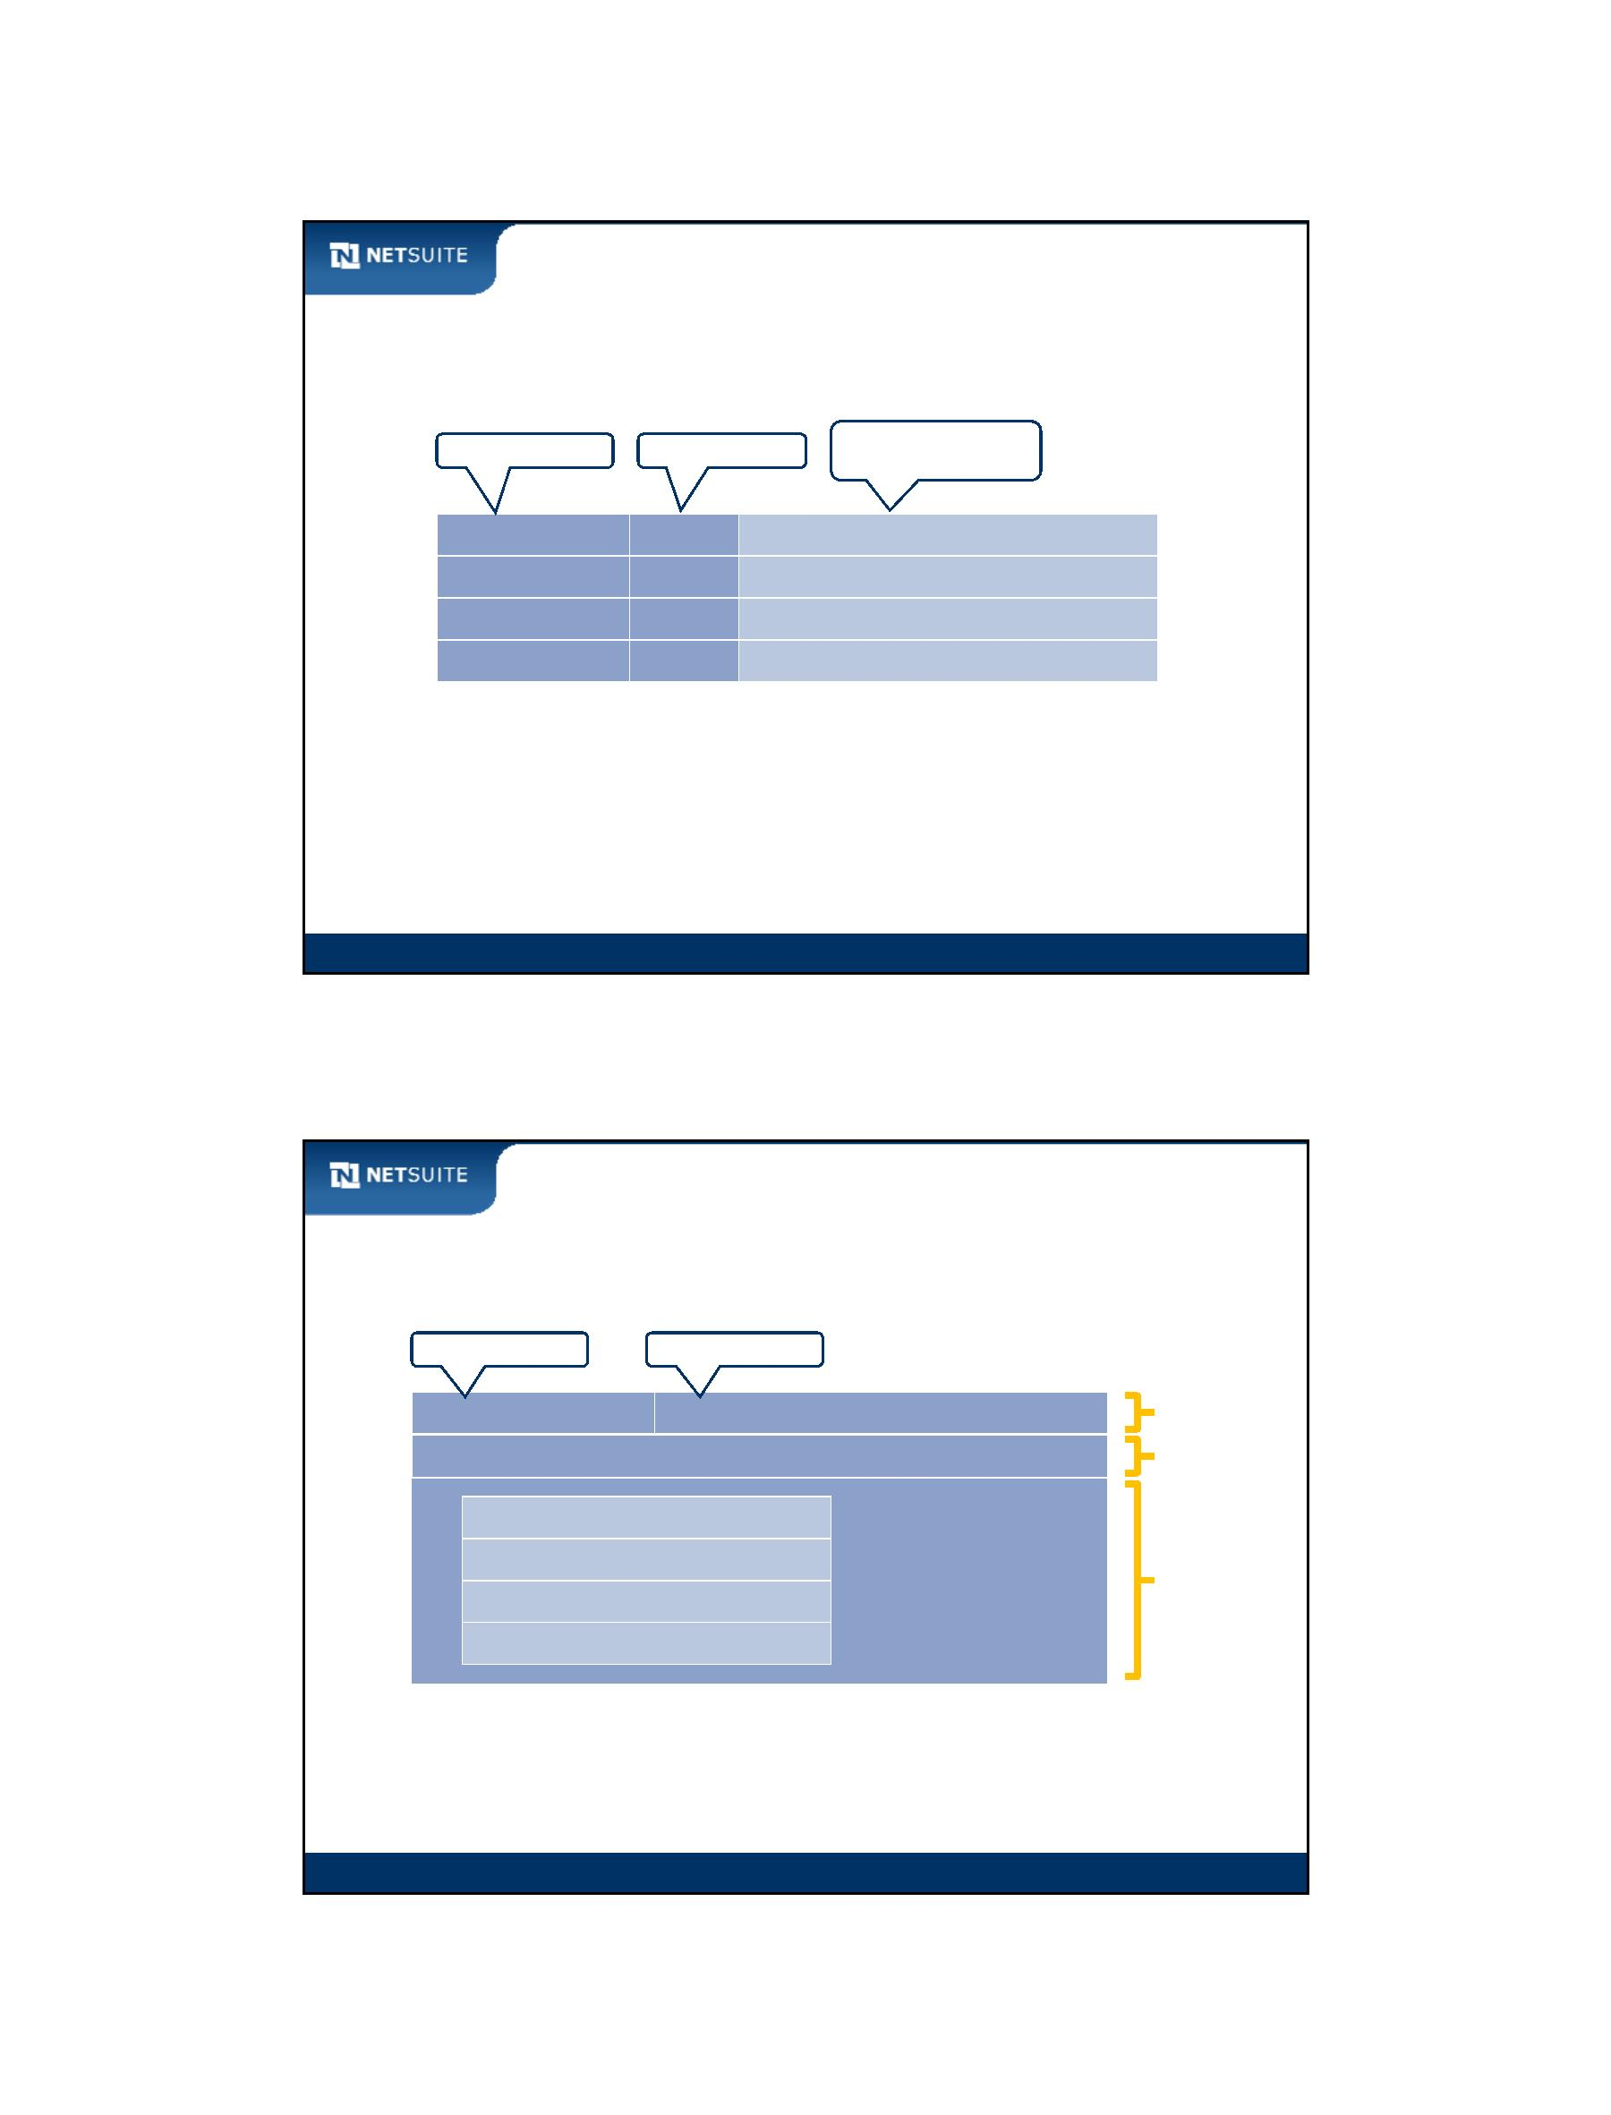

SuiteScript

Objects versus Simple Types

4 “simple types”

(each containing single value)

An “object”

(contains simple types and

other objects)

Module 7: Introduction To Objects

9

Walk Through: Finding SuiteScript Objects and

Methods in Help Center

Scenario:

Find out where to look to get details about SuiteScript objects and their

configuration

Briefly inspect objects nlobjConfiguration and nlobjAssistant for future

scripting opportunities

Skills Covered:

Finding information about SuiteScript objects and their methods

Finding information about standard objects and UI objects

Module 7: Introduction To Objects

10

Module 7: Introduction To Objects - 5

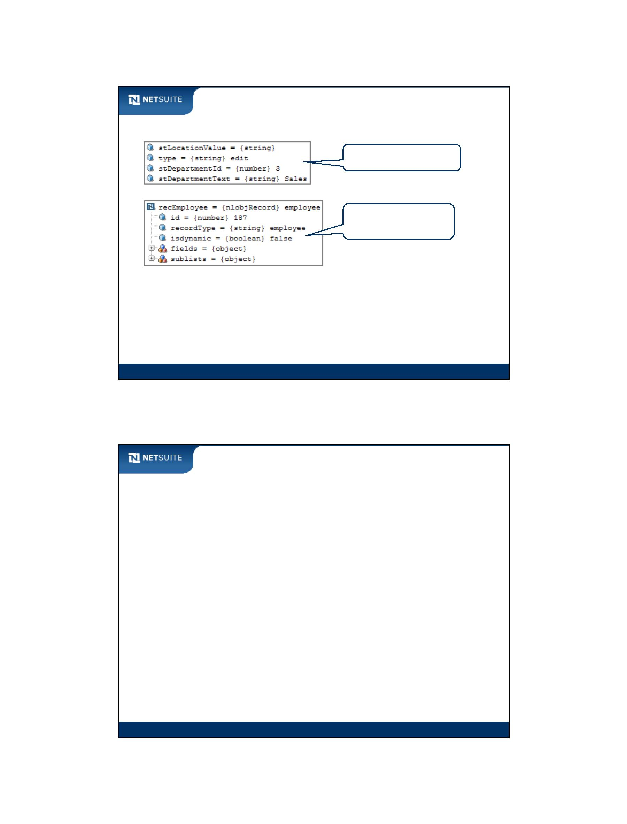

SuiteScript

Activity: Highlight Valid Methods of nlobjContext Object

Search for nlobjContext in Help, and then use the information to determine the available methods.

Circle the available methods for nlobjContext.

getSize()

getLocation()

getSetting()

getName()

getRole()

setSessionObject()

getFormula()

getId()

getEnvironment()

Module 7: Introduction To Objects

11

Activity: About SuiteScript Objects

Investigate the different SuiteScript objects in Help. Most of them give away their usage by their

name. Enter the objects in the right‐hand column.

Objects to…

The Objects (nlobjxxx)

use in executing searches

manipulate the user interface

support exception handling

work with http request and http

response

Module 7: Introduction To Objects

12

Module 7: Introduction To Objects - 6

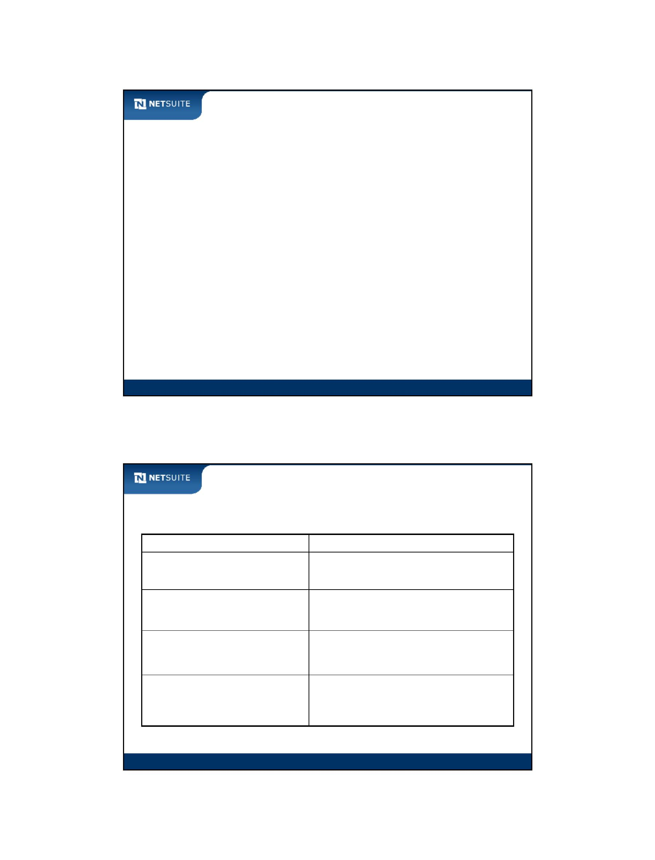

SuiteScript

Activity: Syntax for Working with Objects

Enter the proper syntax for each situation described below. Use the NetSuite Help Center as

needed. Set your font to 12 or 14 pt.

1. A phone field can be set using the syntax

nlapiSetFieldValue(‘phone’, ‘111‐222‐3333’). The same field can be set as follows

on object recEmployee of type nlobjRecord:

________________________________________________________

2. The department of the logged in user can be retrieved using

nlapiGetDepartment(). ___________________________________

is the alternative syntax assuming there is an object context of type nlobjContext.

3. Specify a field object (nlobjField) named fldPhone as a mandatory field by

entering _________________________________________.

4. An Event record contains an Attendees sublist. A script to process this sublist

contains variable recEvent of type nlobjRecord. Enter

___________________________________________________ in order to return

the Send Invitation To field on the 3rd line of the sublist.

Module 7: Introduction To Objects

13

Module 7: Introduction To Objects - 7



SuiteScript

Module 8: Introduction to User Event Scripts

Objectives

Upon completing this module, you should be able to:

Create server‐side user event scripts

Work with SuiteScript objects

Use the NetSuite script debugger to troubleshoot user event scripts

Send an email from a user event script

Module 8: Introduction To User Event Scripts

2

Module 8: Introduction To User Event Scripts - 1



SuiteScript

Activity: Steps to Create a User Event Script

Creating a user event script is nearly identical to creating a record‐level client‐side script. Indicate

the set of steps below.

Module 8: Introduction To User Event Scripts

3

Common uses of user event scripts

Send email

Attach one record to another to secure a relationship

Create records (e.g. tasks, support cases).

Screen redirection (similar to a workflow)

Manipulate forms on page load (e.g. add a message, set defaults, etc.)

Module 8: Introduction To User Event Scripts

4

Module 8: Introduction To User Event Scripts - 2



SuiteScript

Script execution sequence

Seq. End User Function NetSuite

Script Function

JavaScript

Client‐side

Event

1

2

3

4

5

6

7

Opening form

Opening form

Editing form

Before Load

‐‐‐

onLoad

onBlur

onChange

onSubmit

‐‐‐

Page Init

Validate Field

Field Changed

Save Record

Before Submit

After Submit

Editing form

Submitting form

Submitting form

Submitting form

‐‐‐

Module 8: Introduction To User Event Scripts

5

Script execution sequence continued

Page Init

Save Record

Client Triggers

Server Triggers

Before Submit

Database

Before Load

Database

After Submit

Module 8: Introduction To User Event Scripts

6

Module 8: Introduction To User Event Scripts - 3

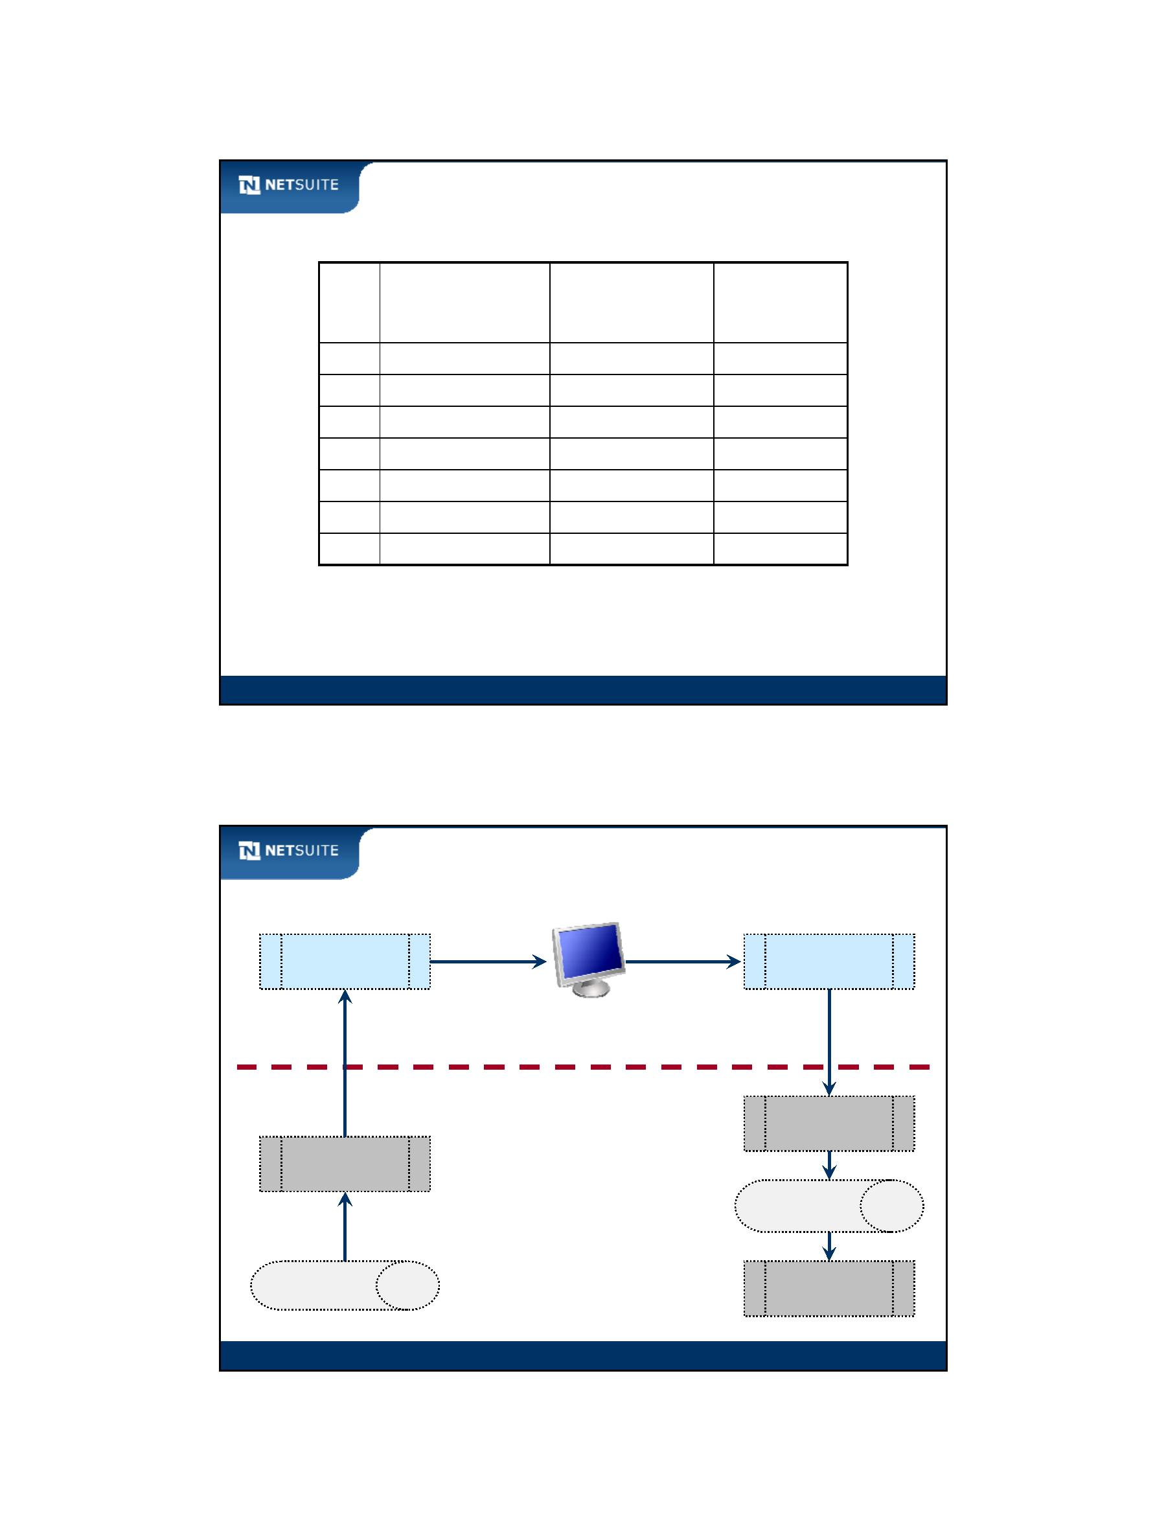

SuiteScript

Investigating record context functions

FunFcutniocntisotnaskteankeonpoarpaamraemteersters

nlapi

GetOldRecord

nlapi

GetNewRecord

Current data

Current data

Defaults set on server

New values

Script Function

Operation

Before Load

Before Load

Before Load

Before Submit

Before Submit

After Submit

After Submit

View

Edit

null

null

Create

null

Existing Record

New Record

Existing Record

New Record

Old values

null

New values

Old values

null

New values

New values

Module 8: Introduction To User Event Scripts

7

Activity: Create User Event Script – Get Access to

Record Object

Create a function to process a click of the Save button on an employee form, but after the

employee record has been persisted to the database. Enter script to return the current contents of

the form being submitted into a record object. That’s it!

Module 8: Introduction To User Event Scripts

8

Module 8: Introduction To User Event Scripts - 4

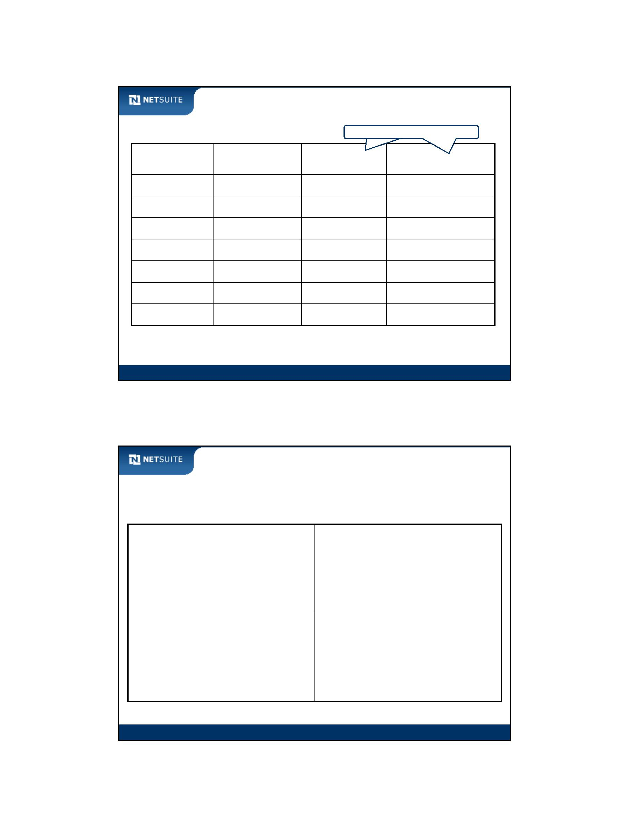

SuiteScript

Activity: Create User Event Script – Get Fields out of

Record Object

Add to the function in the last exercise, but do not re‐enter the contents. Add lines to return the

end user text (e.g. 01 US ‐ West Coast Warehouse) and internal id of an employee’s Location into

individual fields. Location is found in the Classification field group in the main area of the form.

Module 8: Introduction To User Event Scripts

9

Walk Through: User Event Script

Scenario:

Get data out of the employee record as an employee is being saved

Log some of the employee data to the Execution Log. This is for script

troubleshooting purposes.

Skills Covered:

Setting up a user event script

Getting fields out of a record object

Module 8: Introduction To User Event Scripts

10

Module 8: Introduction To User Event Scripts - 5

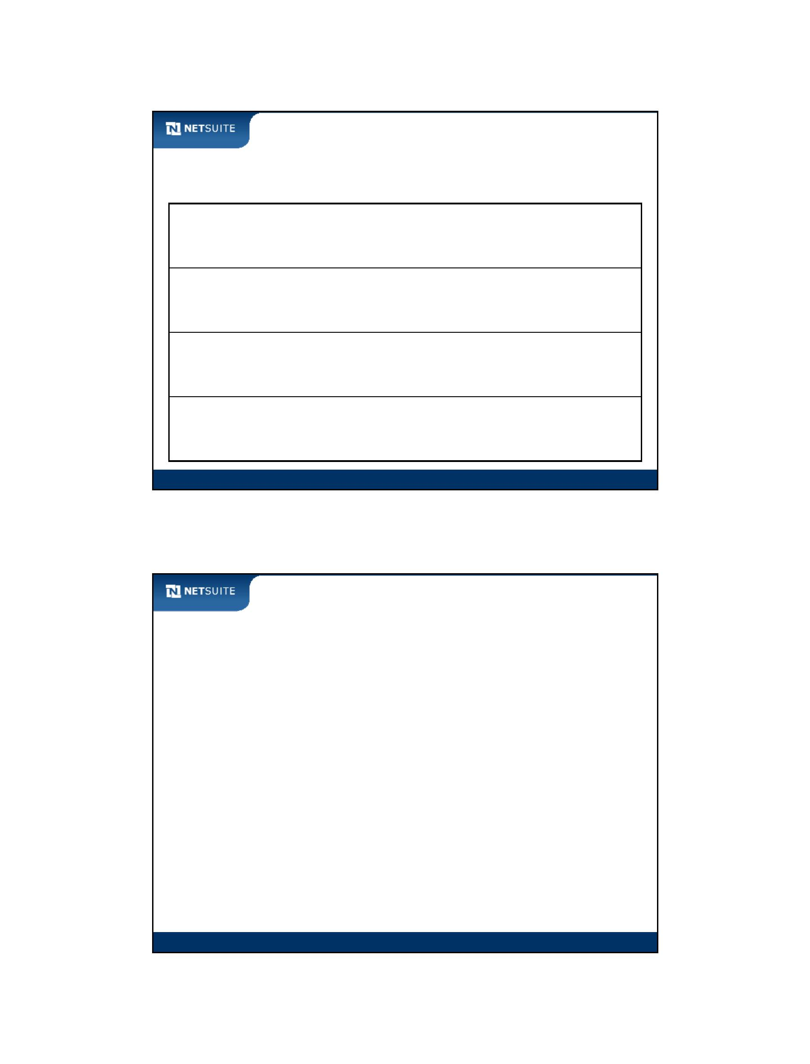

SuiteScript

Special SuiteScript Syntax

Syntax for special cases:

Optional parameters in function or method

– Use null as a placeholder

– Drop parameter if at end of function or method

Unselected List/Record field (text or value)

– Returns empty string; use quote‐quote (‘’)

Evaluating object that may be null

– e.g. if (recEmployee == null)

– e.g. if (recEmployee != null)

Module 8: Introduction To User Event Scripts

11

Activity: Working with Parameters

Indicate how to write a function with the following definition:

nlapiSubmitRecord (nlobjRecord, boolean, boolean).

Assume there is a variable recEmployee of nlobjRecord.

when 1st

boolean parameter is not needed, but the 2nd is set to true

when 1st

boolean parameter is set to false, but the 2nd is not needed

when both boolean parameters are not needed

Module 8: Introduction To User Event Scripts

12

Module 8: Introduction To User Event Scripts - 6



SuiteScript

Activity: Evaluating List/Record Fields

Assuming there is a variable recEmployee of nlobjRecord; create the script to return the value of

the employee Department field (Classification field group) into a variable. Log the message

“no department selected” when this is the case.

Module 8: Introduction To User Event Scripts

13

Debugger Architecture

Normal Domain

Debugger Domain

system.netsuite.com

debugger.netsuite.com

NetSuite

DB

shared database

SepSaerpaatreaateppalpicpalitcioatniosnersveerrvsers

Module 8: Introduction To User Event Scripts

14

Module 8: Introduction To User Event Scripts - 7

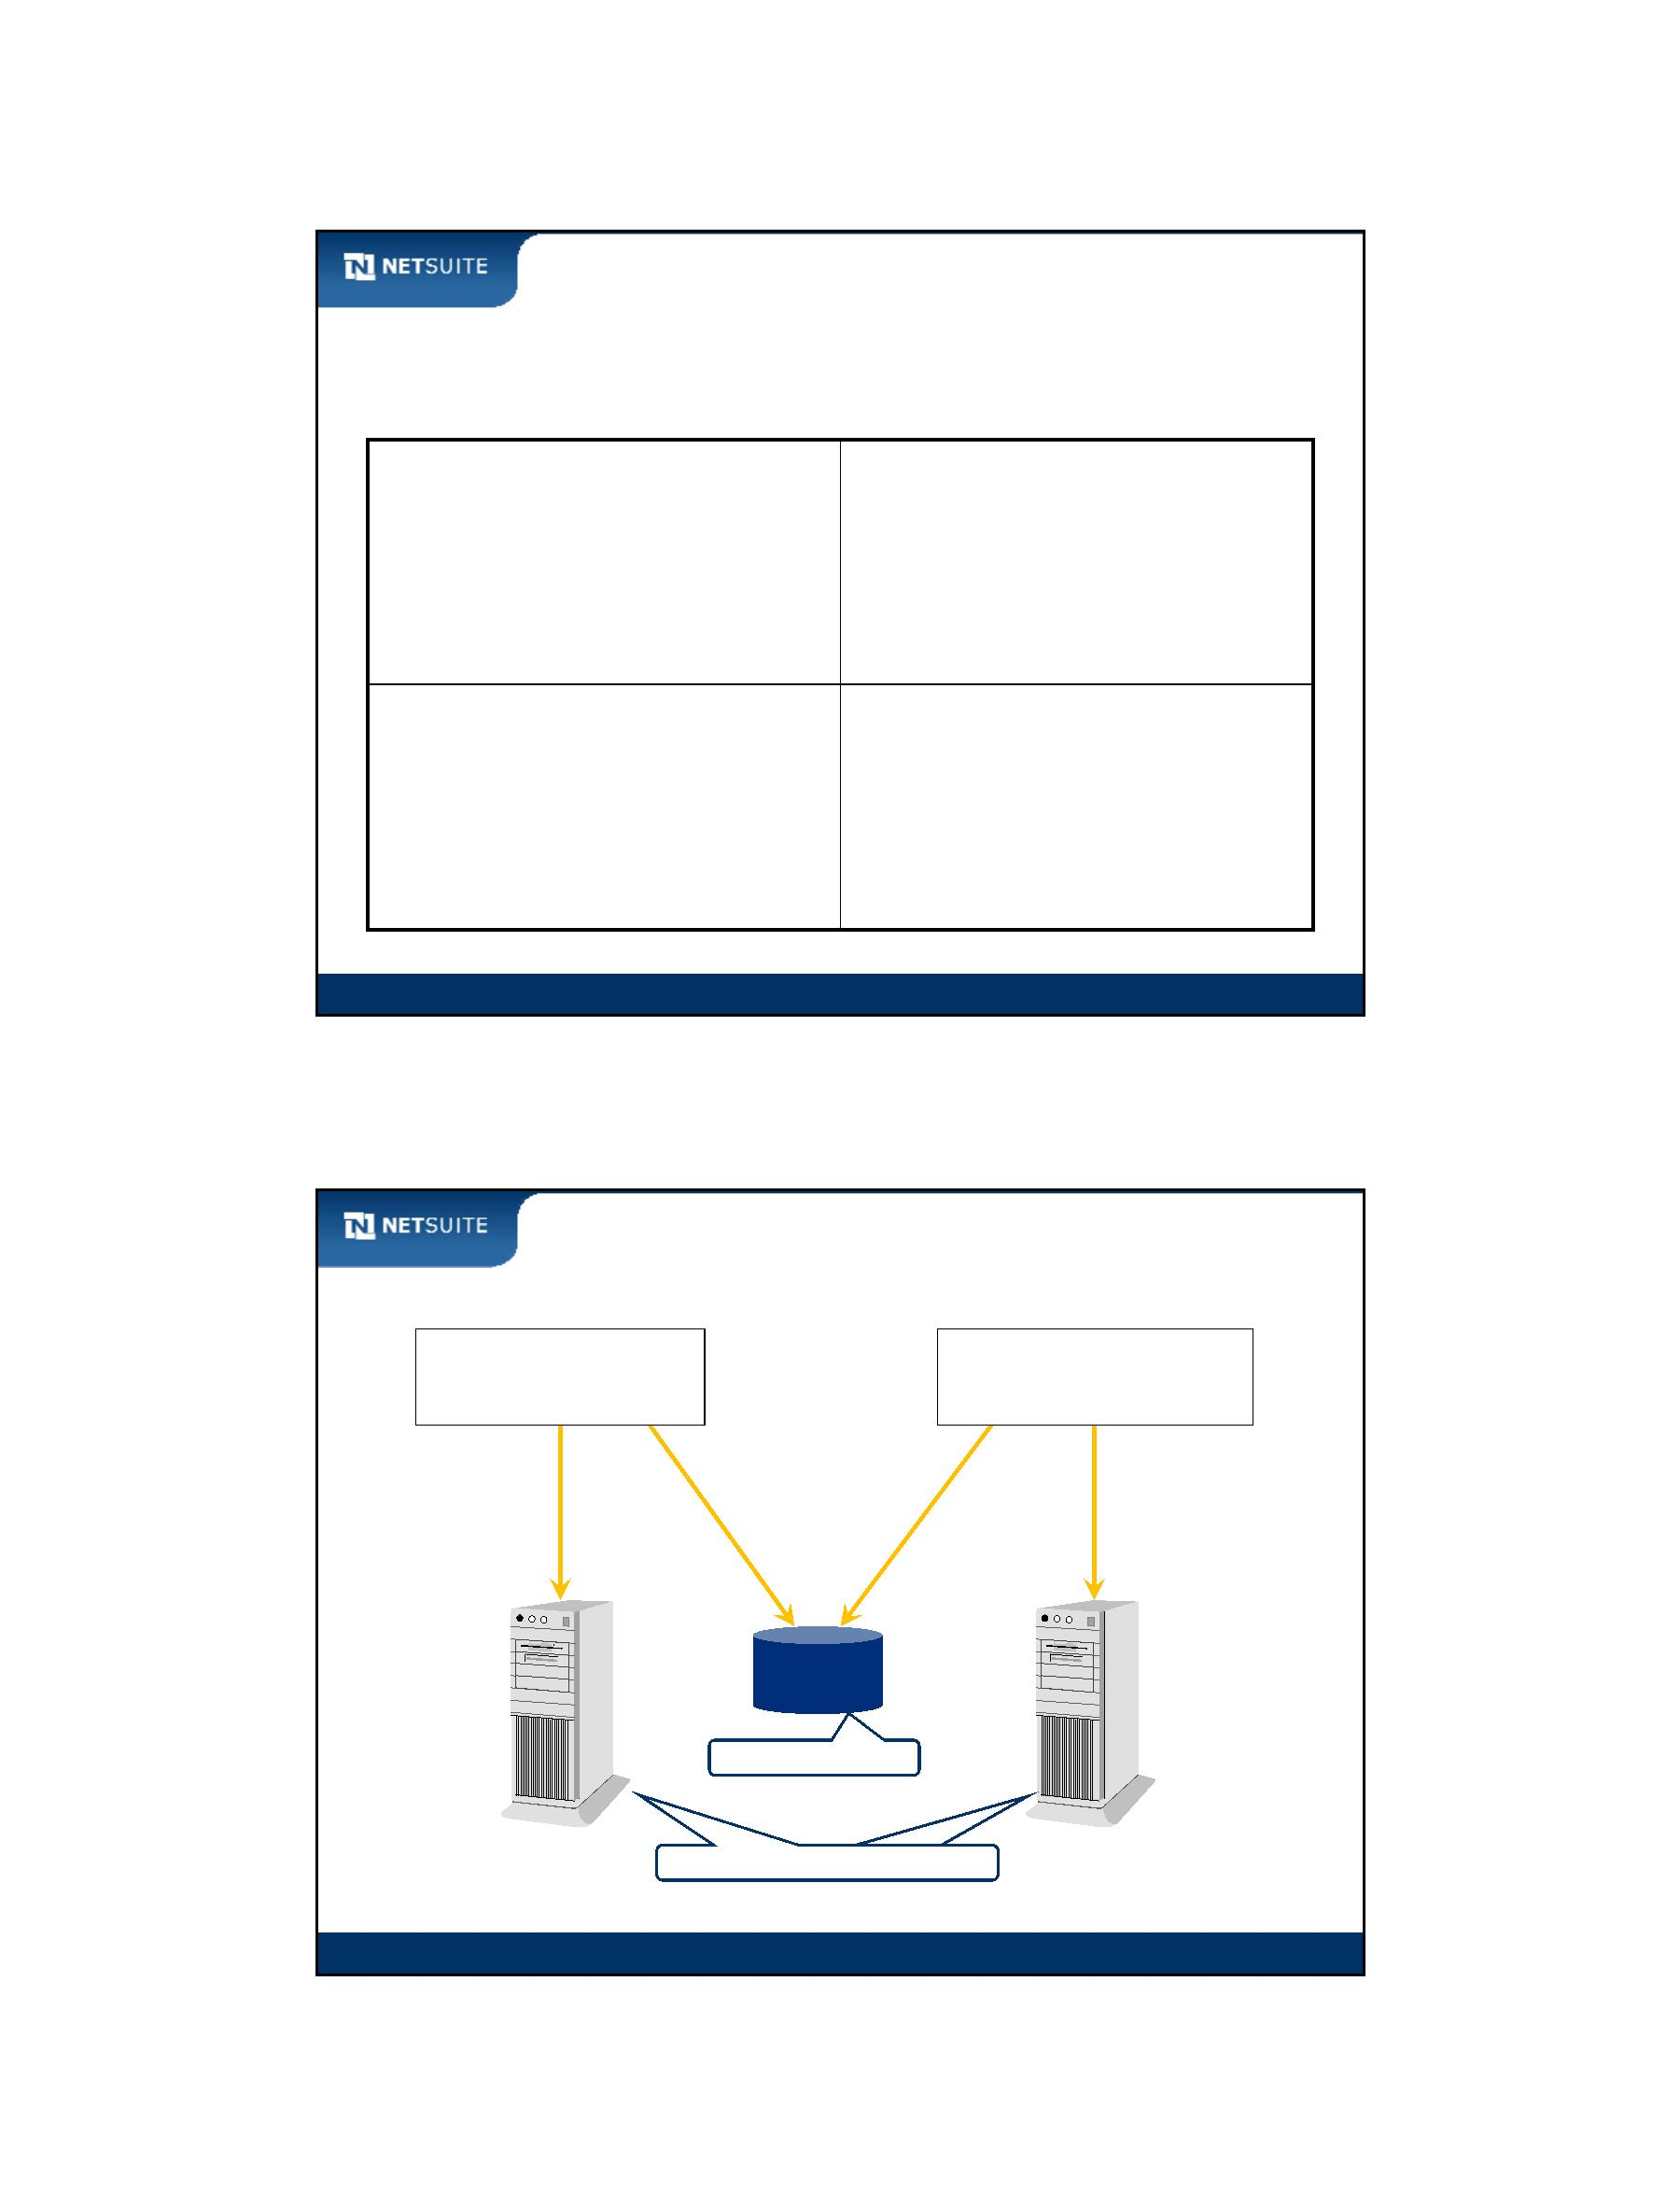

SuiteScript

Walk Through: Debugging a User Event Script

Scenario:

Assume there may be an error in the employee user event script that

logs field values to the Execution Log.

Use the script debugger to troubleshoot.

Skills Covered:

Logging in to the script debugger

Debugging a user event script

Using the tools available through the debugger

Module 8: Introduction To User Event Scripts

15

Activity: Steps to Debug a User Event Script

Identify the steps to debug a user event script. Add any details that may be relevant to debugging a

user event script successfully.

Module 8: Introduction To User Event Scripts

16

Module 8: Introduction To User Event Scripts - 8

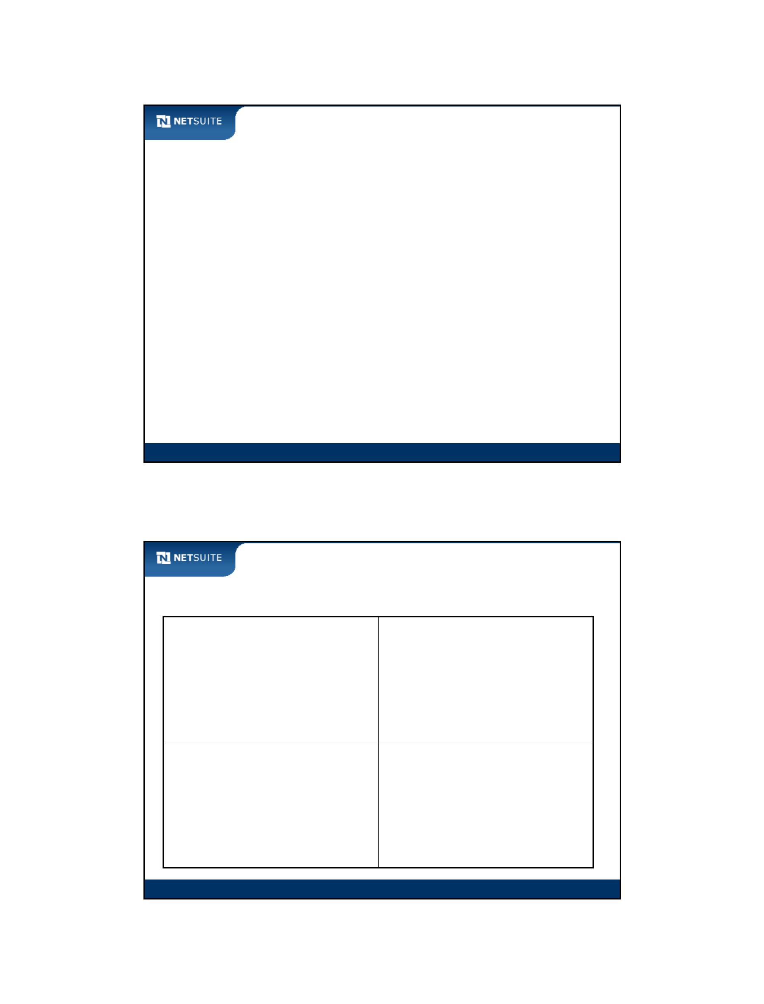

SuiteScript

Best Practices

Limited hardcoding of internal id’s where possible

Place critical business logic in a user event script instead of a client

side script

Use nlapiLogExecution to debug your user event scripts (also used

for other server side scripts)

Use the script debugger to troubleshoot your scripts

Module 8: Introduction To User Event Scripts

17

Now It’s Your Turn

In these hands on exercises, you practice:

Creating server‐side user event scripts

Working with SuiteScript objects

Logging data from a user event script

Sending an email from a user event script

Using the NetSuite script debugger to troubleshoot user event scripts

Module 8: Introduction To User Event Scripts

18

Module 8: Introduction To User Event Scripts - 9



SuiteScript

Module 9: Manipulating Record Objects

Objectives

Upon completing this module, you should be able to:

Load records in user event scripts

Create records in user event scripts

Identify the relationship between record creation in script and the

NetSuite user interface

Module 9: Manipulating Record Objects

2

Module 9: Manipulating Record Objects - 1



SuiteScript

Record Resources

Use the NetSuite Help Center to find IDs to represent standard record

types, including their fields:

SuiteCloud > SuiteScript > SuiteScript Reference >

SuiteScript Supported Records, then click on record type

Open SuiteScript Records Browser

use this ID in script to

identify record types when

loading or creating them

IDs that represent the fields in standard record types;

equivalent to Field ID when clicking label in UI

Module 9: Manipulating Record Objects

3

Activity: Enter Function to Load a Record

Complete the nlapiLoadRecord

statements to load the record for Caitlin

McGyver into a variable.

nlapiLoadRecord (record type id, internal id)

nlapiLoadRecord(

nlapiLoadRecord(

nlapiLoadRecord(

nlapiLoadRecord(

,

,

,

,

)

)

)

)

Module 9: Manipulating Record Objects

4

Module 9: Manipulating Record Objects - 2

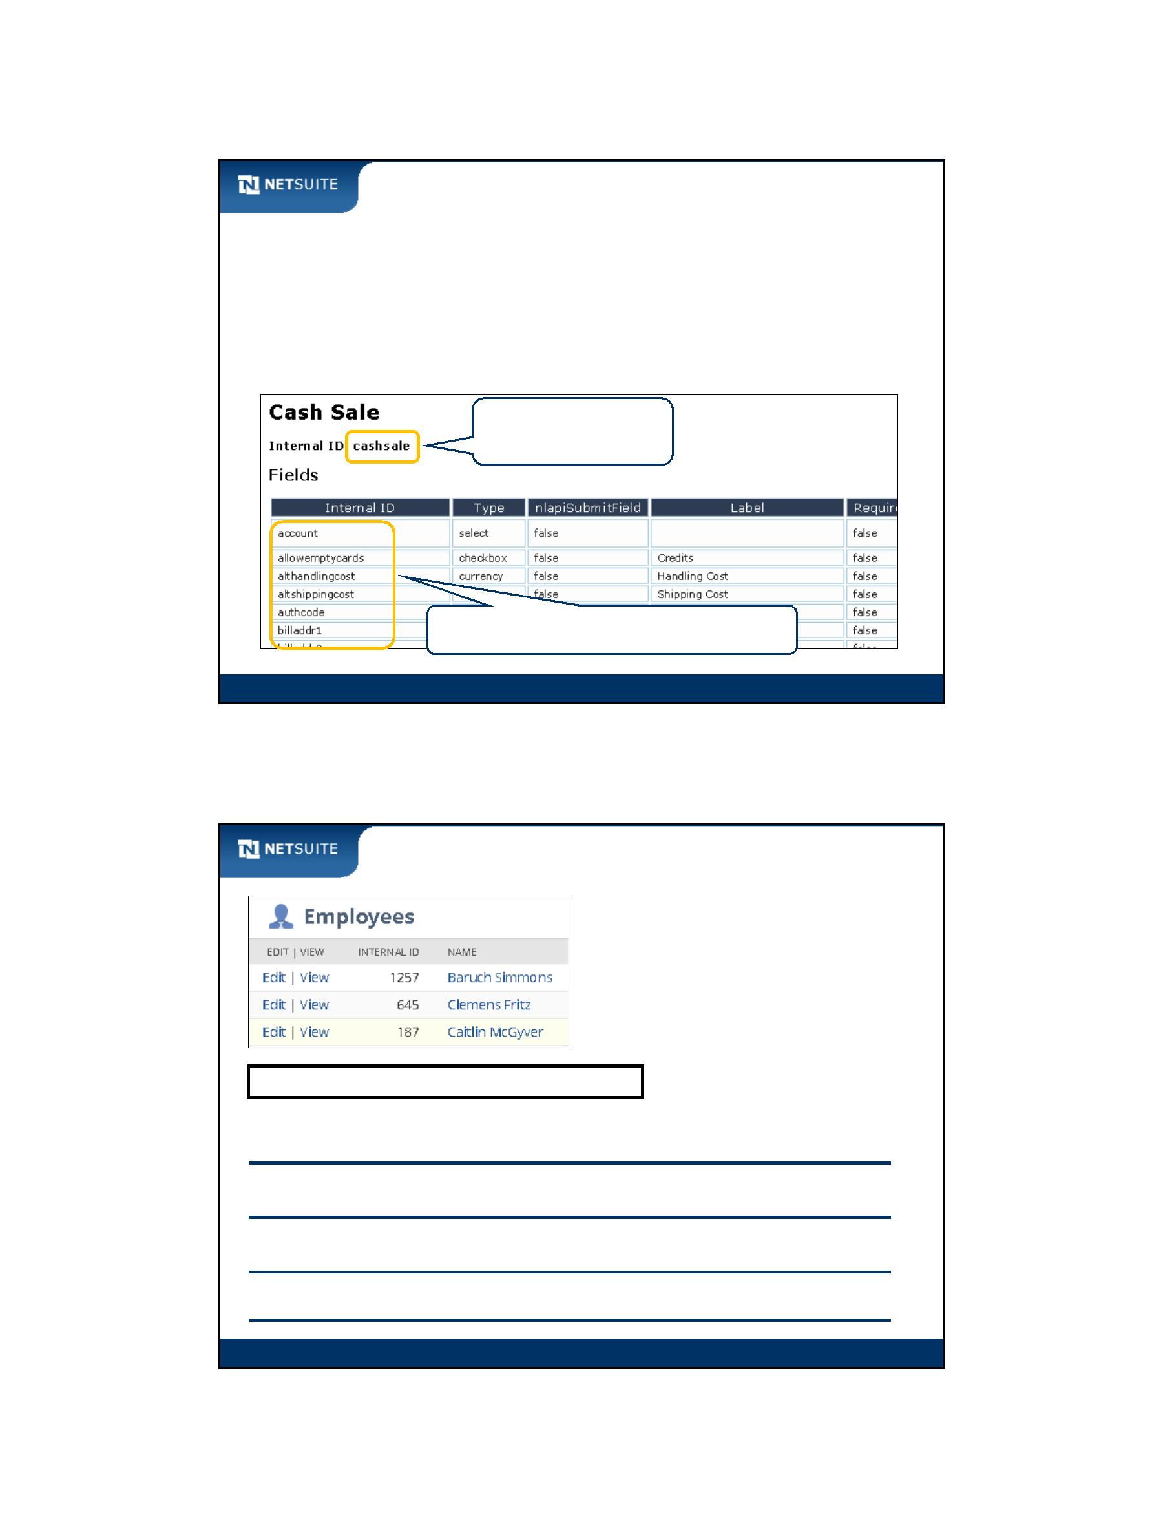

SuiteScript

Activity: Get Phone Call Information

Circle fields that are mandatory. Highlight mandatory fields the end user must actively type into in order

to save the record. Specify the record type id. Specify the field id’s for fields in the main area of the form.

You can create new phone calls at Activities > Scheduling > Phone Calls > New.

Module 9: Manipulating Record Objects

5

Memory versus Database

nlapiCreateRecord returns reference to nlobjRecord in memory

nlapiSubmitRecord persists nlobjRecord to database

nlapiCreateRecord

nlapiSubmitRecord

Server Memory

NetSuite

Database

Module 9: Manipulating Record Objects

6

Module 9: Manipulating Record Objects - 3

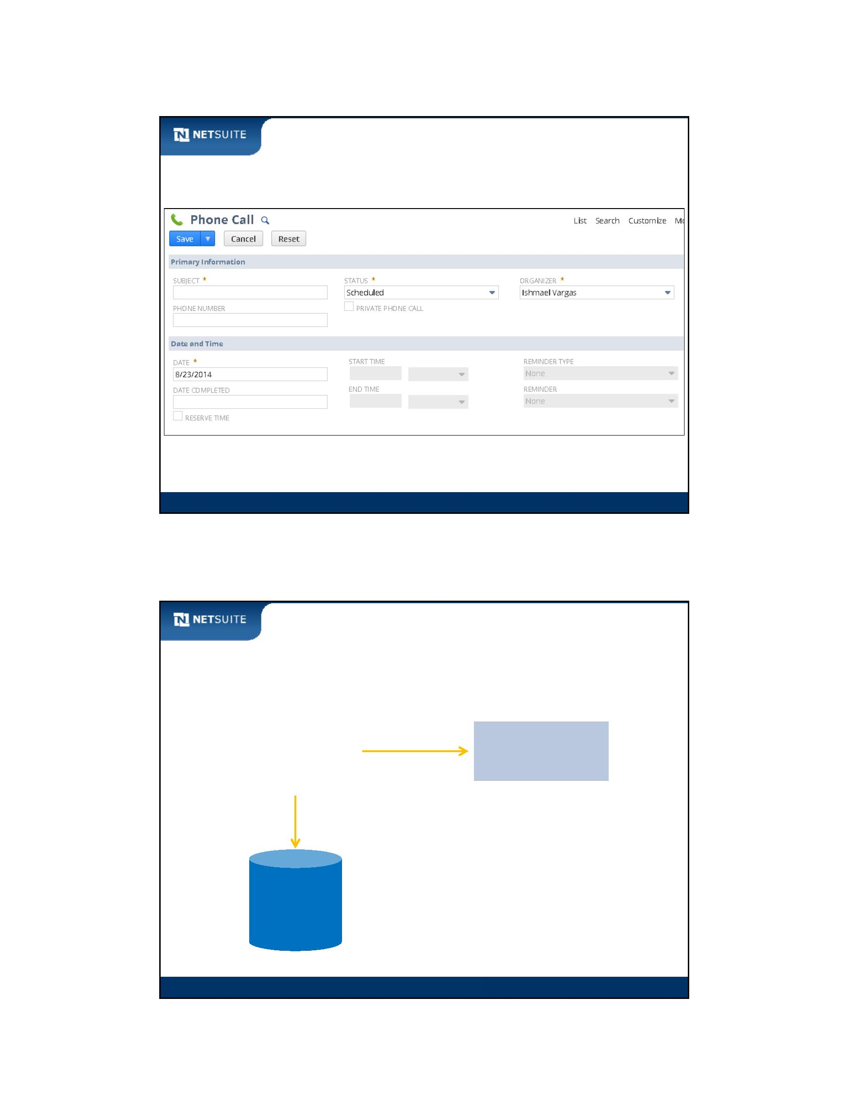

SuiteScript

Activity: End User Activity and nlapi Functions

Fill in the nlapi function that corresponds with the end user activity of either bringing up a “new”

form, or clicking the Save button.

Activities > Scheduling > Calendar > New

nlapi_______________________

End user

clicks Save

**nlapi**____________________________

Module 9: Manipulating Record Objects

7

Walk Through: Create a Record

Scenario:

Generate a phone call record upon creation of an employee. The phone

call is assigned (Organizer) to the employee so they can have a phone

call with the SuiteDreams human resources department about their

benefits.

Outstanding phone calls show on the Organizer’s Calendar Activities or

Phone Calls portlet on the home dashboard.

Skills Covered:

Creating a record from a user event script

Defining the relationship between custom forms and script

Setting the custom form through script

Module 9: Manipulating Record Objects

8

Module 9: Manipulating Record Objects - 4

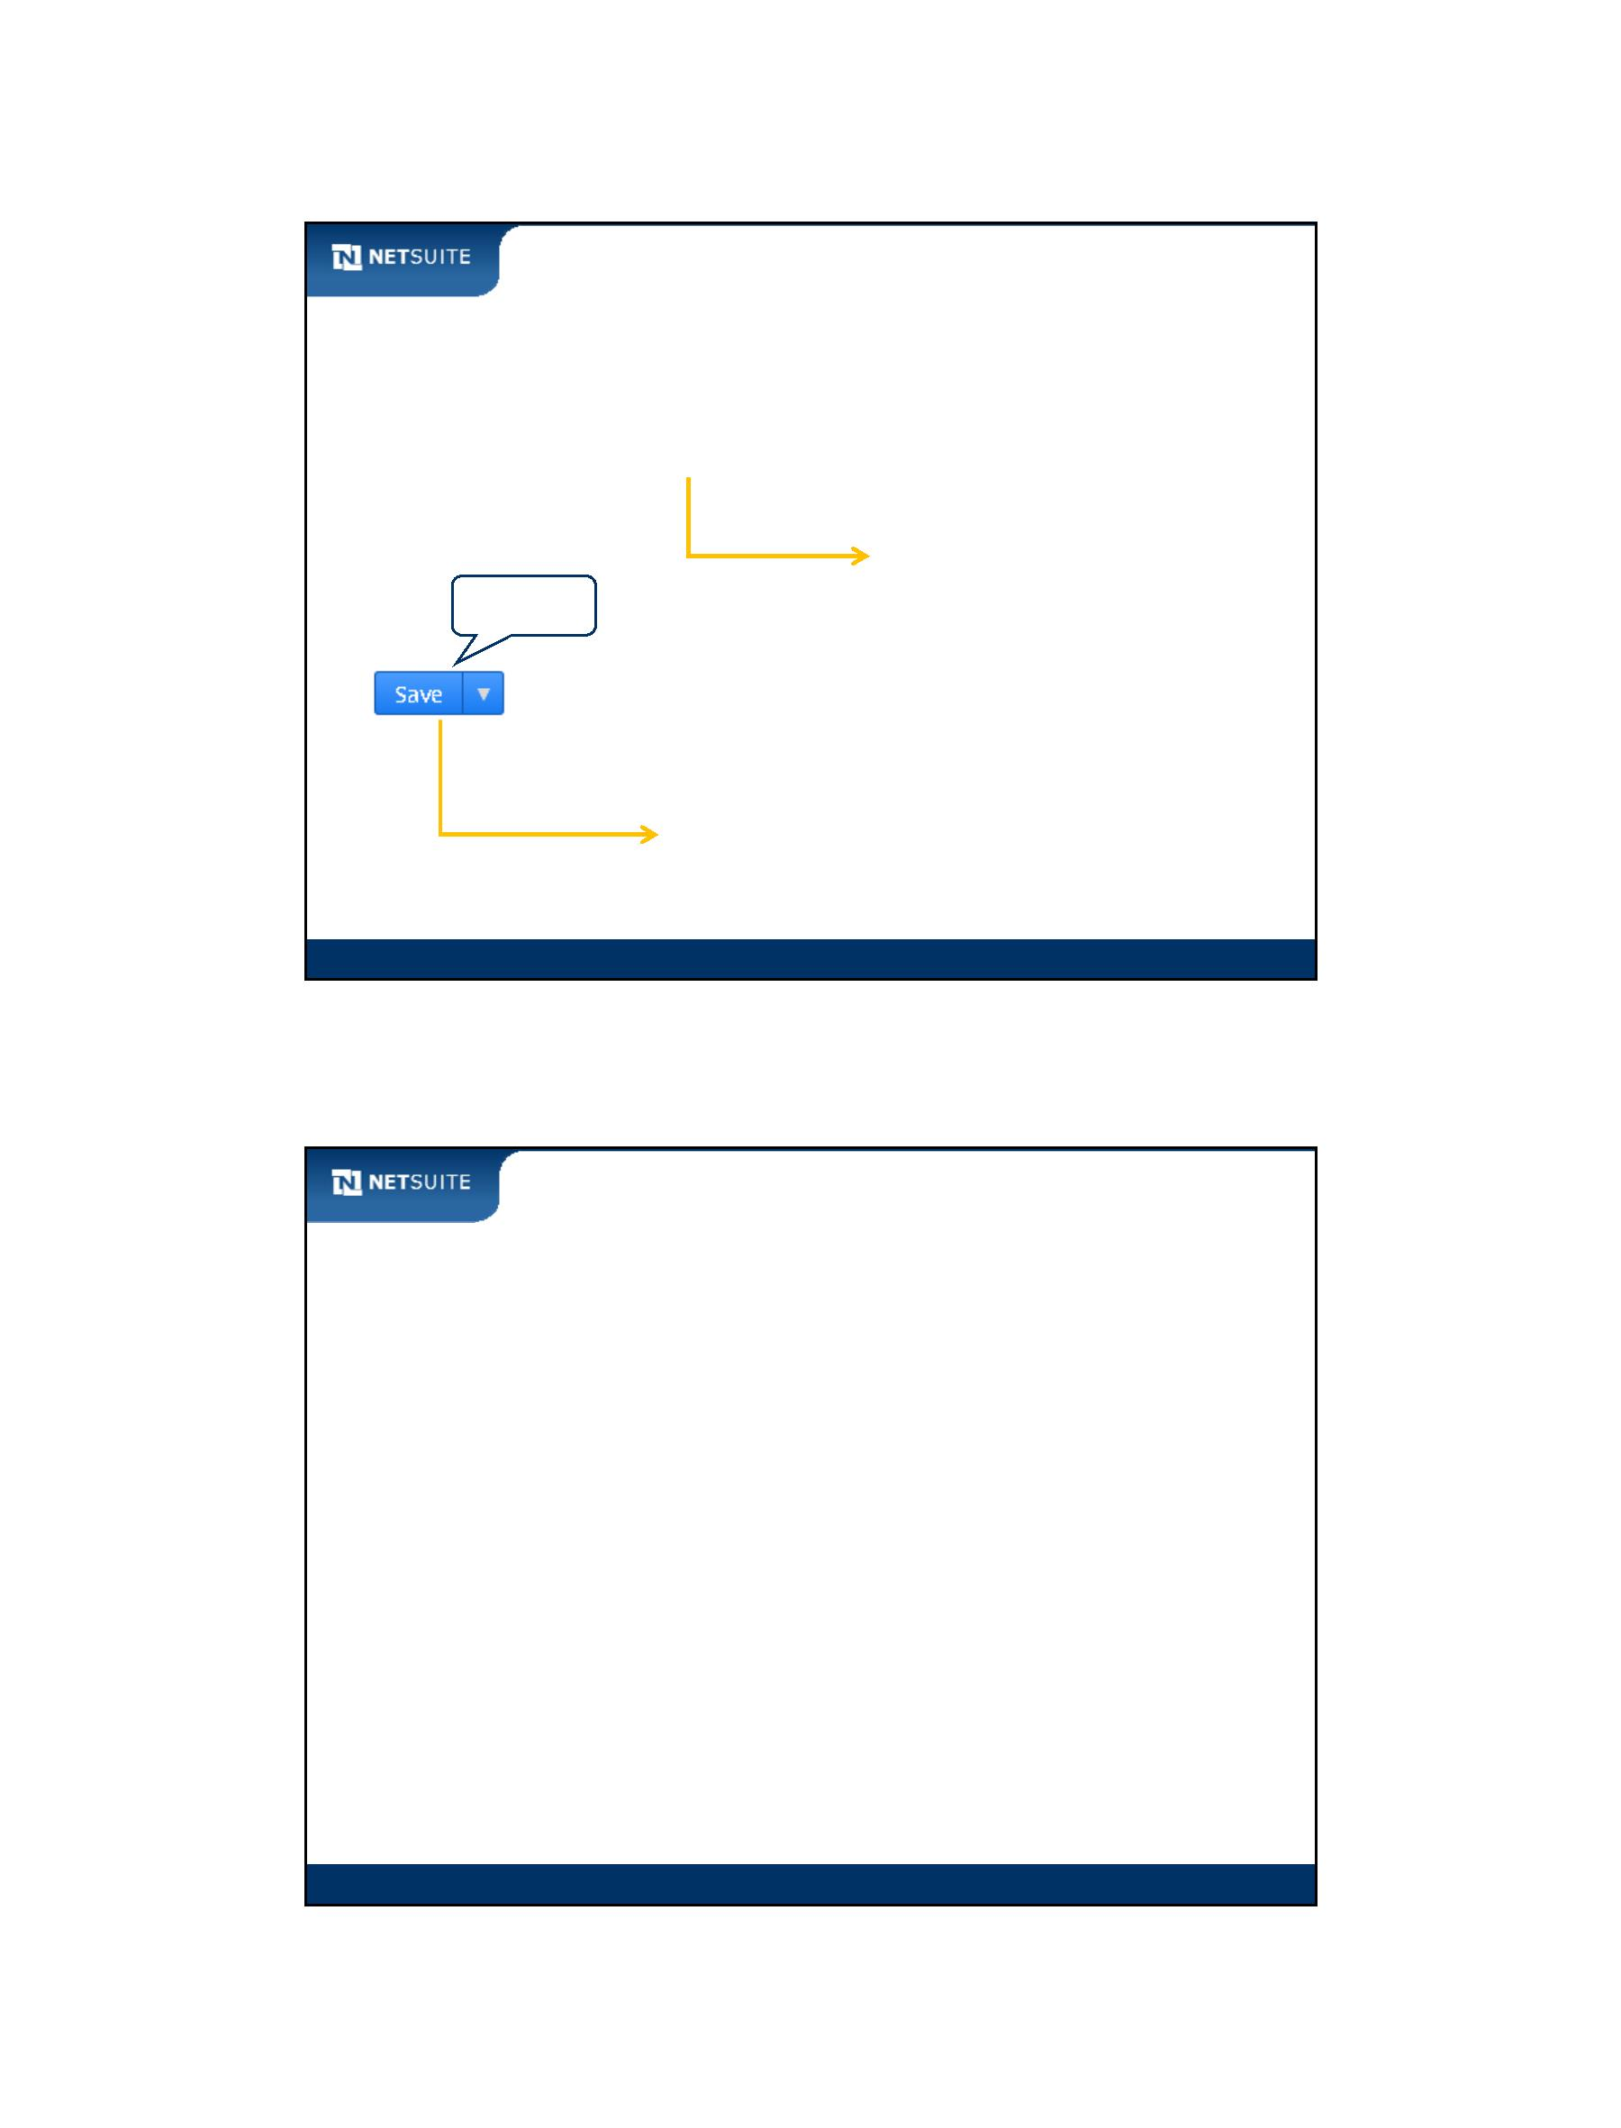

SuiteScript

Best Practices

Explicitly set the customform property through the initialization

parameter when executing nlapiCreateRecord

Use the NetSuite Help Center to verify which records are

scriptable and in what contexts

Module 9: Manipulating Record Objects

9

Now It’s Your Turn

In these hands on exercises, you practice:

Loading records in user event scripts

Creating records in user event scripts

Identifying the relationship between record creation in script and the

NetSuite user interface

Continuing to use the script debugger to troubleshoot user event

scripts

Module 9: Manipulating Record Objects

10

Module 9: Manipulating Record Objects - 5



SuiteScript

Module 10: Scripting Sublists on Server

Objectives

Upon completing this module, you should be able to:

Insert line items into a sublist when working with server‐based

functions, objects, and methods.

Module 10: Scripting Sublists on Server

2

Module 10: Scripting Sublists On Server - 1



SuiteScript

Walk Through: Script Sublist when Creating Records

Scenario:

Set up an event between an employee and their supervisor

Skills Covered:

Review on finding sublist and field IDs

Scripting sublists using server scripting techniques

Module 10: Scripting Sublists on Server

3

Now It’s Your Turn

In these hands on exercises, you practice:

Inserting line items into a sublist when working with server‐based

functions, objects, and methods.

Creating records from a client request (custom button) and having the

new record open in a browser window.

Module 10: Scripting Sublists on Server

4

Module 10: Scripting Sublists On Server - 2



SuiteScript

Module 11: Scripting Searches

Objectives

Upon completing this module, you should be able to:

Define the search architecture

Determine required information for searches using the NetSuite

Help Center, along with the SuiteScript Records Browser

Execute a saved search from script

Compose a search from script

Module 11: Scripting Searches

2

Module 11: Scripting Searches - 1



SuiteScript

What are Searches?

Similar to database queries (SQL):

NetSuite Search

Terminology

Search Column

Search Filter

Search Join

Module 11: Scripting Searches

3

Saved Searches

NetSuite's version of a database query

Search Filters

Search Join to

vendor

Search

Operator

Search Columns

Module 11: Scripting Searches

4

Module 11: Scripting Searches - 2

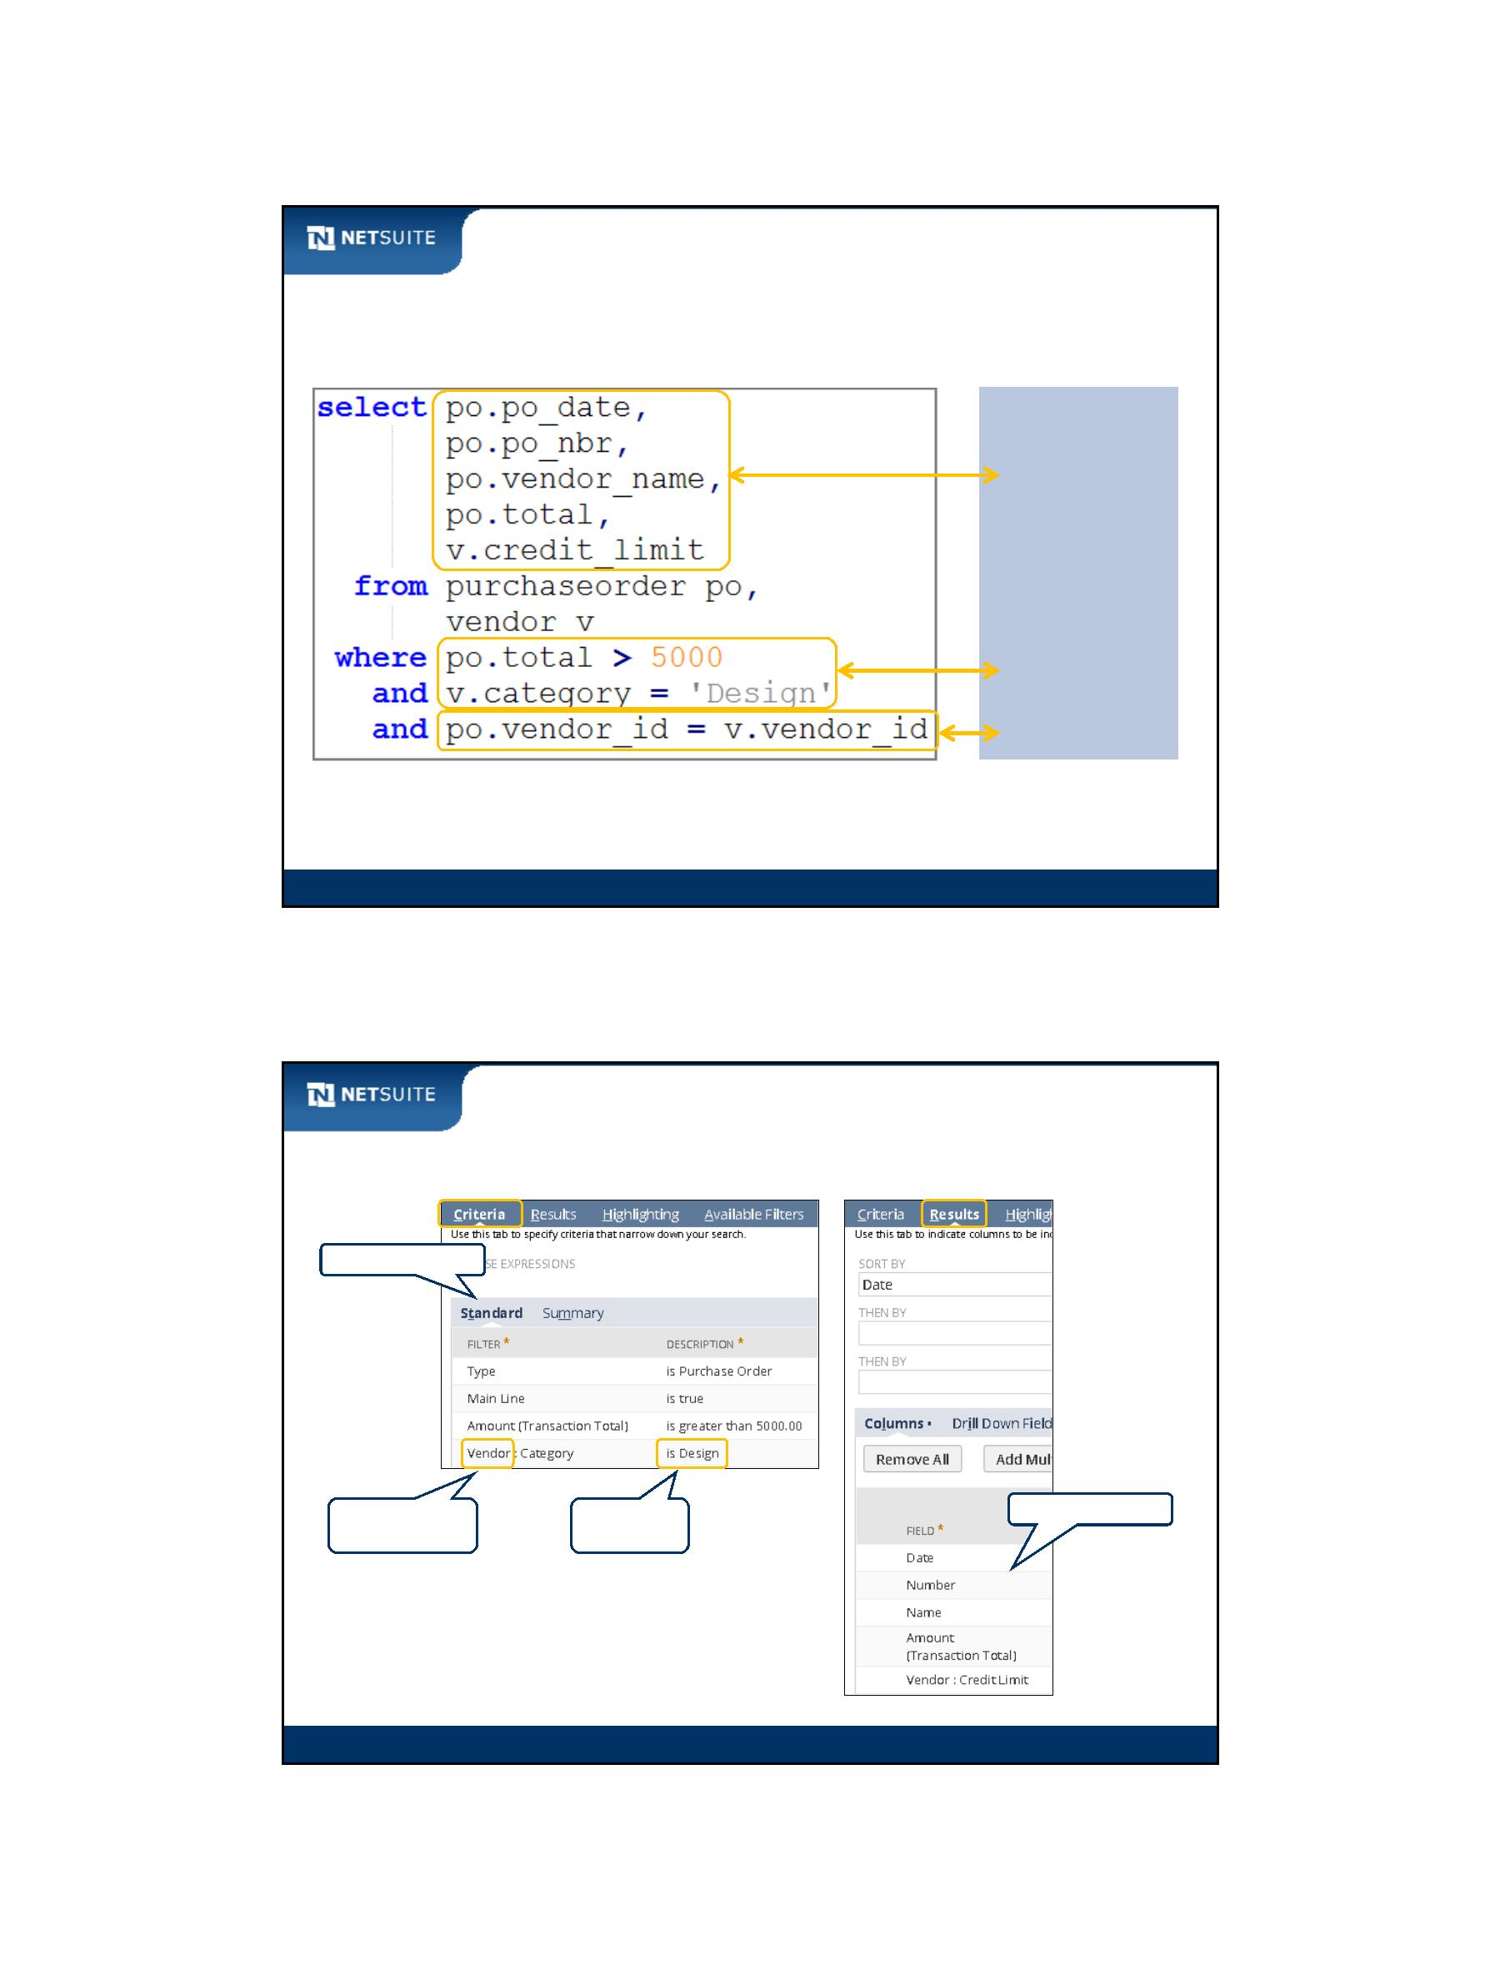

SuiteScript

Search Architecture

Search

Non‐Search

SuiteScript API Functions

• nlapiLookupField

SuiteScript API Functions

• nlapiLoadRecord

• nlapiGetFieldValue

• nlapiNewRecord

• many others

• nlapiSearchRecord

• nlapiSearchDuplicate

• nlapiSearchGlobal

SuiteScript Objects

• nlobjSearchColumn

• nlobjSearchFilter

• nlobjSearchJoin

SuiteScript Objects

• nlobjRecord

• nlobjSearchResult

Module 11: Scripting Searches

5

Search Architecture continued

Search

Non‐Search

IDs

IDs

• Search Columns

• Search Filters

• Search Joins

• Fields

Record Internal IDs

• activity

Record Internal IDs

• customer

• employee

• job

• entity

• item

• customer

• employee

• job

Module 11: Scripting Searches

6

Module 11: Scripting Searches - 3



SuiteScript

Walk Through: Finding IDs for Search Columns,

Filters, and Joins

The demonstration is based upon the following business case:

Find all purchase orders

where purchase order **Total** greater than **5,000**

where vendor **Category** is **Design**

return **Date**, **PO #**, **Vendor**, and **Total** from the purchase

order

return **Credit Limit** from the vendor

Module 11: Scripting Searches

7

Activity: Find IDs for Support Case Search

Evaluate the query pseudocode for selecting support cases. Use the SuiteScript Records Browser to

determine the various IDs required to script the search. A support case is listed as a Case record.

Note: Support cases can be found through the user interface at Lists > Support > Cases.

where Status is Escalated

where Job Title of the Assigned To employee contains Support

return Subject, Incident Date, Status, and Assigned To from the support case

return Department and Job Title from the Assigned To employee

Search Filter ID

Search Column ID

Subject

Incident Date

Status

Department

Job Title

Record Internal ID for support cases ______________________

Search Join ID for employee record _______________________

Module 11: Scripting Searches

8

Module 11: Scripting Searches - 4

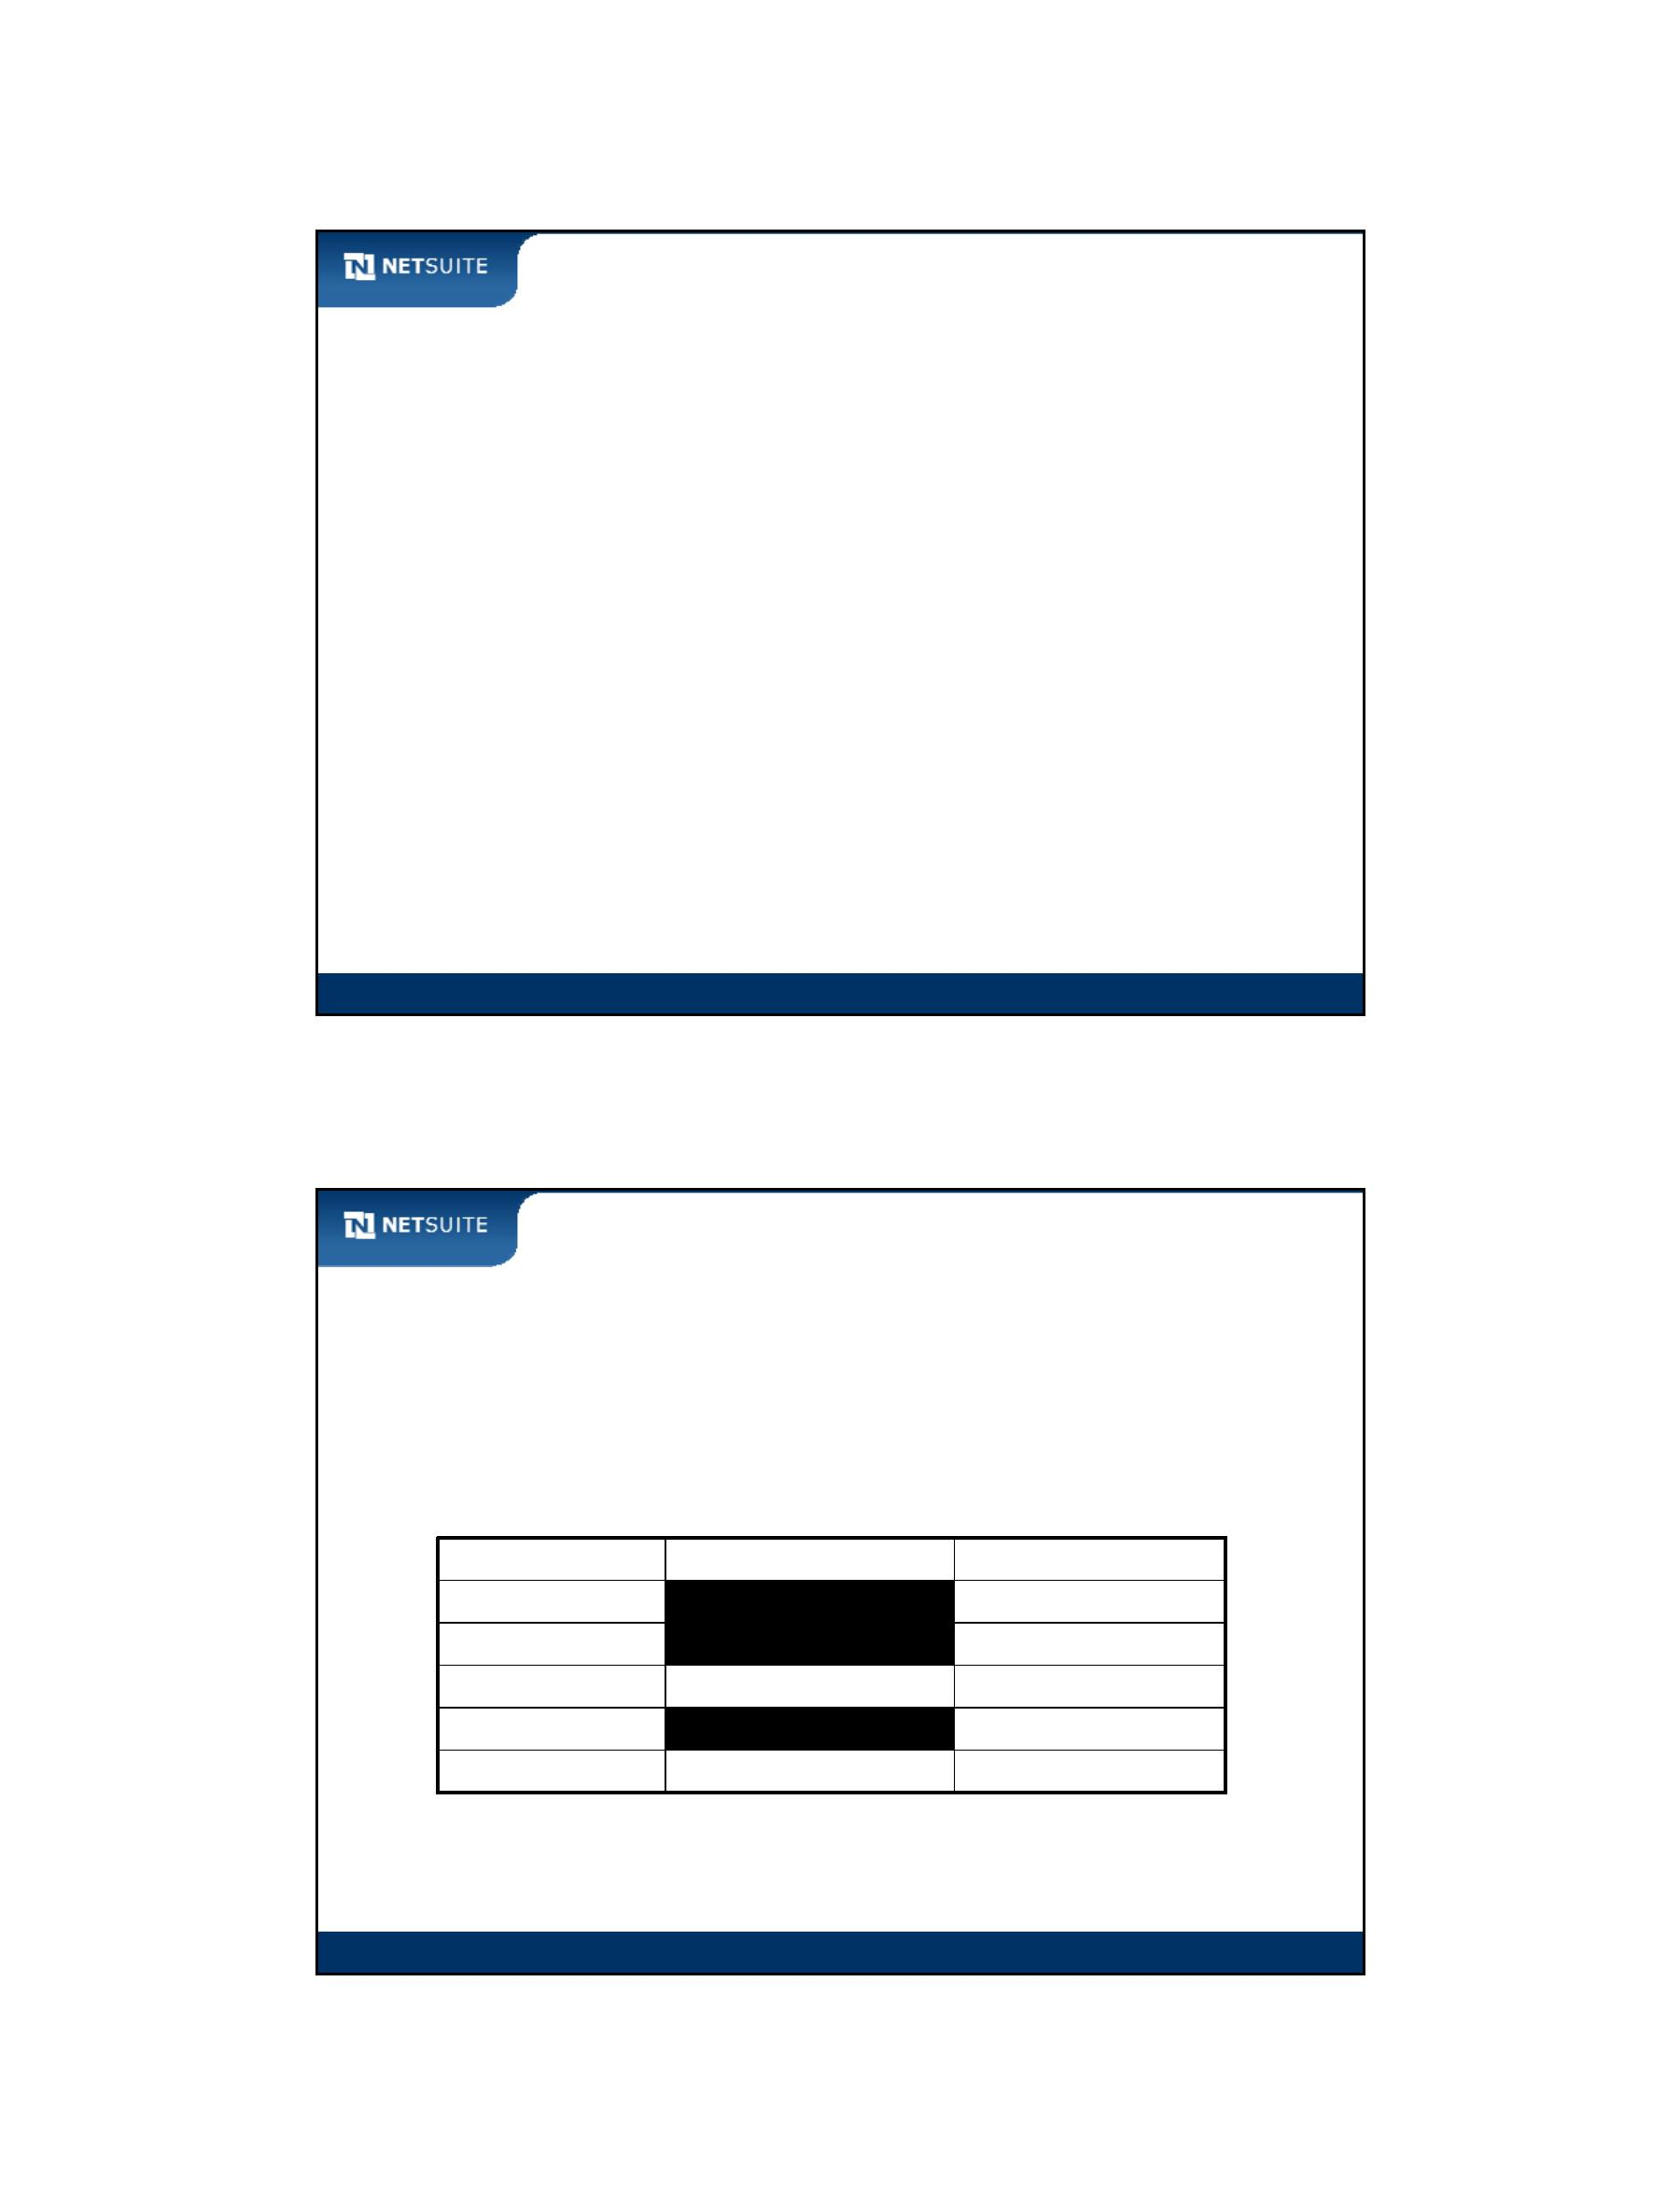

SuiteScript

Activity: Fill in Constructors for Search Filter and

Column Objects

Construct 5 search column objects and 2 search filter objects based on the syntax

examples. Note: Support case statuses found at Setup > Support > Case Statuses

var col = new nlobjSearchColumn(searchColumn, searchJoin);

var ftr = new nlobjSearchFilter(searchFilter, searchJoin, operator, value);

Subject

Incident Date

Status

Status (filter)

Department

Job Title

Job Title (filter)

Module 11: Scripting Searches

9

Walk Through: Creating and Executing a Saved Search

Scenario:

Create saved search based on the following conditions:

– Search for Support Cases

– Select support cases where Status is Escalated and the Job Title of the

Assigned To employee contains ‘Support’

– Return Subject, Incident Date, Status, and Assigned To from the

support case

– Return Department and Job Title form the Assigned To employee

Skills Covered:

Creating and executing a saved search

Module 11: Scripting Searches

10

Module 11: Scripting Searches - 5



SuiteScript

Walk Through: Executing a Saved Search from Script

Scenario:

Re‐use the previously created saved search from the script

Skills Covered:

Executing existing saved searches from the script

Using the script debugger to execute script that is not assigned to a

script type

Module 11: Scripting Searches

11

Walk Through: Building a Search in Script

Scenario:

Rebuild the previous saved search from the script. Same conditions:

– Search for Support Cases

– Select support cases where Status is Escalated and the Job Title of the

Assigned To employee contains ‘Support’

– Return Subject, Incident Date, Status, and Assigned To from the

support case

– Return Department and Job Title form the Assigned To employee

Skills Covered:

Manually composing a search from script by building out arrays of

search filters and search columns

Module 11: Scripting Searches

12

Module 11: Scripting Searches - 6



SuiteScript

Search Terminology and Custom Record Types

Search Column or

Search Filter

Module 11: Scripting Searches

13

Best Practices

Search results are limited to 1000 rows. You can get around this

limitation by sorting the results in a specific order, and then

executing additional searches with criteria that navigates you

through the larger result set. You can use the setSort method

when constructing an nlobjSearchColumn object in script.

Leverage the ability to simulate OR conditions on select type fields

instead of executing multiple searches

You can leverage saved searches for reuse by combining the saved

search and an array of custom filters when executing

nlapiSearchRecord

Module 11: Scripting Searches

14

Module 11: Scripting Searches - 7

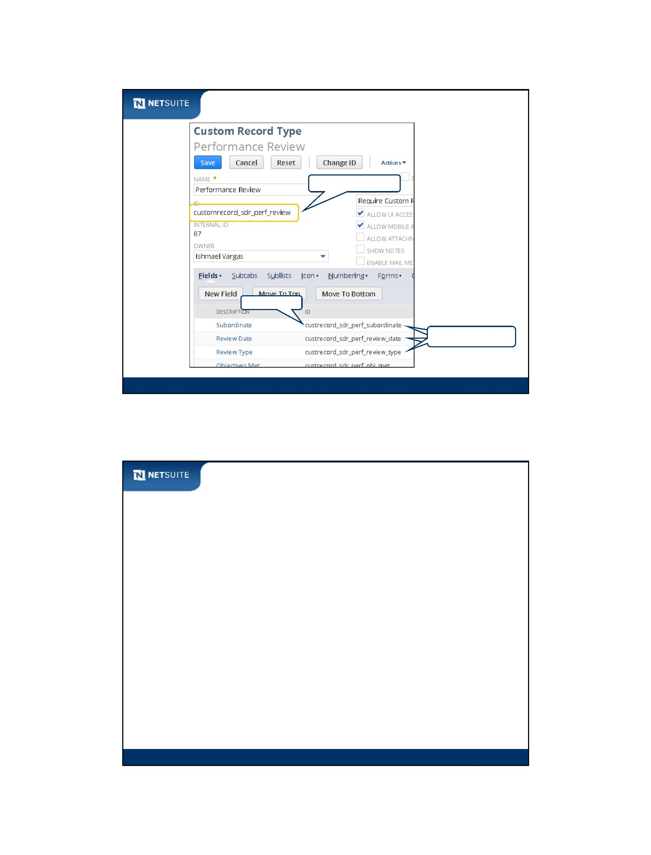

SuiteScript

Now It’s Your Turn

In these hands on exercises, you practice:

Creating a saved search, and then executing it from script

Composing a search from script

Combining a saved search and additional filters

Module 11: Scripting Searches

15

Module 11: Scripting Searches - 8



SuiteScript

Module 12: Scheduled Scripts and Search Results

Objectives

Upon completing this module, you should be able to:

Process search results generated by nlapiSearchRecord

Create and test a scheduled script

Perform other processing against each search result

Module 12: Scheduled Scripts and Search Results

2

Module 12: Scheduled Scripts and Search Results - 1



SuiteScript

Walk Through: Processing Search Results

Scenario:

Log results of a search on support cases

Skills Covered:

Setting up for loop against the array of search results

Executing methods off of a search result object (nlobjSearchResult) to

obtain column values (or text for drop down lists)

Module 12: Scheduled Scripts and Search Results

3

What are scheduled scripts?

Scheduled scripts…

are similar to a batch job

execute on a periodic basis

have no user interface context

– nlapiGetOldRecord() not available

– nlapiGetNewRecord() not available

Module 12: Scheduled Scripts and Search Results

4

Module 12: Scheduled Scripts and Search Results - 2



SuiteScript

Script Queue

3 scripts created to run at the same time…

Script A

5:00pm

Script B

5:00pm

Script C

5:00pm

Will never run at the same time…

Script A

5:00pm

Script B

5:00pm

Script C

5:00pm

Up to 15 queues (SuiteCloud Plus License*)

*\* Talk to your local sales representative about the pricing.*

5

Module 12: Scheduled Scripts and Search Results

Script Scheduler

Scripts are pushed to the queue when the Scheduler picks up the script.

Schedule to

run at 5:00pm

Script C

5:00pm

Scheduler

(Executes every 30 mins)

Pushed to the

queue at 5:10pm

Script C

Script A

5:10pm

4:30pm

Module 12: Scheduled Scripts and Search Results

6

Module 12: Scheduled Scripts and Search Results - 3

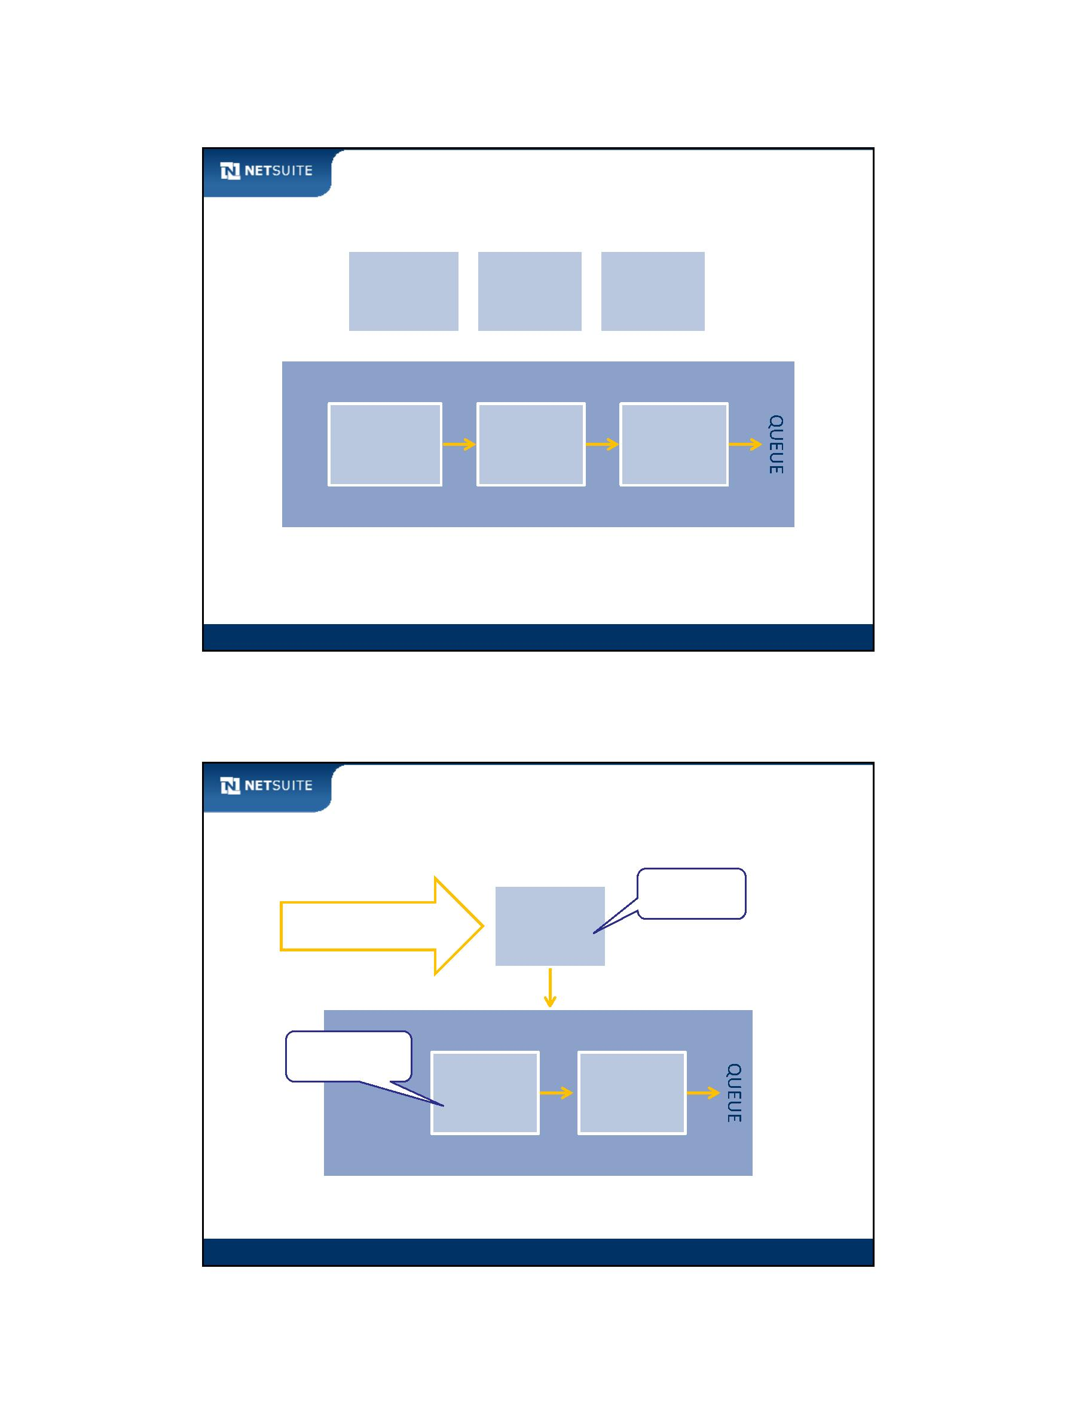

SuiteScript

Script execution status

Pending

(waiting)

In Progress

(processing)

Completed

(success or failure)

Module 12: Scheduled Scripts and Search Results

7

Walk Through: Creating a Scheduled Script

Scenario:

Execute a search of support cases as a scheduled script

Skills Covered:

Creating script record and deployment for a scheduled script

Executing a scheduled script immediately

Module 12: Scheduled Scripts and Search Results

8

Module 12: Scheduled Scripts and Search Results - 4



SuiteScript

Execution environment

Client

function afterSubmit(type) {

nlapiScheduleScript()

}

ondemand

userinterface

scheduled

function myScheduledScript(type, queue) {

}

Module 12: Scheduled Scripts and Search Results

9

Best Practices

Try to schedule your scripts to run when the server load is lower

Heavy user event script processing should be offloaded to

scheduled scripts when real‐time execution is not an issue

Module 12: Scheduled Scripts and Search Results

10

Module 12: Scheduled Scripts and Search Results - 5

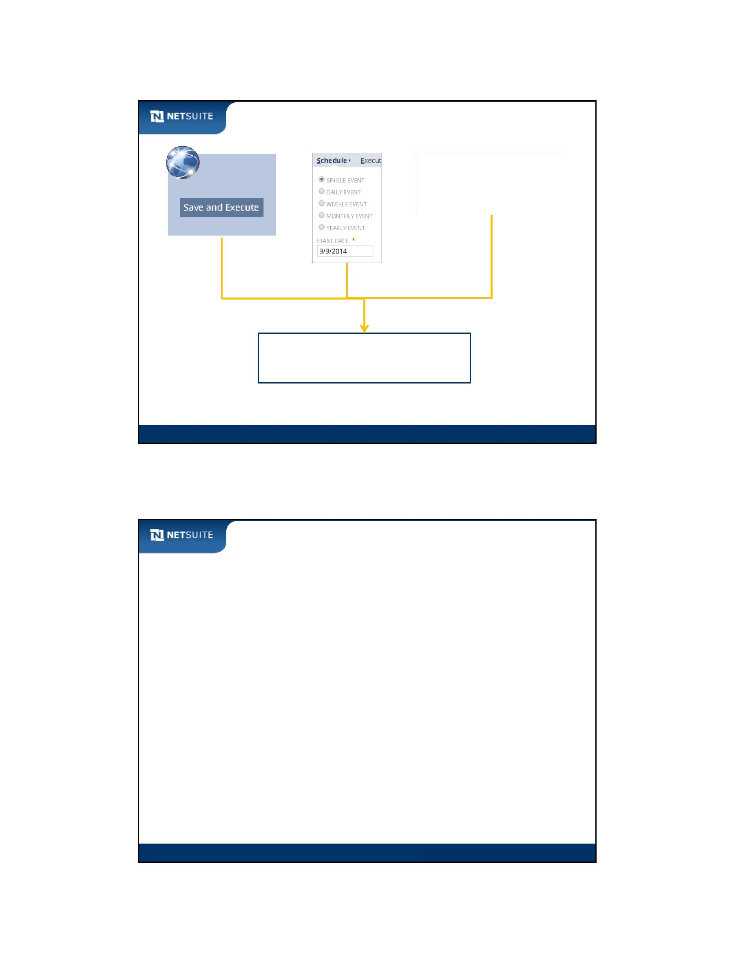

SuiteScript

Now It’s Your Turn

In these hands on exercises, you practice:

Processing the result set of search (extension from prior module)

Executing a scheduled script

Combining a saved search with additional search filters

Module 12: Scheduled Scripts and Search Results

11

Module 12: Scheduled Scripts and Search Results - 6



SuiteScript

Module 13: Script Parameters

Objectives

Upon completing this module, you should be able to:

Incorporate a User specific script parameter

Incorporate a Company specific script parameter

Incorporate a Deployment specific script parameter

Module 13: Script Parameters

2

Module 13: Script Parameters - 1



SuiteScript

What are script parameters?

Script parameters…

are not parameters passed between JavaScript functions

can be scoped to...

– a single user

– the whole company

– a script deployment

can be overridden in calls to nlapiScheduleScript

can be used to pass parameters between workflows and scripts

(module 14)

Module 13: Script Parameters

3

Why use script parameters?

Script parameters can reduce maintenance cost:

Business policies can change without changing script

Configurable by administrators and end users

Easily implement user and company configuration values

Differentiate script based on deployment

Module 13: Script Parameters

4

Module 13: Script Parameters - 2



SuiteScript

Script parameter usage

[1]

[2]

Script Parameter

Definition

generates Script Configuration

User Interface

retrieved in

[4]

[3]

affects

Script Function

Functionality

Module 13: Script Parameters

5

Walk Through: Script Parameters

Scenario:

Default the employee code based on configuration by the administrator

Skills Covered:

creating a script parameter field

configuring the value of a script parameter

retrieving a script parameter inside of script

Module 13: Script Parameters

6

Module 13: Script Parameters - 3

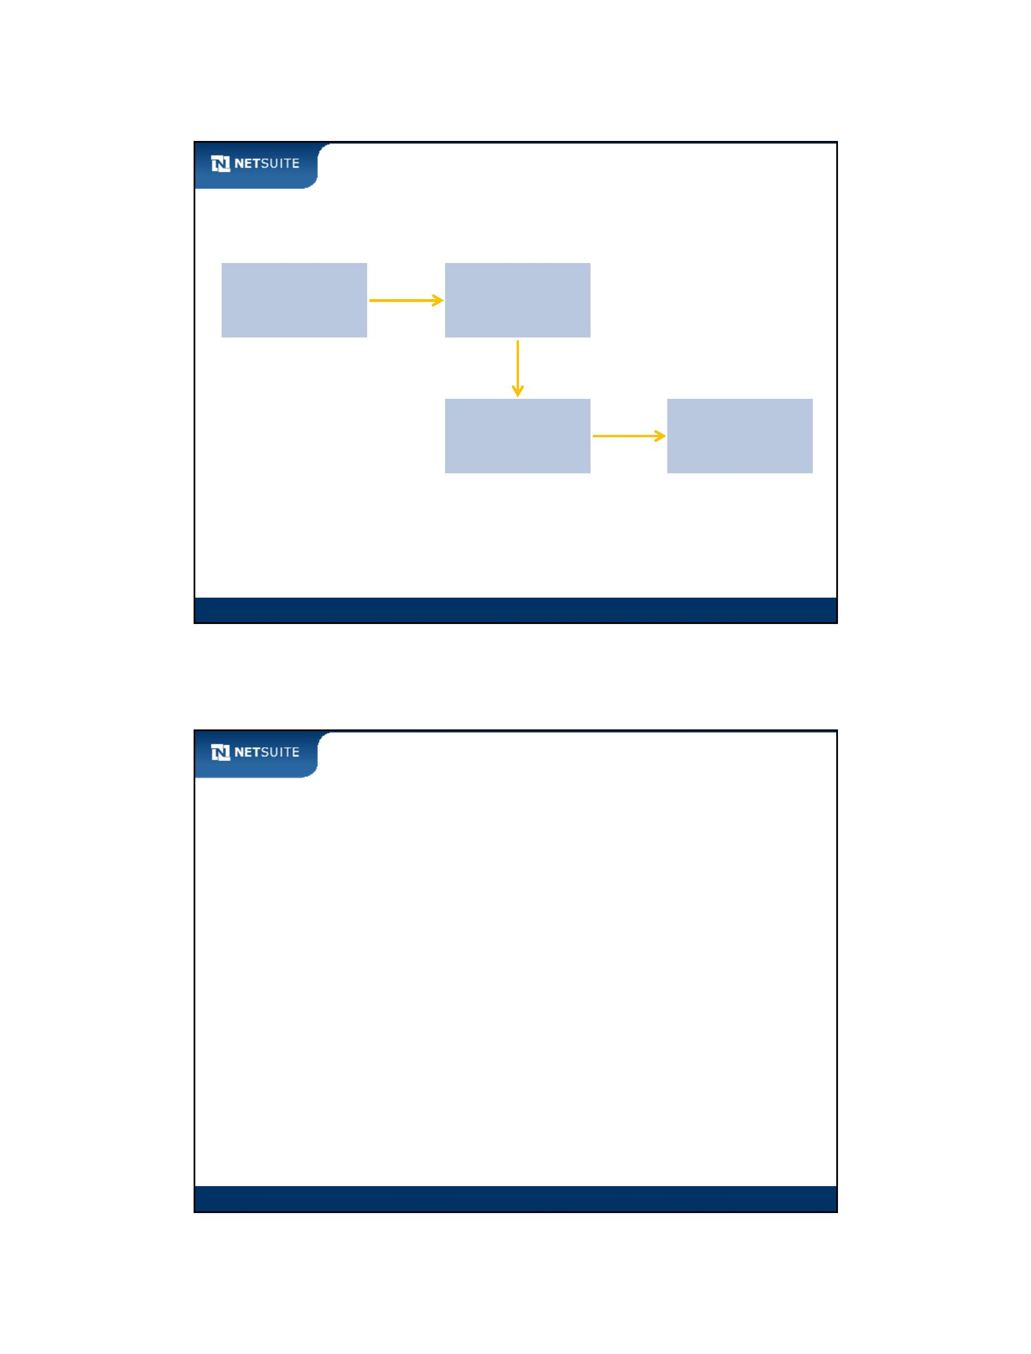

SuiteScript

Activity: Set a field value from a Script Parameter

Phone call title is hardcoded, but a Free‐Form Text script

parameter is accessible. Modify script to access the parameter.

Module 13: Script Parameters

7

Best Practices

Use script parameters…

when you want to give flexibility to an end user (User)

when business logic is subject to frequent change (Company)

to cut down on the amount of script that needs to be written

(Deployment)

Module 13: Script Parameters

8

Module 13: Script Parameters - 4

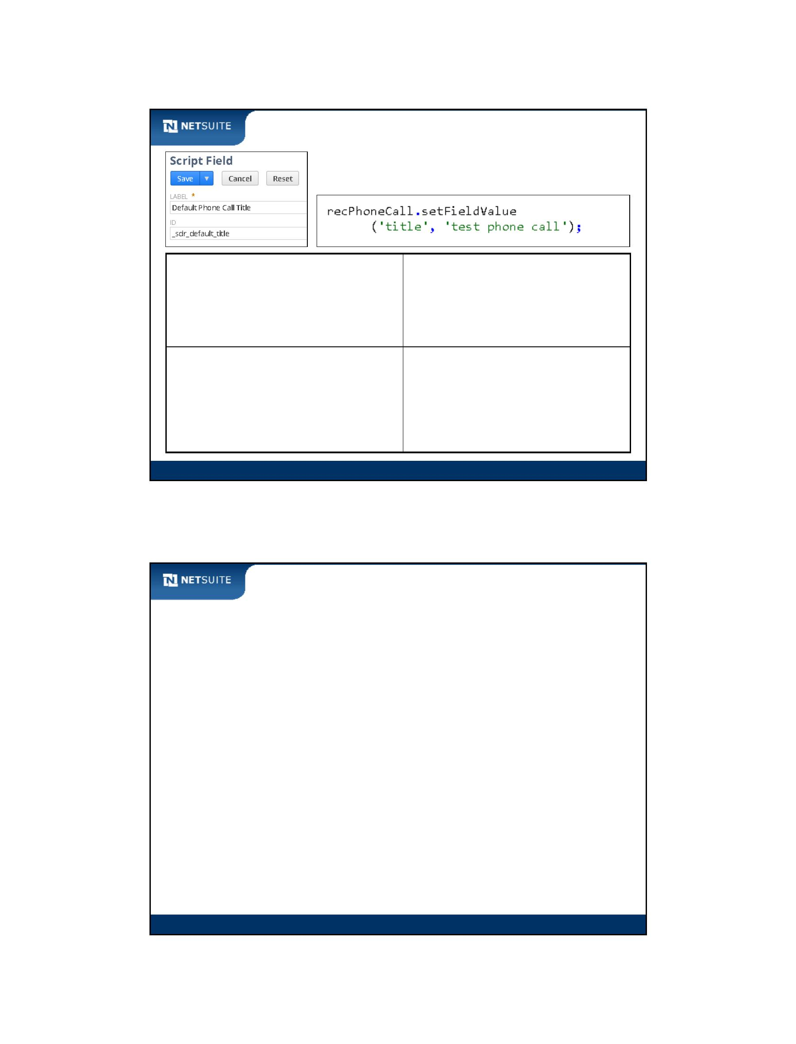

SuiteScript

Now It’s Your Turn

In these hands on exercises, you practice:

Working with User specific script parameters

Working with Deployment specific script parameters

Executing nlapiScheduleScript to offload processing from a user event

script

Module 13: Script Parameters

9

Module 13: Script Parameters - 5



SuiteScript

Module 14: Workflow Action Scripts

Objectives

Upon completing this module, you should be able to:

Describe SuiteFlow

Configure a simple workflow

Create a workflow action script

Extend a workflow through custom actions (workflow action script)

Module 14: Workflow Action Scripts

2 of 16

2

Module 14: Workflow Action Scripts - 1



SuiteScript

What is SuiteFlow?

SuiteFlow…

is a business process automation tool used to create workflows

can do some things that SuiteScript can do

can be extended through SuiteScript (workflow action scripts)

can be thought of as a “visual SuiteScript” tool

Module 14: Workflow Action Scripts

3 of 16

3

SuiteFlow Components

State

Send Email

Action

Transition

Trigger

Status = Recalled

Module 14: Workflow Action Scripts

4

Module 14: Workflow Action Scripts - 2

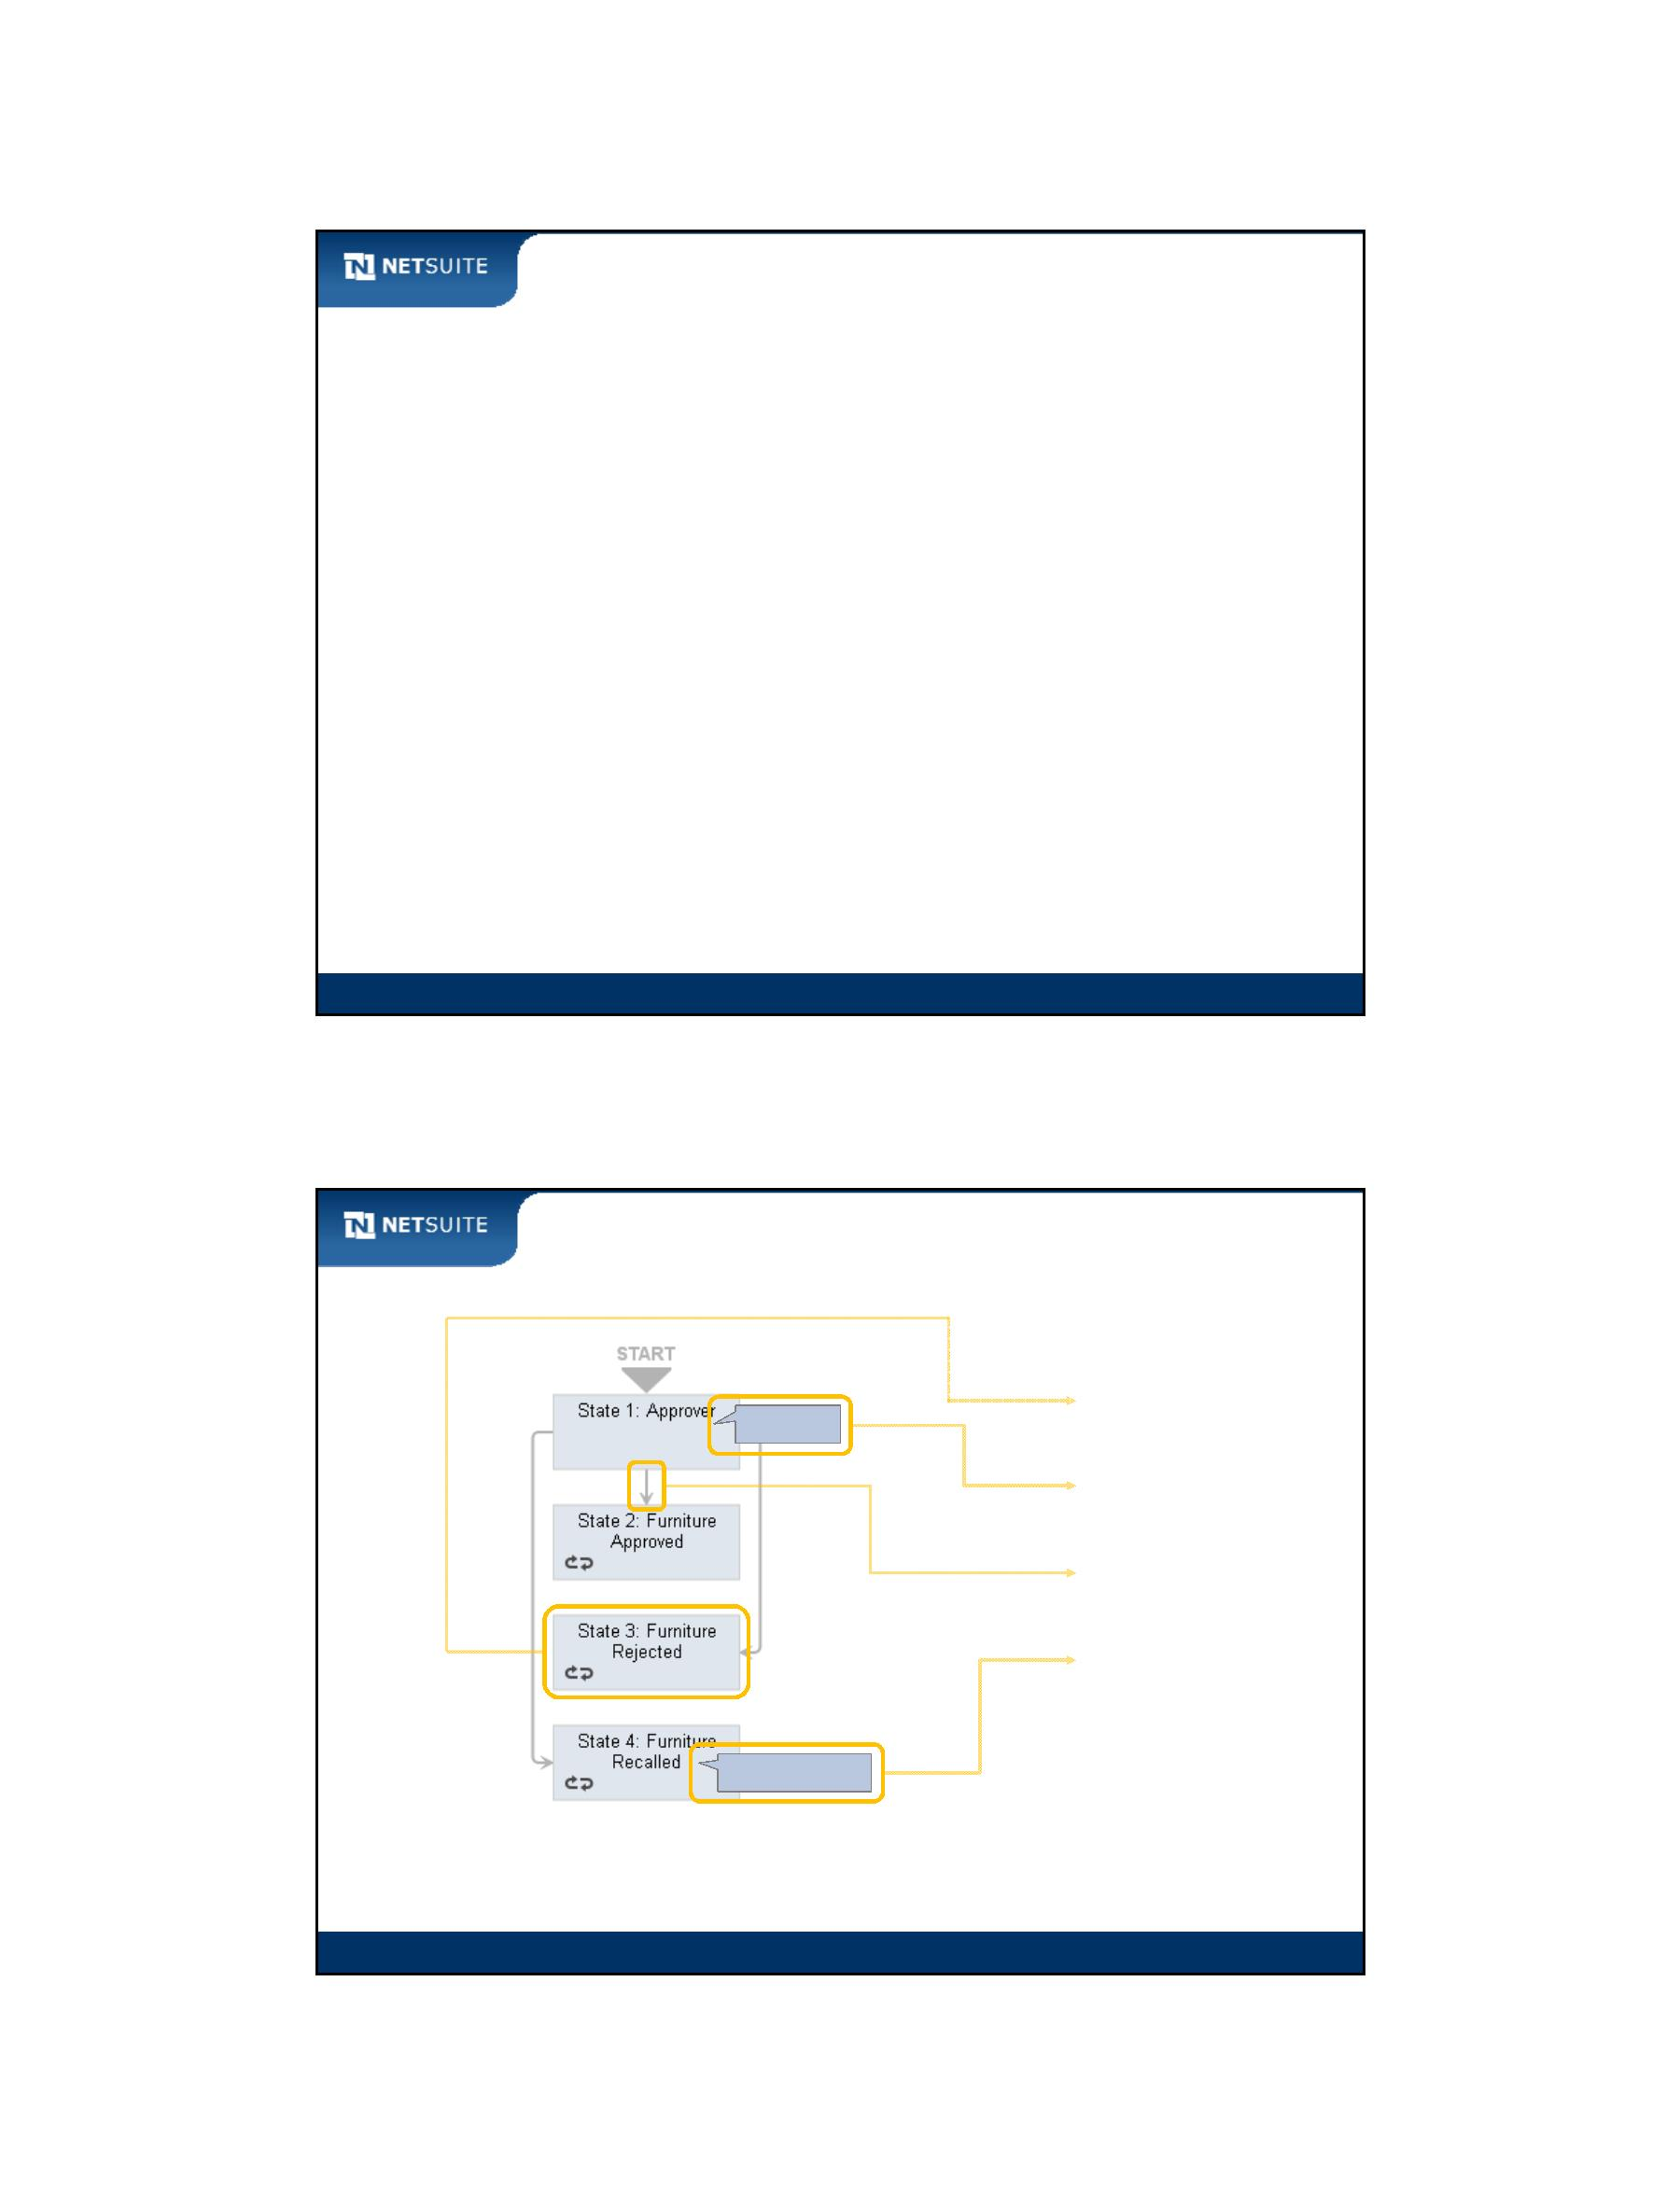

SuiteScript

A snapshot of workflow standard actions

Standard Action

What it Does

SuiteScript API

Create Record

Go To Record

create records

nlapiCreateRecord

navigate end user to a different

record

nlapiSetRedirectURL

return an error message to the alert,

Return User Error

Send Email

end user

throw nlapiCreateError

send an email

nlapiSendEmail

Set Field Value

set a field value

nlapiSetFieldValue

Module 14: Workflow Action Scripts

5 of 16

5

Walk Through: Configure a Basic Workflow

Scenario:

Create a workflow for an expense report transaction

Upon saving the expense report transaction:

– navigate the end user to another expense report form

– default the Employee to the one from the existing expense report

– this increases productivity when multiple expense reports are to be

created

Skills Covered:

Enable workflow feature

Create a workflow

Navigate end user using the Go To Record action

Module 14: Workflow Action Scripts

6 of 16

6

Module 14: Workflow Action Scripts - 3

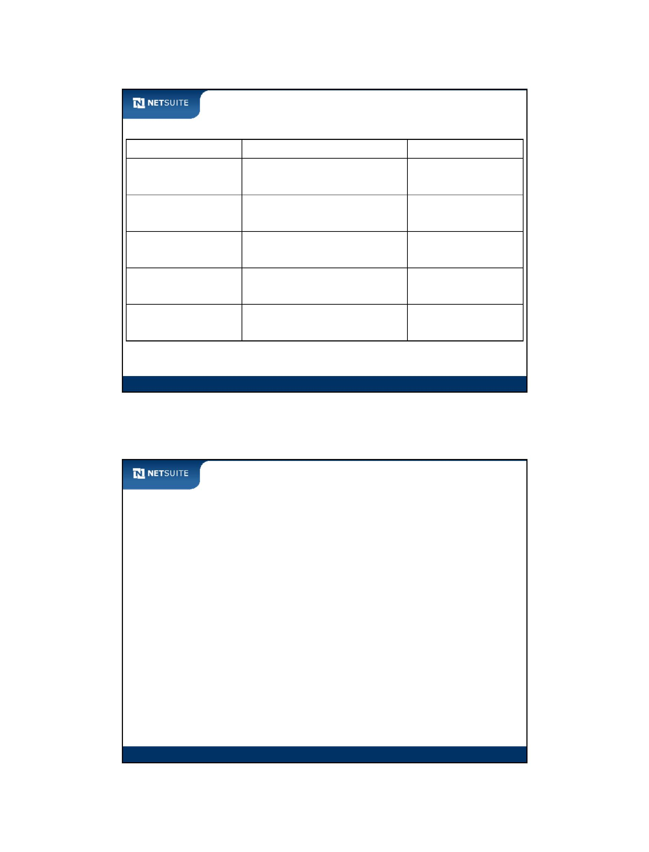

SuiteScript

When to Use a Custom Action

Use custom actions to…

access sublists

call a web service

update other records

initiate a workflow on related records

other complex business logic

Module 14: Workflow Action Scripts

7 of 16

7

Walk Through: Create a Workflow Action Script

Scenario:

Create a workflow action script to extend an expense report workflow

Script does the following:

– accept the expense report total as input from the workflow

– get the number of expense lines

– post the expense report total and number of expense lines to the Notes

field on the Info subtab of the related employee record

– return a script status to the workflow (whether or not the update failed)

Skills Covered:

Create a script of type Workflow Action

Module 14: Workflow Action Scripts

8 of 16

8

Module 14: Workflow Action Scripts - 4



SuiteScript

Activity: Complete Workflow Action Script

Complete the statements to return the script parameter, get the number of expense lines,

load the employee record, and update information to the employee record.

Module 14: Workflow Action Scripts

9

Walk Through: Extend Workflow with Custom Action

Scenario:

Extend the expense report workflow by executing the workflow action

script as a custom action

Skills Covered:

Configure a custom action in the workflow

Add transitions and states to process the result of a custom action

Module 14: Workflow Action Scripts

10 of 16

10

Module 14: Workflow Action Scripts - 5

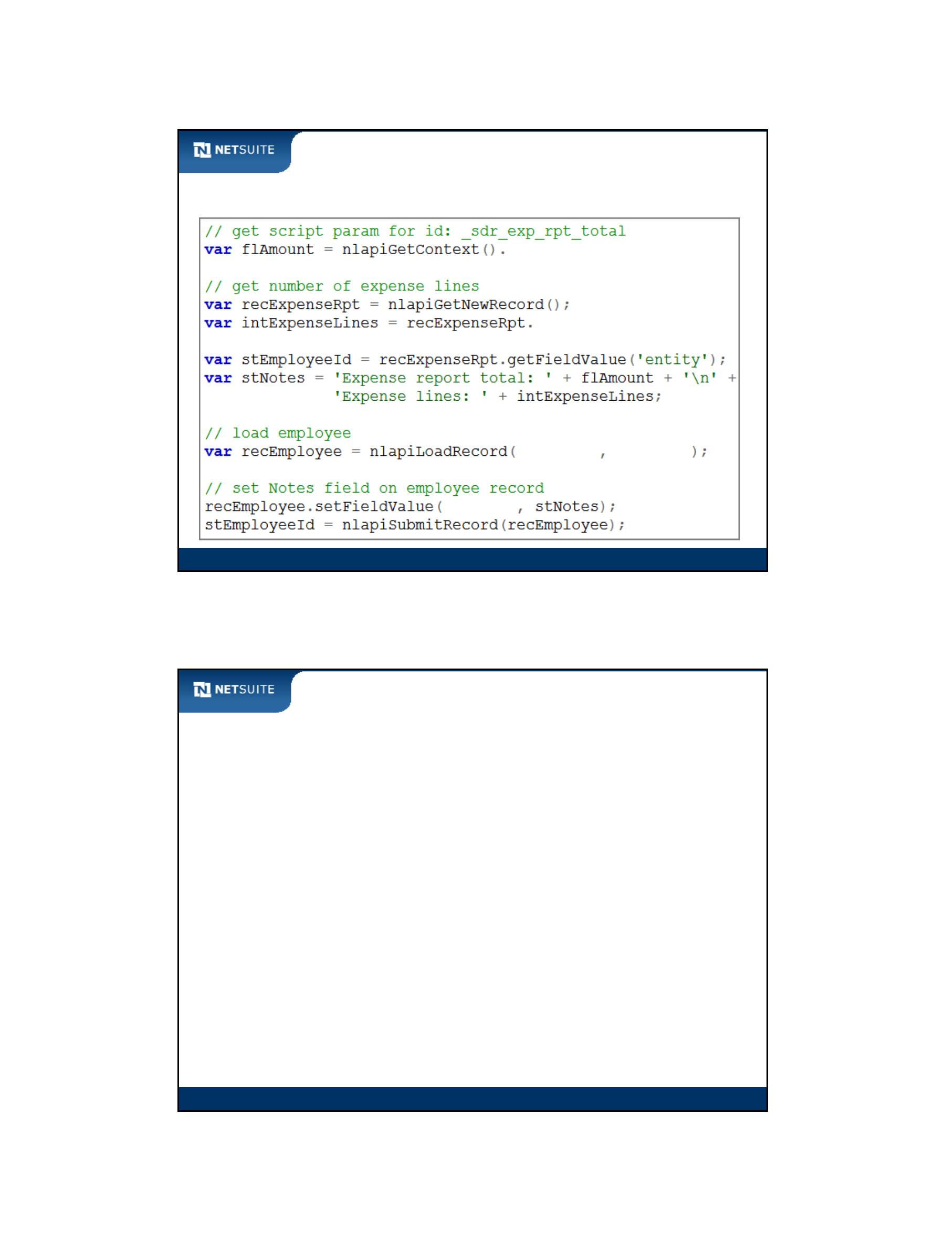

SuiteScript

Activity: Configuring a Custom Action

List everything you need to do to apply a new custom action to an existing workflow, a

custom action that accepts input and passes back a result.

Module 14: Workflow Action Scripts

11 of 16

11

Best Practices: Custom Actions

Only use custom actions in your workflows when you cannot do the

same thing through standard actions

Be careful about how you name the script record, as this is what

appears to the workflow end user

Module 14: Workflow Action Scripts

12 of 16

12

Module 14: Workflow Action Scripts - 6



SuiteScript

Now It’s Your Turn

In these hands on exercises, you practice:

Creating a basic workflow

Building a custom workflow action script

Extending a workflow by executing a custom action

Module 14: Workflow Action Scripts

13 of 16

13

Module 14: Workflow Action Scripts - 7



SuiteScript

Module 15: Front‐End Suitelets

Objectives

Upon completing this module, you should be able to:

Create a Suitelet using the NetSuite form object

Redirect from one form to another

Process URL parameters

Add client‐side script to a suitelet

Module 15: Front‐End Suitelets

2

Module 15: Front-End Suitelets - 1



SuiteScript

Web Concepts: Request and Response

Client (browser)

request

response

Server

Module 15: Front‐End Suitelets

3

Web Concepts: Request and Response continued

Client (browser)

GET request

POST request

response

ASP, JSP, PHP, Java Servlet,

NetSuite Suitelet

Module 15: Front‐End Suitelets

4

Module 15: Front-End Suitelets - 2

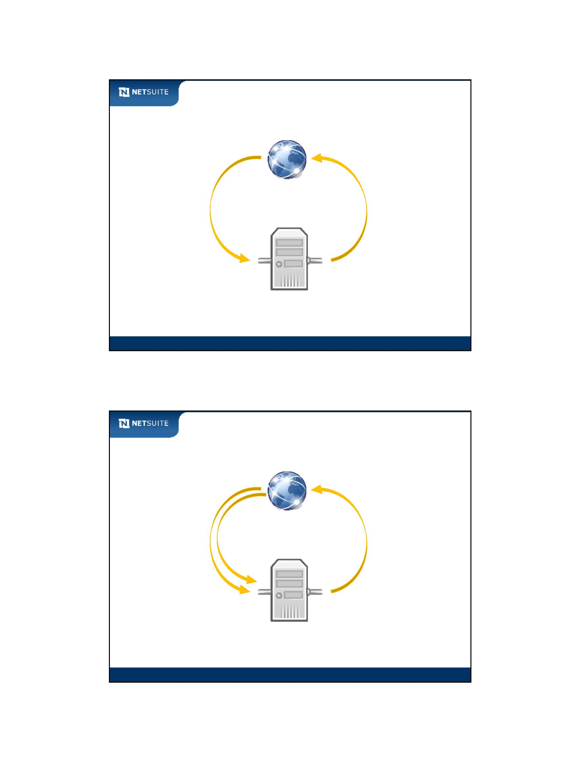

SuiteScript

Web Concepts: GET and POST details

GET

URL parameters encoding on query string

POST

URL parameters in body of request

Module 15: Front‐End Suitelets

5

Overview of Suitelets

Suitelets are designed to…

Process a request

Send a response

Differentiate processing based on GET or POST

Process parameters from a request

Package up parameters for a response

Module 15: Front‐End Suitelets

6

Module 15: Front-End Suitelets - 3

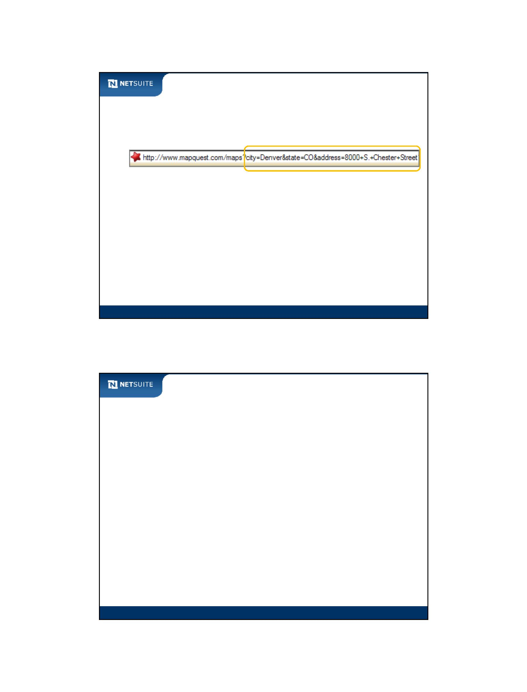

SuiteScript

Types of Front‐End Suitelets

Front‐end

NetSuite UI Forms (module 15 exercises)

NetSuite UI Lists

Pure HTML

XML

Module 15: Front‐End Suitelets

7

UI Suitelets versus Client/User Event scripts

Suitelet scripts

Create new forms

Client scripts / User Event scripts

Customize existing forms

Associated with record type

NetSuite UI elements only

Not associated with record type

Custom HTML

Module 15: Front‐End Suitelets

8

Module 15: Front-End Suitelets - 4

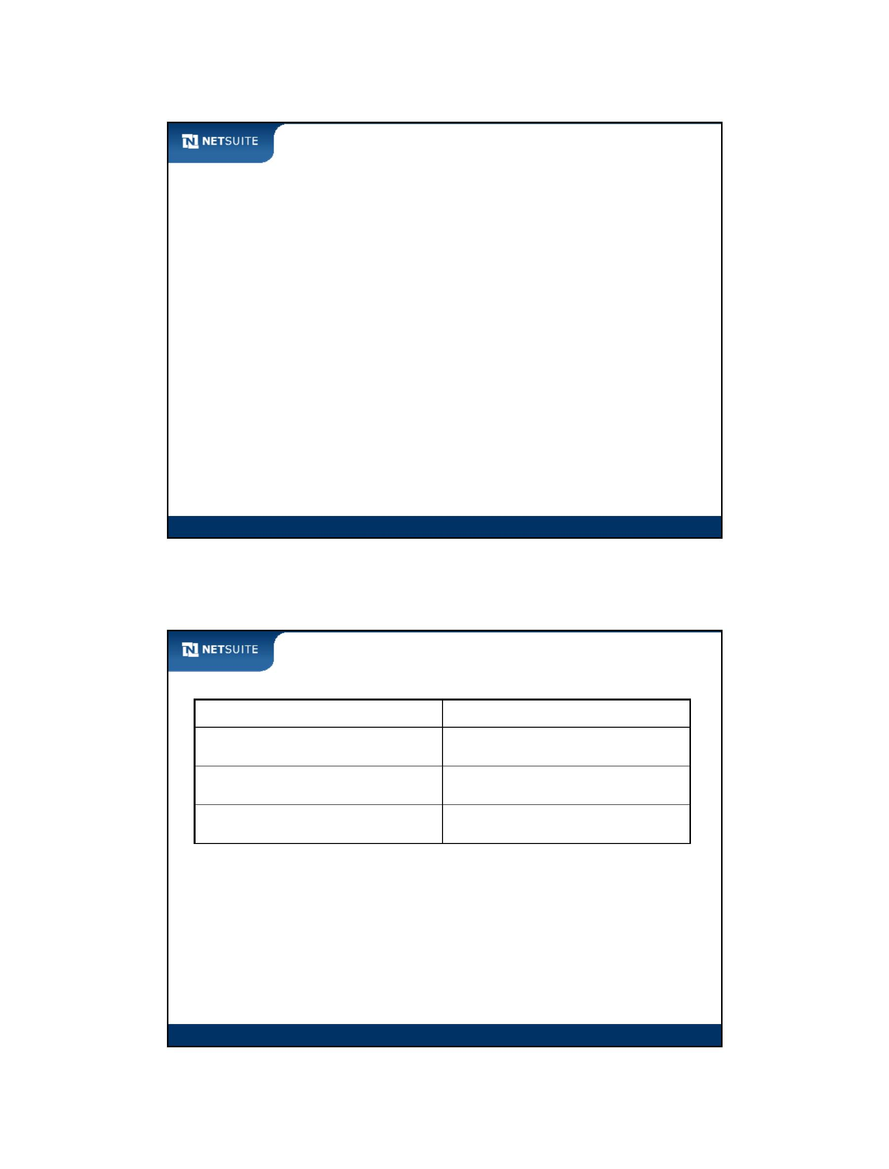

SuiteScript

Processing a Suitelet GET Request

Custom Suitelet

Field 1

Submit

Field 2

Field 3

Field 4

UserEventX.js

1

AfterSubmit

CustomSuitelet.js

Process GET

2

Process POST

Module 15: Front‐End Suitelets

9

Processing a Suitelet POST Request

Custom Suitelet

Field 1

Field 2

Field 3

Field 4

Submit

3

CustomSuitelet.js

Employee.js

4

Process GET

BeforeLoad

Process POST

Module 15: Front‐End Suitelets

10

Module 15: Front-End Suitelets - 5

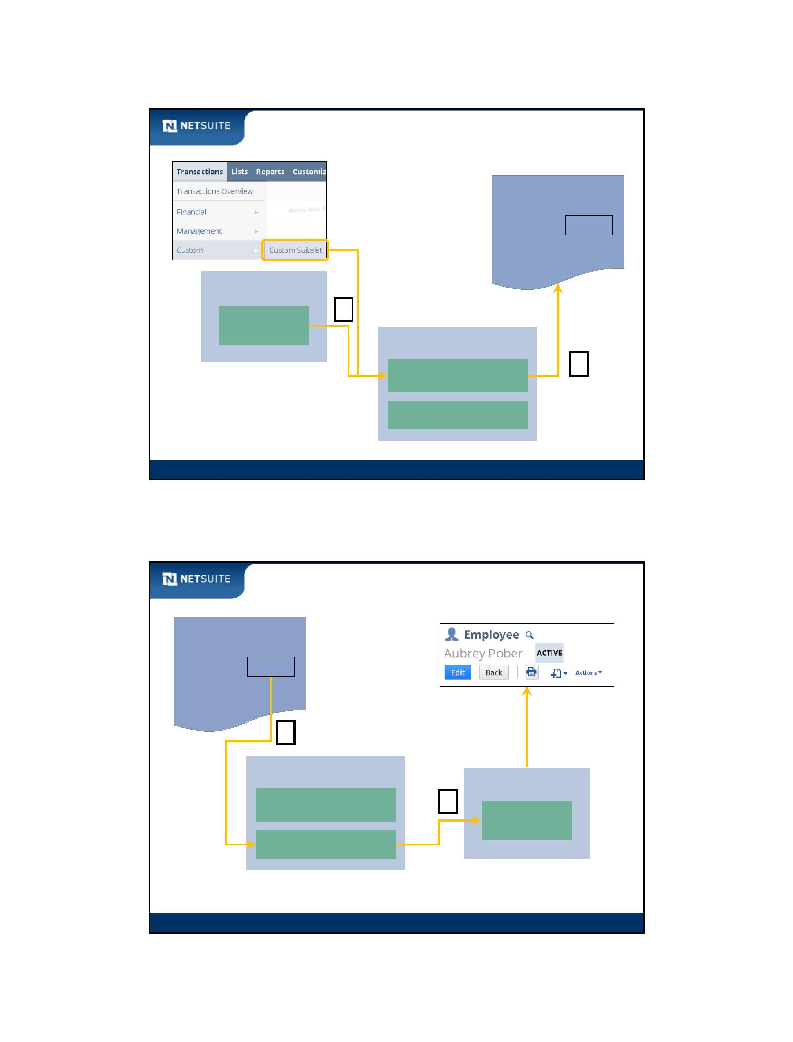

SuiteScript

Walk Through: Configure a Form Suitelet

Scenario:

Create a Suitelet to allow updating of employee notations

Upon saving an employee:

– redirect to Suitelet form, displaying employee data

– allow update of the employee notes

Upon submitting the Suitelet

– update employee record and redirect back to employee

Skills Covered:

UI Form Suitelets

URL Parameters

Redirection

Module 15: Front‐End Suitelets

11

Form and Field objects

Form is a collection of Field objects

Use methods to construct Field objects on Forms

Use methods to set attributes on Field objects

Form frmX

Field fruitFld

frmX.addField (‘fieldFruit’,’text’,’apple’);

Field vegFld

frmX.addField(‘fieldVeg’,’text’,’carrot’);

Field fruitFld

fieldFruit.setLabel (‘fruit’)

fieldFruit.setMandatory (true)

Module 15: Front‐End Suitelets

12

Module 15: Front-End Suitelets - 6

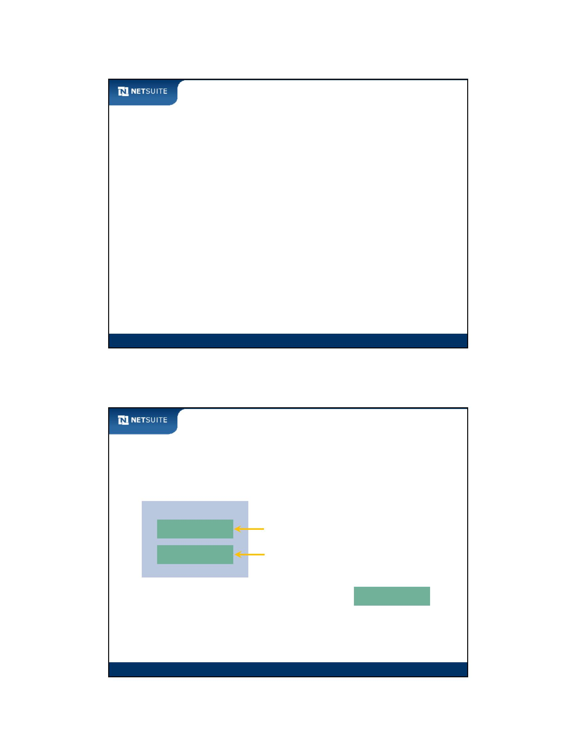

SuiteScript

Best Practices

Parameter fields (URL parameters) are defined with a prefix of

custparam

Fields on a Suitelet form are defined with a prefix of custpage

Prefer Suitelets built with the NetSuite UI form object over custom

HTML

Module 15: Front‐End Suitelets

13

Sales Order Financing (GET)

Sales Order

Financing Suitelet

Customer

Date

Order #

Total

Customer

Submit

Txn Date

Save

Sales Order #

Sales Order Total

Financing Price

SalesOrder.js

FinancingSuitelet.js

Process GET

AfterSubmit

form.addField(‘Customer’)

form.setTitle

nlapiSetRedirectURL

Module 15: Front‐End Suitelets

14

Module 15: Front-End Suitelets - 7

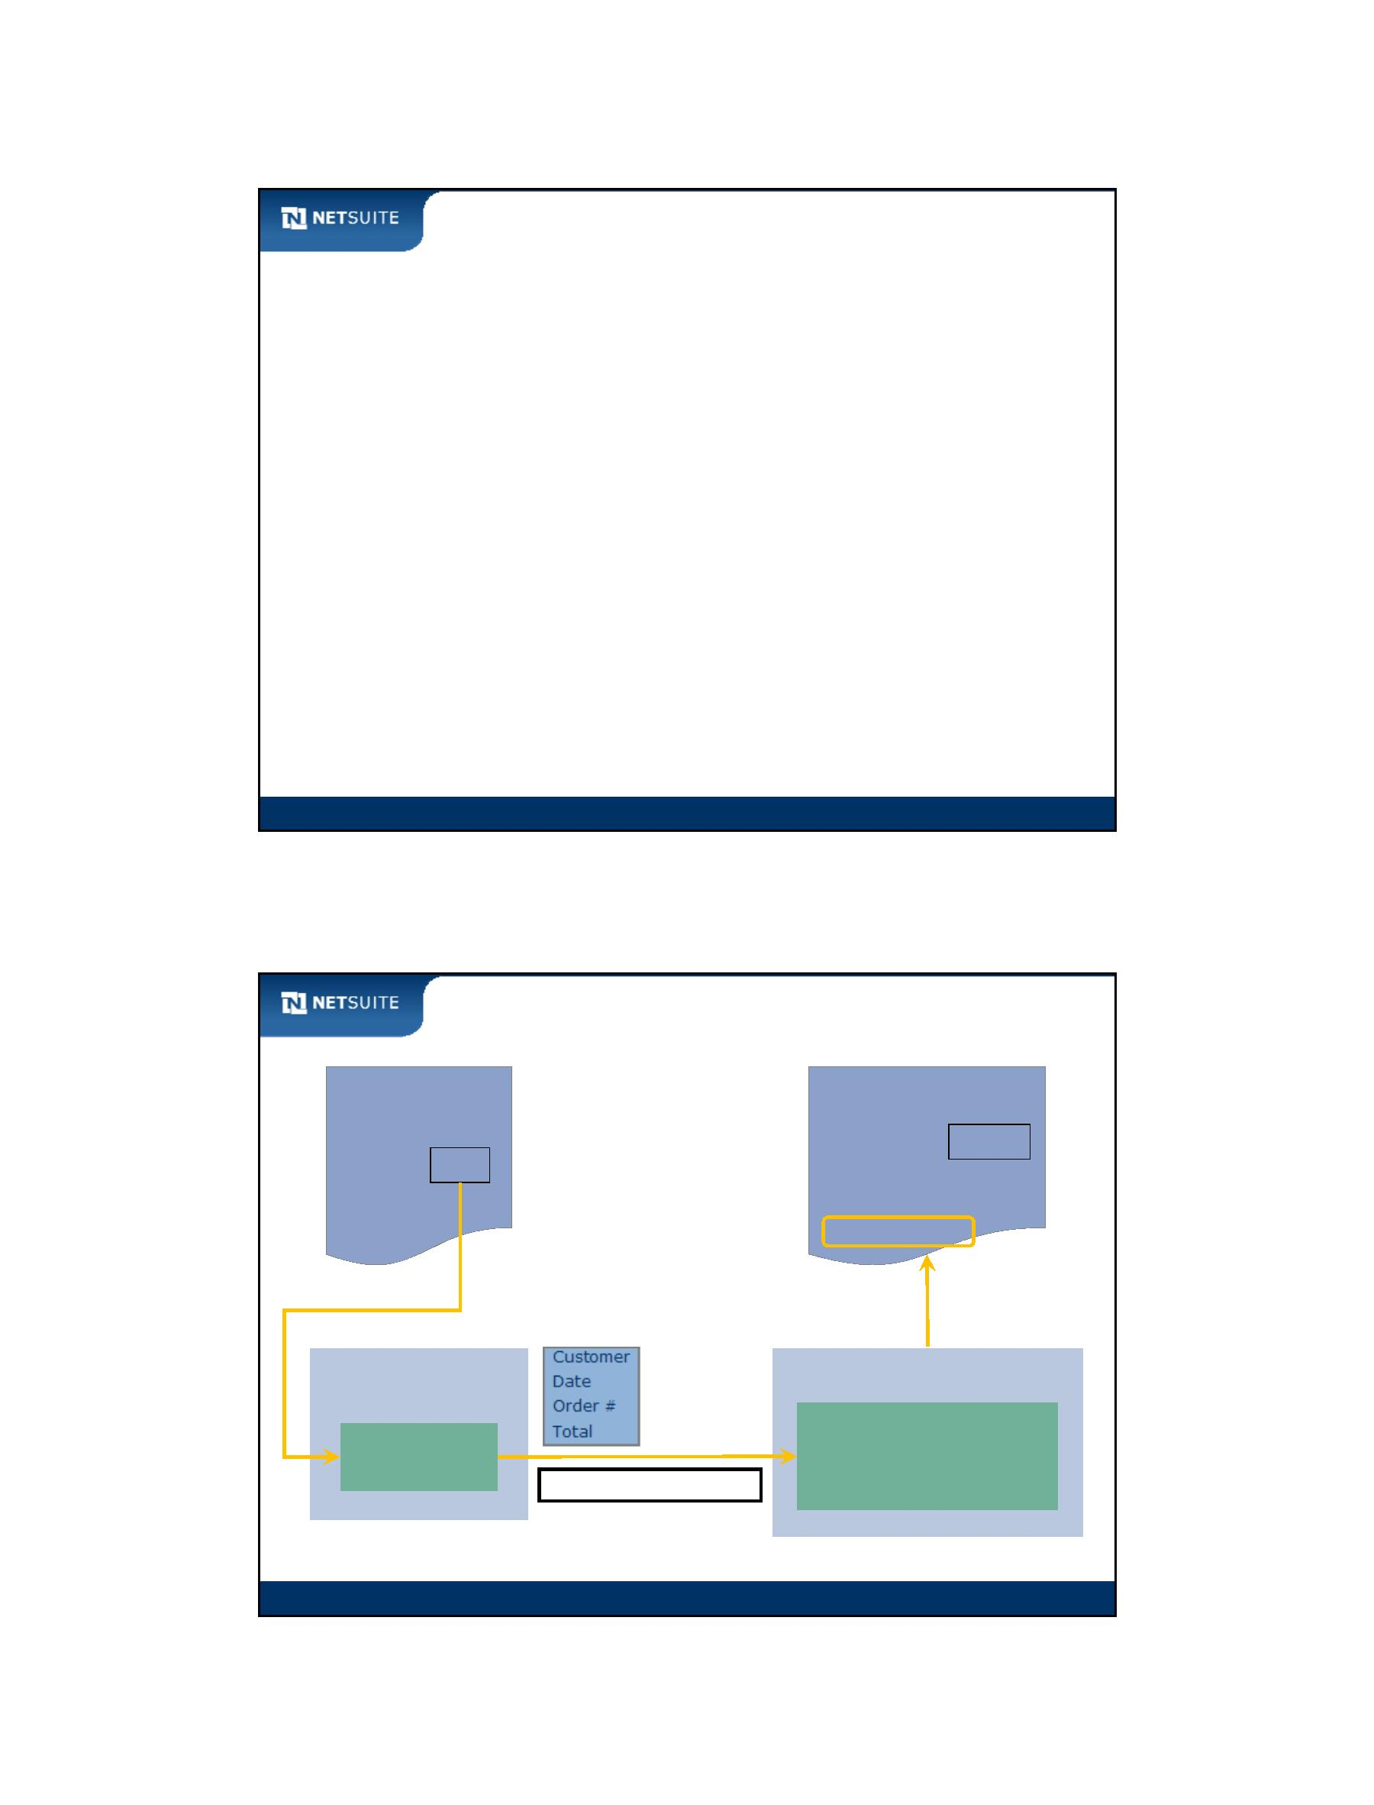

SuiteScript

Sales Order Financing (POST)

Financing Suitelet

Sales Order

Customer

Txn Date

Sales Order #

Sales Order Total

Financing Price

Customer

Date

Order #

Total

Submit

Save

Financing Price

FinancingSuitelet.js

SalesOrder.js

nlapiSetRedirectURL

Database

Proces POST

BeforeLoad

Module 15: Front‐End Suitelets

15

Now It’s Your Turn

In these hands on exercises, you practice:

Progressively building out a Suitelet over several exercises

Generating a NetSuite form during a suitelet GET request

Processing a suitelet POST request

Attaching a client‐side script to a suitelet

Module 15: Front‐End Suitelets

16

Module 15: Front-End Suitelets - 8

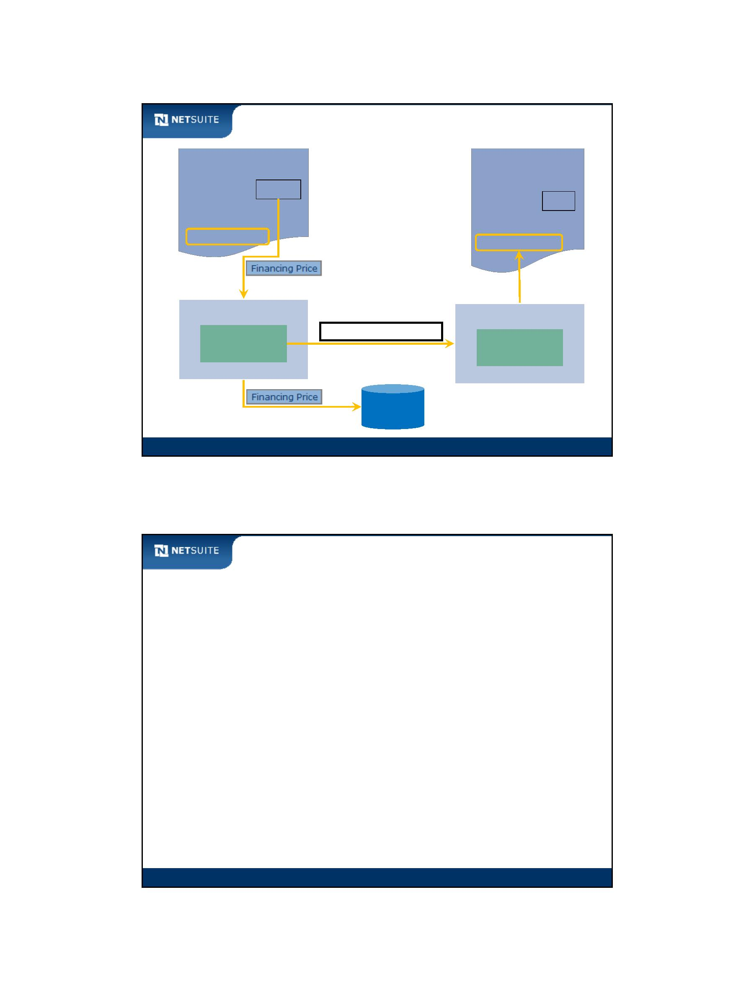

SuiteScript

Module 16: Back‐End Suitelets

Objectives

Upon completing this module, you should be able to:

Create a Suitelet that executes business logic (no UI)

Request a Suitelet from a client‐side script

Alter client‐script based on Suitelet response

Module 16: Back‐End Suitelets

2

Module 16: Back-End Suitelets - 1



SuiteScript

What is a Backend Suitelet?

Back‐end

No user interface

Execute business logic, then return response (Web Service)

Hide business logic on client validations

Module 16: Back‐End Suitelets

3

Walk Through: Configure Back End Suitelet

Scenario:

Create a Suitelet to validate employee code

Skills Covered:

Requesting Suitelet from client‐side script

Module 16: Back‐End Suitelets

4

Module 16: Back-End Suitelets - 2



SuiteScript

Best Practices

Prefer Suitelets to execute your client‐side business logic

Single JavaScript implementation

Secures business logic

Module 16: Back‐End Suitelets

5

Now It’s Your Turn

In these hands on exercises, you practice:

Build a back‐end Suitelet to validate the coupon code

Module 16: Back‐End Suitelets

6

Module 16: Back-End Suitelets - 3



SuiteScript

Module 17: Best Practices and Review

Best Practices

Error Handling

SuiteScript Governance

Script Filtering

Development Life Cycle

Additional Resources

Module 17: Best Practices and Review

2

Module 17: Best Practices and Review - 1

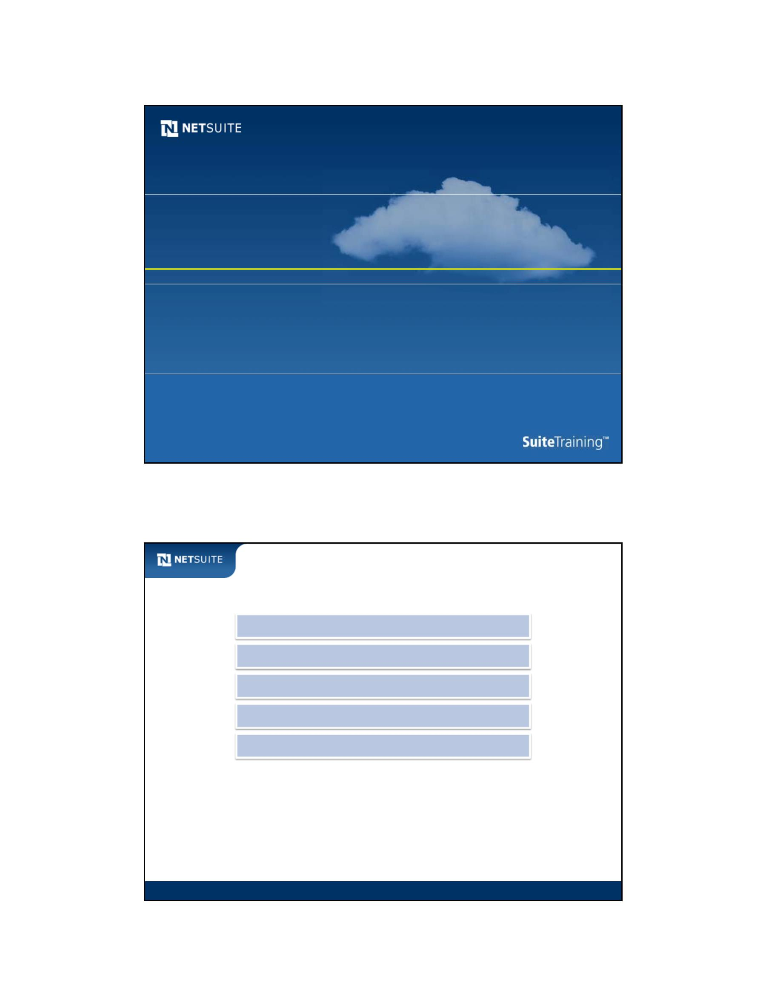

SuiteScript

Exception Handling

Implementing exception handling:

try/catch blocks

NetSuite errors versus JavaScript errors

NetSuite error object

JavaScript instanceof statement

Module 17: Best Practices and Review

3

Exception Handling Example – Client Script

Causes NetSuite

exception

NetSuite error object

getCode and getDetails

methods for NetSuite errors

Property for

JavaScript errors

Module 17: Best Practices and Review

4

Module 17: Best Practices and Review - 2

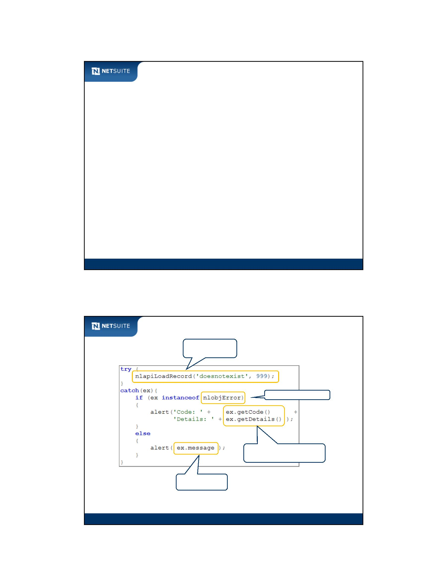

SuiteScript

Exception Handling Example – Server Script

Causes NetSuite exception

Re‐throw an error

Module 17: Best Practices and Review

5

Governance – What and Why

Governance is about…

usage unit consumption with API functions

usage unit restrictions on scripts

Governance exists to…

optimize server performance

Module 17: Best Practices and Review

6

Module 17: Best Practices and Review - 3

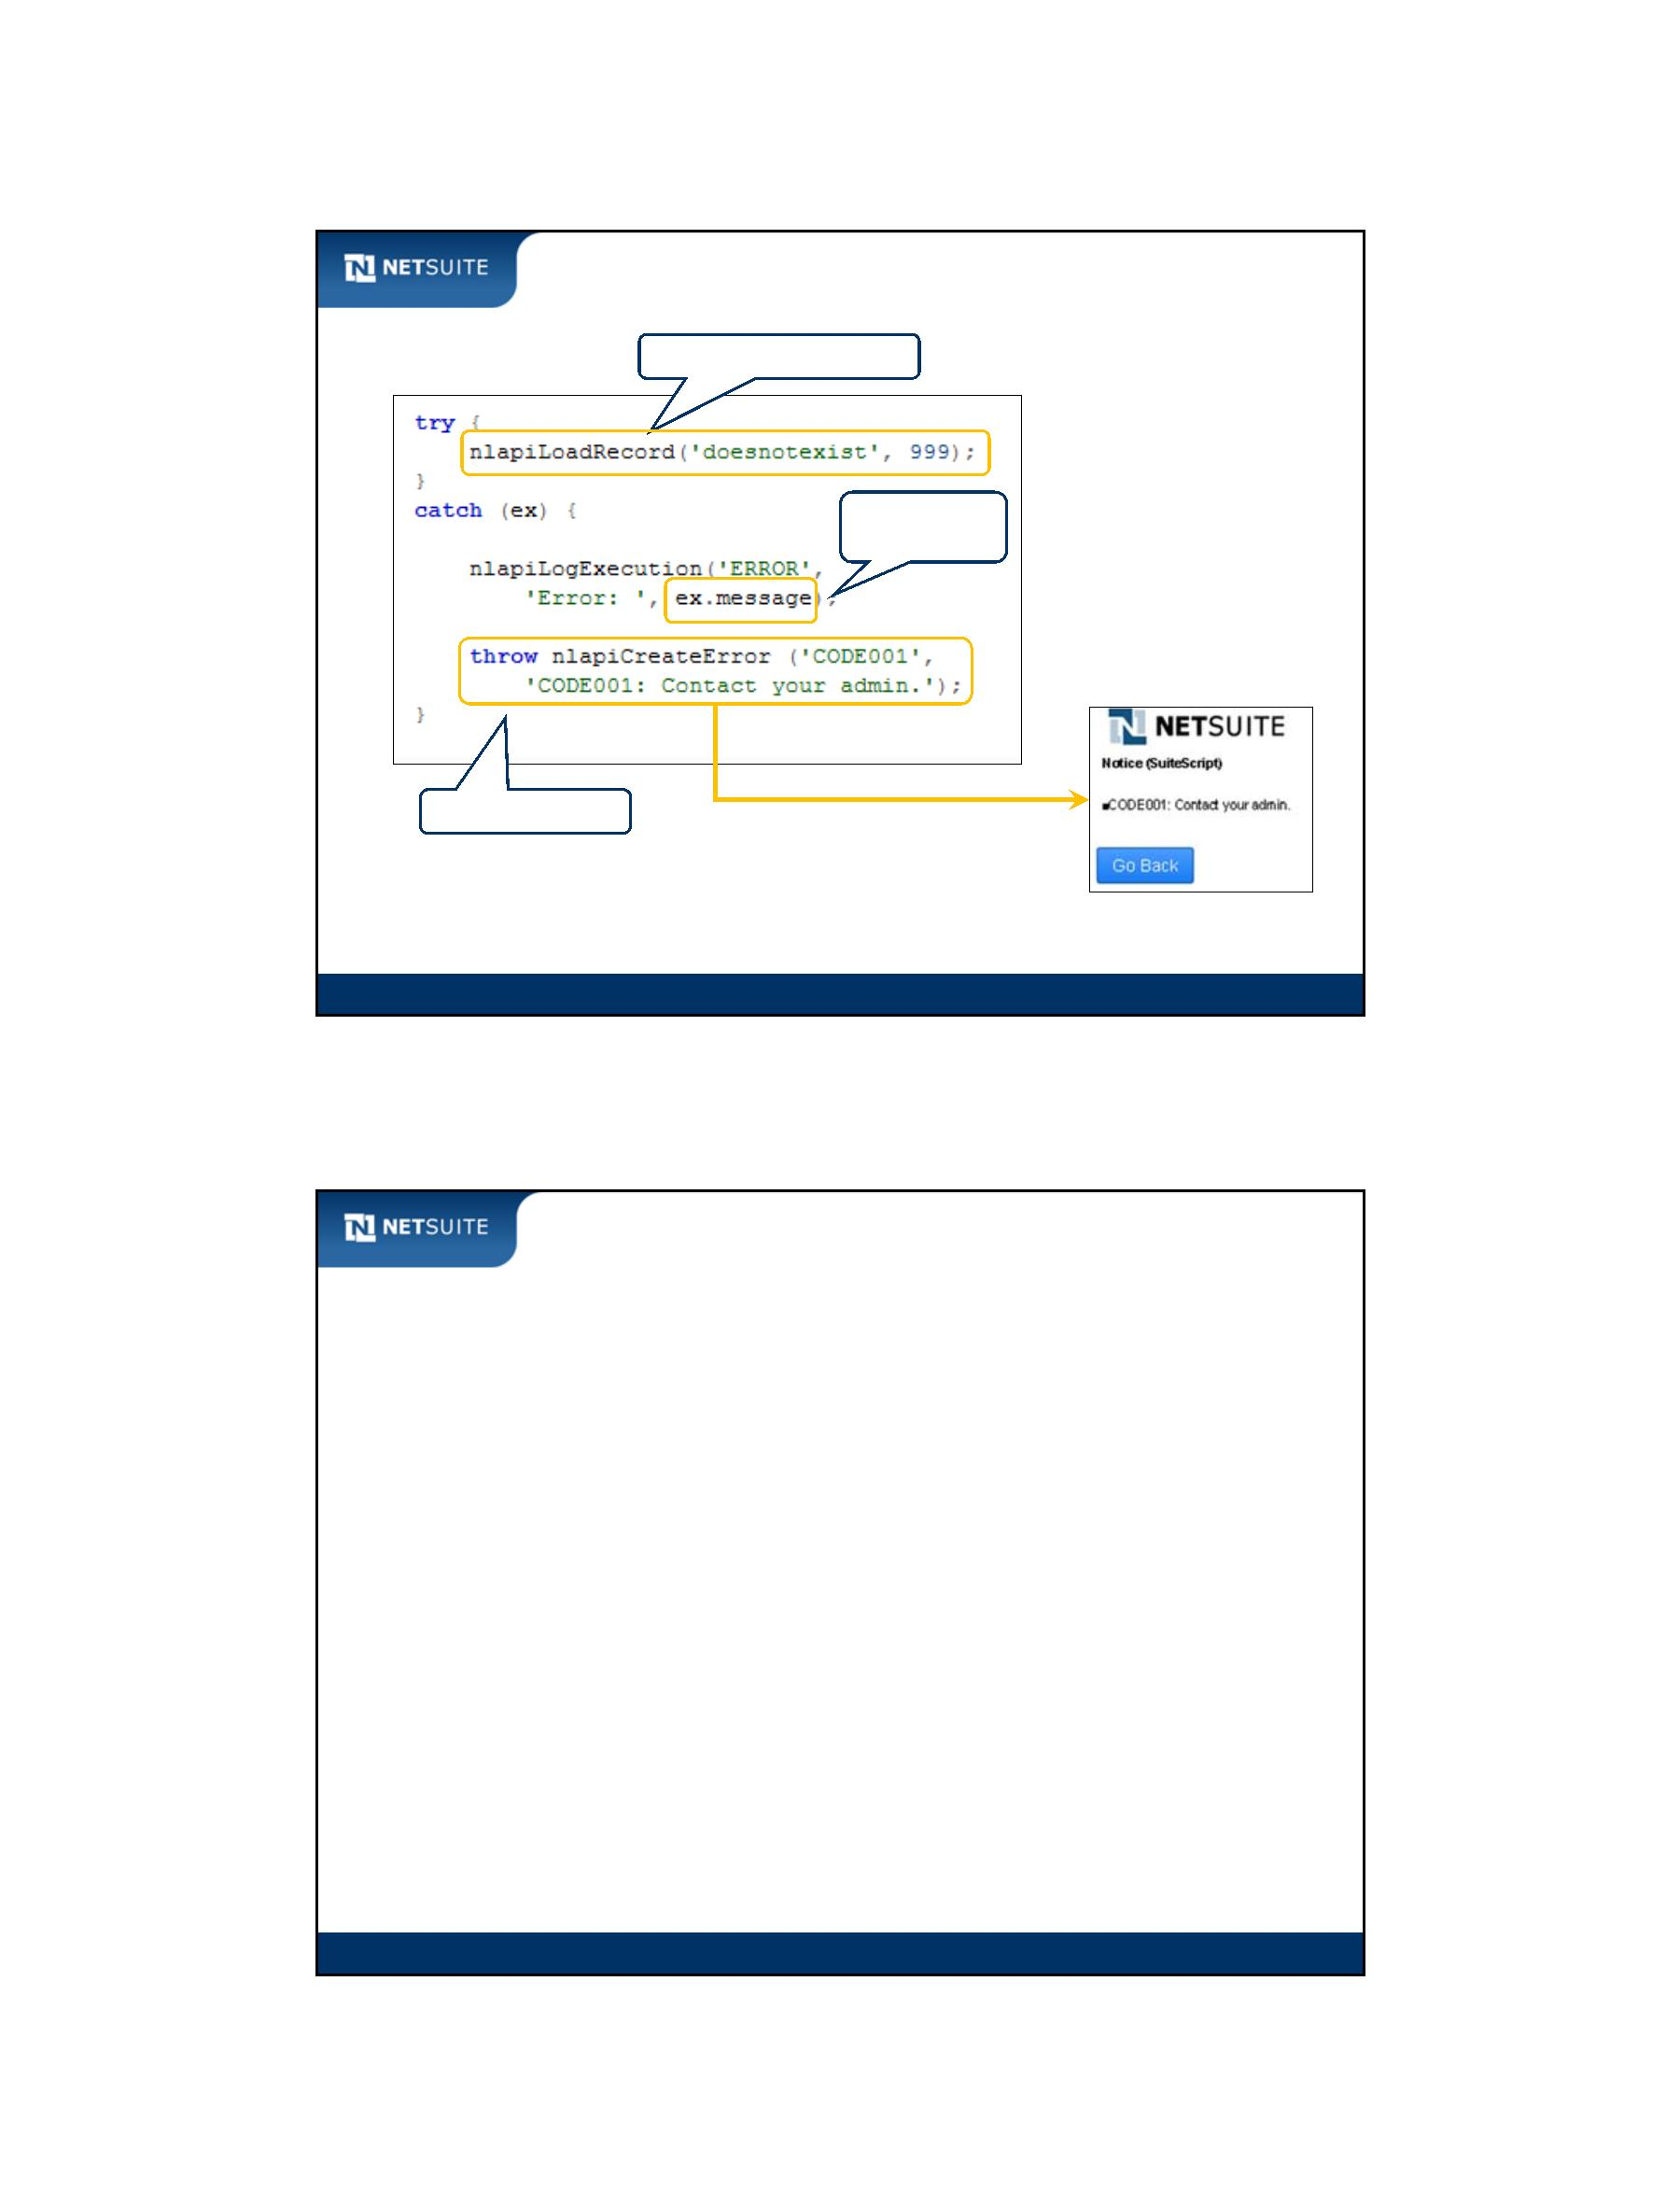

SuiteScript

Governance ‐ Optimizing Unit Usage

Prefer nlapiSubmitField over nlapiLoadRecord + nlapiSubmitRecord

Call nlapiScheduleScript

Use Mass Update scripts when applicable

Module 17: Best Practices and Review

7

Script Filtering – What and Why

Script filtering restricts script execution based on…

event type

execution context

attributes of current user

Incorporate script filtering to…

execute scripts only when you intend to

Module 17: Best Practices and Review

8

Module 17: Best Practices and Review - 4



SuiteScript

Script Filtering – Execution Context

User

Interface

Portlet Scheduled Suitelet Mass Update CSV Import

Script

Script

Script

Script

Wizard

triggers (clicking Save, call nlapiSubmitRecord)

if Execution Context equals Scheduled then

…

triggers (web service operations: add, update)

executes

Application

Web Service

Module 17: Best Practices and Review

9

Script Filtering ‐ nlobjContext

**nlobjContext Method Filtering Usage**

getDepartment

getDeploymentId

getExecutionContext

getLocation

End user department

Currently executing script deployment

How user event script is executed

End user location

getFeature

Is feature enabled?

getPermission

getSubsidiary

Does end user have permission?

End user subsidiary. Available in

OneWorld.

Module 17: Best Practices and Review

10

Module 17: Best Practices and Review - 5

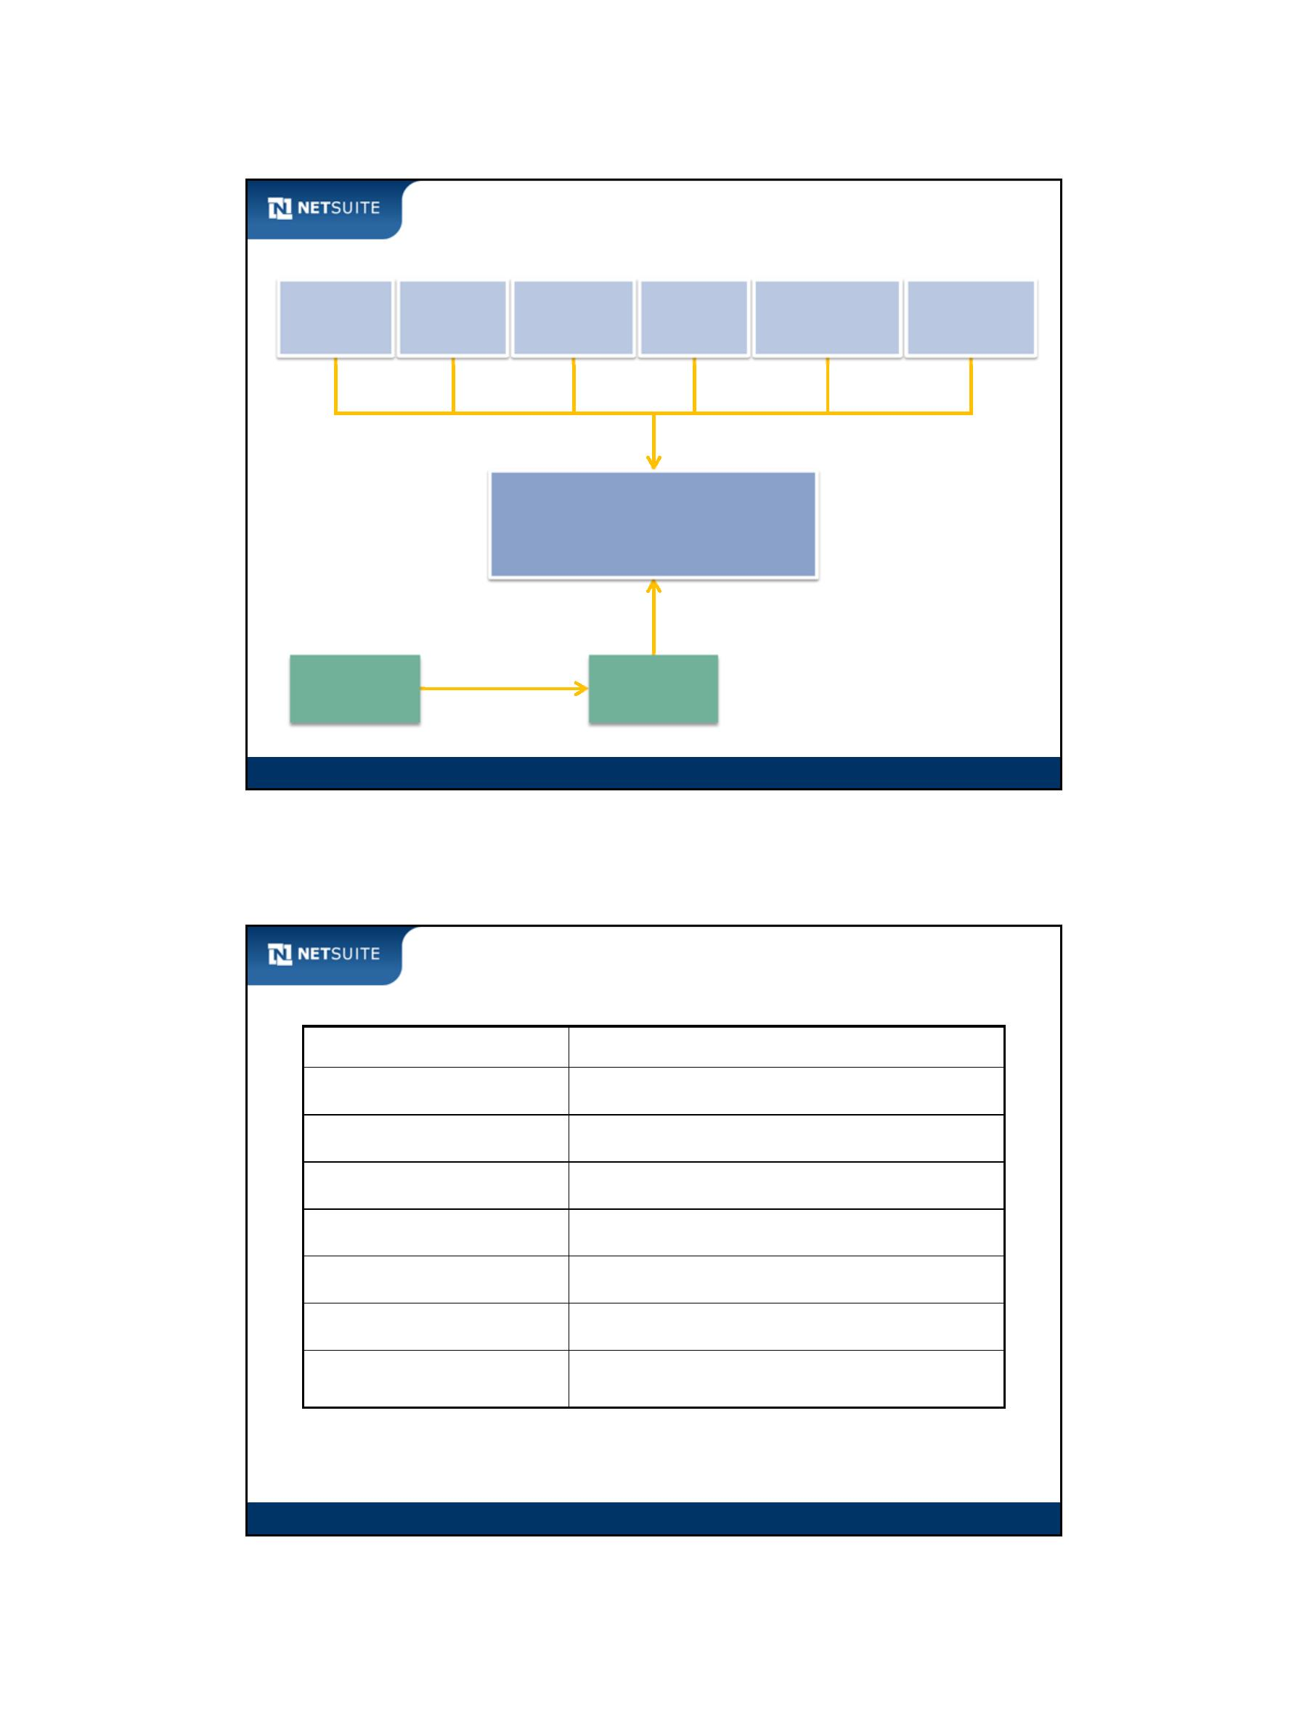

SuiteScript

Development Lifecycle

Production (No Sandbox)

Prepare test data

Sandbox

Develop scripts

DEV

Develop scripts

Test with end user roles

Set log levels

Test with end user roles

Set log levels

TEST

Release to limited audience Release to full audience

Bundle with SuiteBundler

Change released audience Deploy with SuiteBundler

to full audience

PROD

Module 17: Best Practices and Review

11

Course Objectives Review

You should now be able to:

Automate forms through client, user event, and Suitelet scripts

Incorporate a foundational set of SuiteScript functions in your scripts

Manipulate sublists

Integrate searches with scripts

Implement batch processing through scheduled scripts

Create custom actions that extend workflows (SuiteFlow)

Make use of back‐end Suitelets

Test and debug scripts through client and server‐side debugging tools

Develop scripts that incorporate a variety of best practices

Module 17: Best Practices and Review

12

Module 17: Best Practices and Review - 6

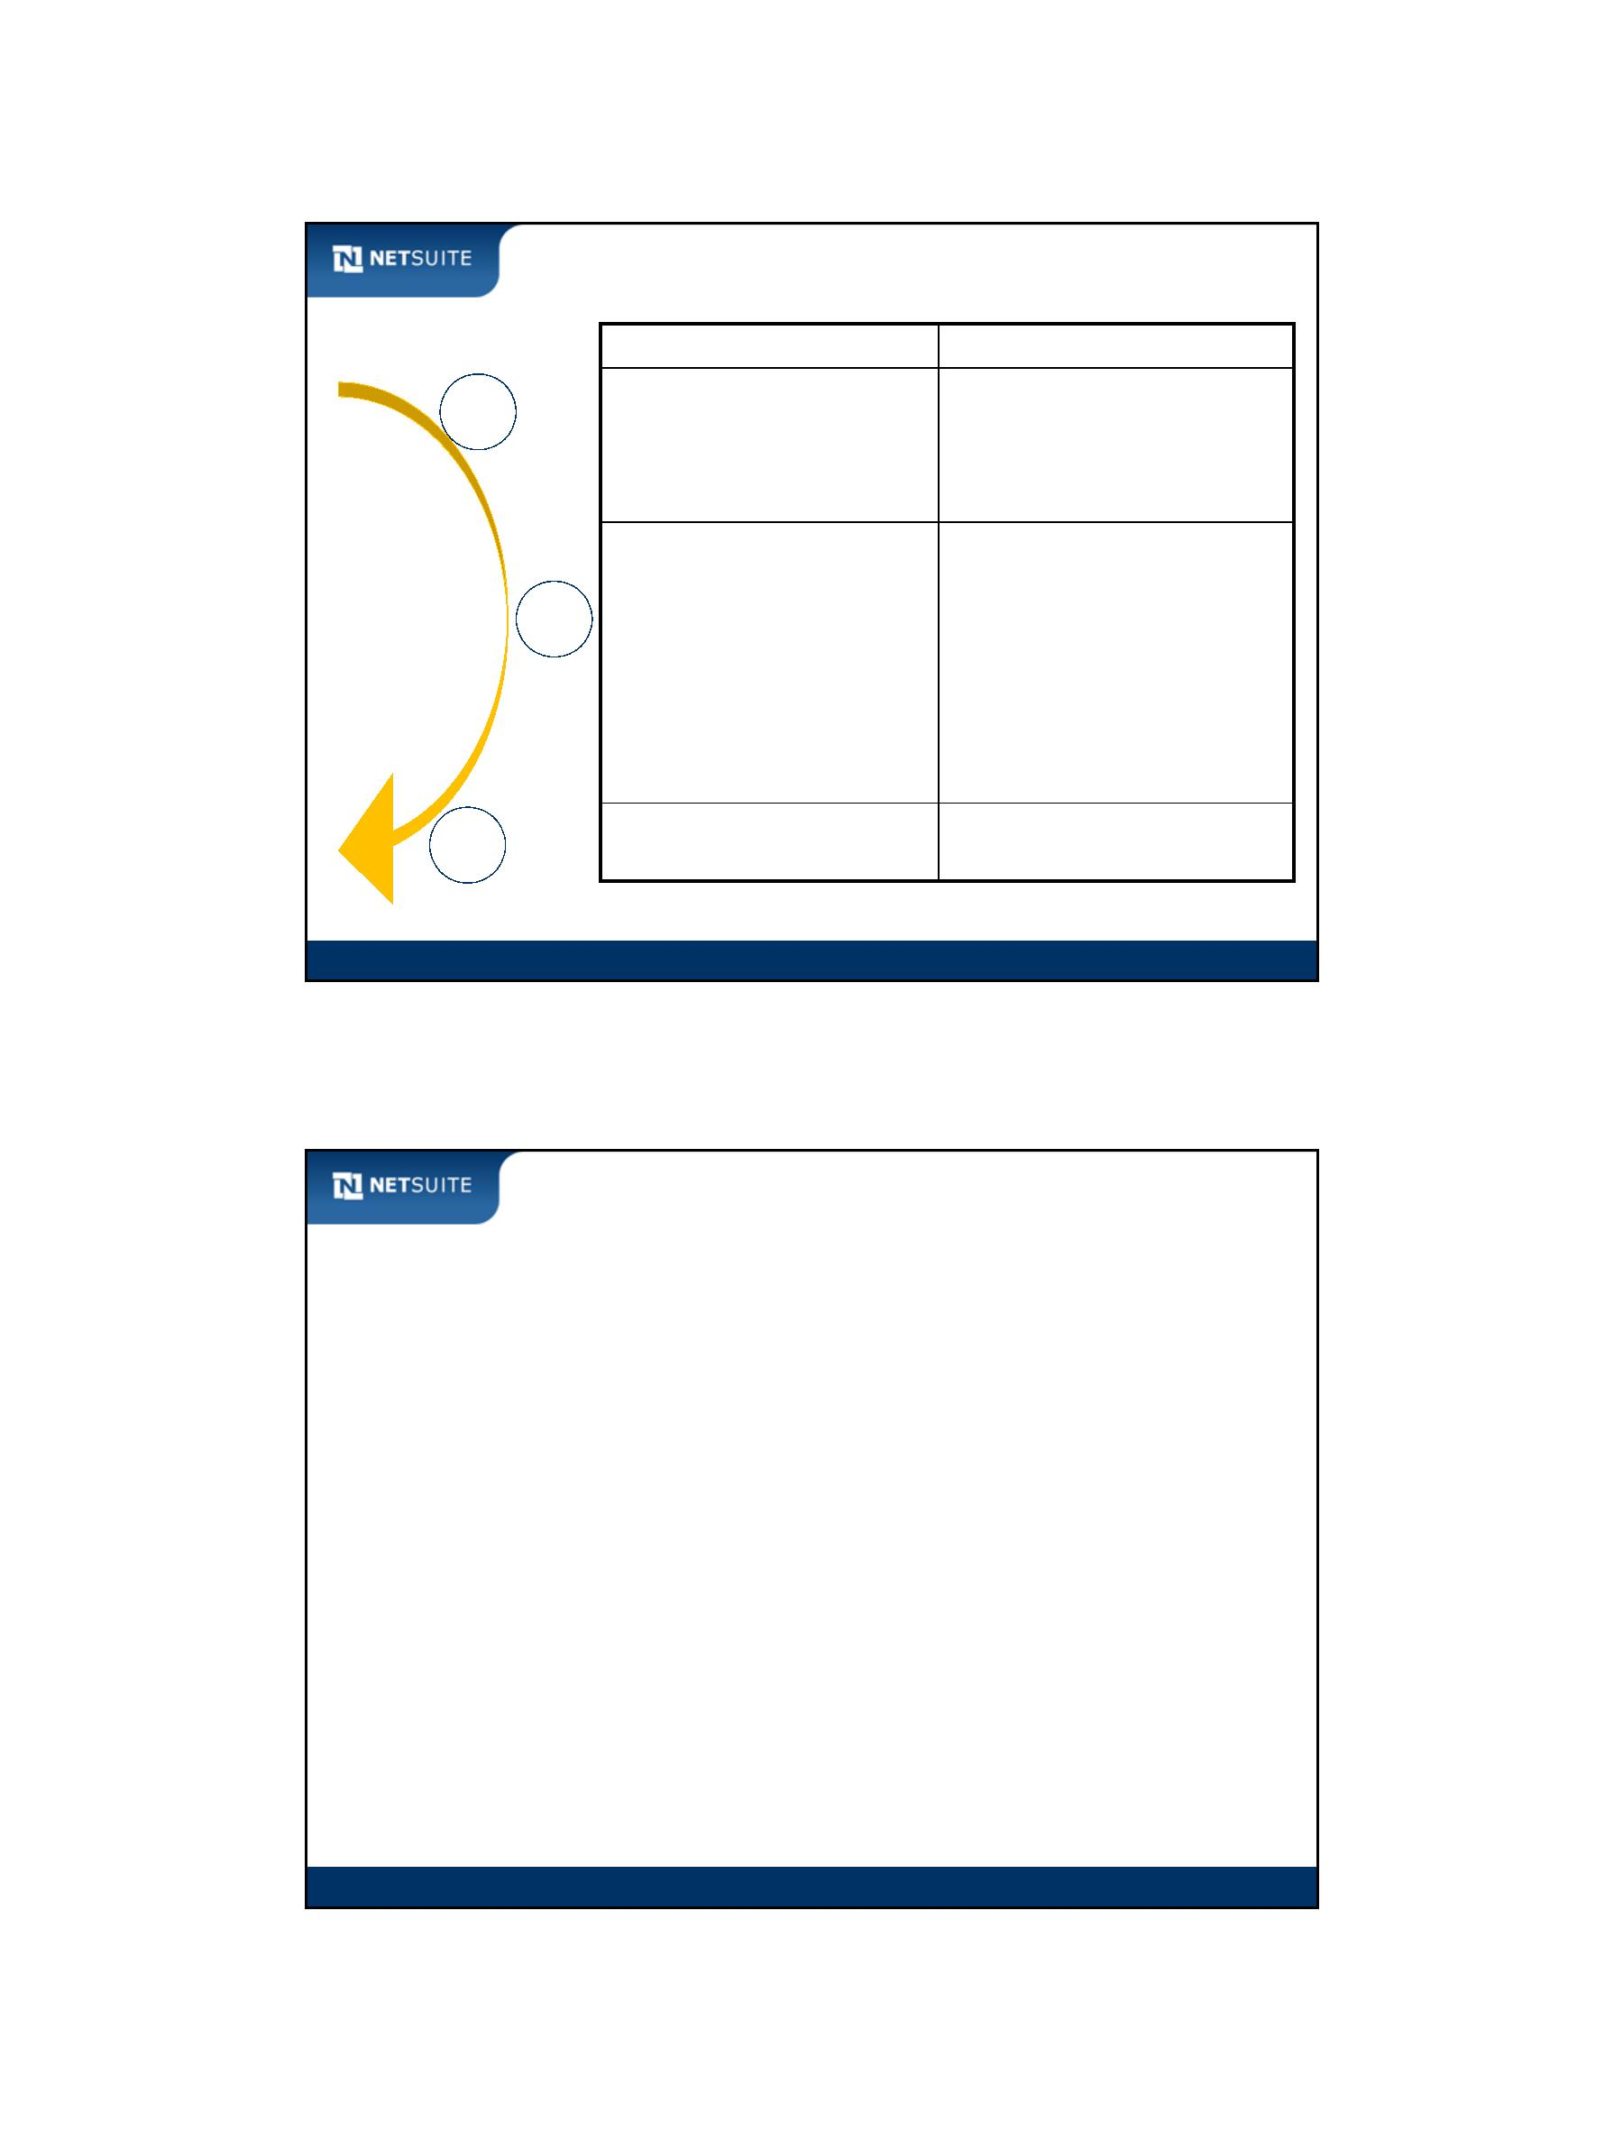

SuiteScript

Activity: Enter Other Best Practices

Module 17: Best Practices and Review

13

Activity: List your Top Takeaways

Module 17: Best Practices and Review

14

Module 17: Best Practices and Review - 7



SuiteScript

Additional Resources…

Other training and information resources:

NetSuite Help Center

SuiteAnswers

SuiteTraining Course Offerings

Training Webinar Series

NetSuite User Group

NetSuite Technical Support

Support > Visit the SuiteAnswers Site

Implementation resources:

NetSuite Professional Services

NetSuite Partner Channel

Support > NetSuite User Group

Module 17: Best Practices and Review

15

New Feature Training

NetSuite changes! New features

become available twice a year

Be sure to take advantage of

new features as they become

available

Read the Release Notes in the

Support > Help > Release Notes

Help Center

Watch New Feature training

to get the most out of new

features – go to the New

Feature Training category in

the Suite Answers Learning

Center

Support > Visit the SuiteAnswers Site > Learning Center

Module 17: Best Practices and Review

16

Module 17: Best Practices and Review - 8

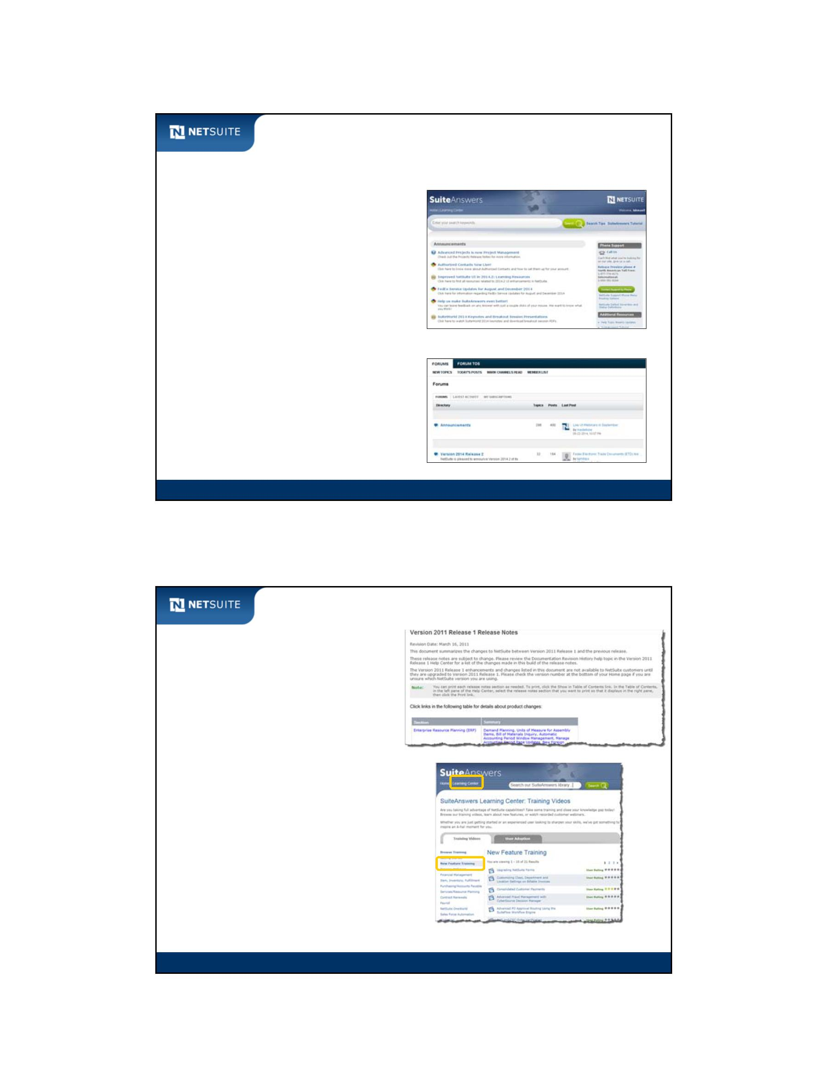

SuiteScript

Complimentary Education Assessment!

From our Education Advisor

Why should we assess your training needs?

This benefit is FREE

Assessing the skill set of your team and then sharpening their knowledge will result in

higher productivity and return on investment.

Untrained users cost at least five times more to support than trained users

Two‐thirds of enterprises will pay informal training costs (out of the support budget) that

are at least 20 times higher than would have been required for up‐front formal training.”

70% of companies cite the most critical factor for new software implementation success

and ROI is effective training and user adoption

Available Assessment times are filling up quickly.

Call Kerman Camacho at 650‐627‐1438 to save your spot.

Or you can email kcamacho@netsuite.com

Module 17: Best Practices and Review

17

Now It’s Your Turn

We continually seek to improve our training

services.

Student feedback is vital to this process.

We welcome your feedback and we ask you to

complete the SuiteTraining course

evaluation form.

If you haven’t completed an online evaluation

of this course, follow this link:

http://psu.netsuite.com/admin

Module 17: Best Practices and Review

18

Module 17: Best Practices and Review - 9

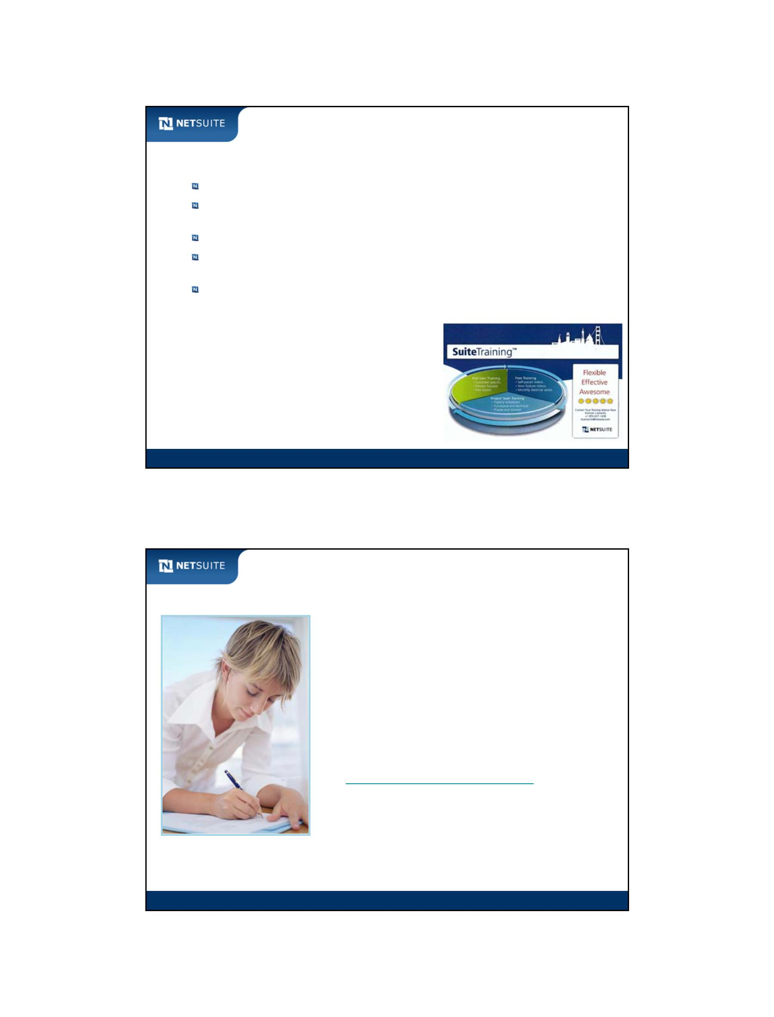

SuiteScript

Thank You!

Module 17: Best Practices and Review

19

Module 17: Best Practices and Review - 10



SuiteScript

Optional Module: Portlet Scripts

Objectives

Upon completing this module, you should be able to:

Create portlet scripts

Associate custom portlets with the Home dashboard

Optional Module: Portlet Scripts

2

Module 18: Portlet Scripts - 1



SuiteScript

What are Portlets?

Portlets allow you to

view information

at a glance.

Portlets

Optional Module: Portlet Scripts

3

Types of Portlets

Form portlet

HTML portlet

Links portlet

Optional Module: Portlet Scripts

4

Module 18: Portlet Scripts - 2

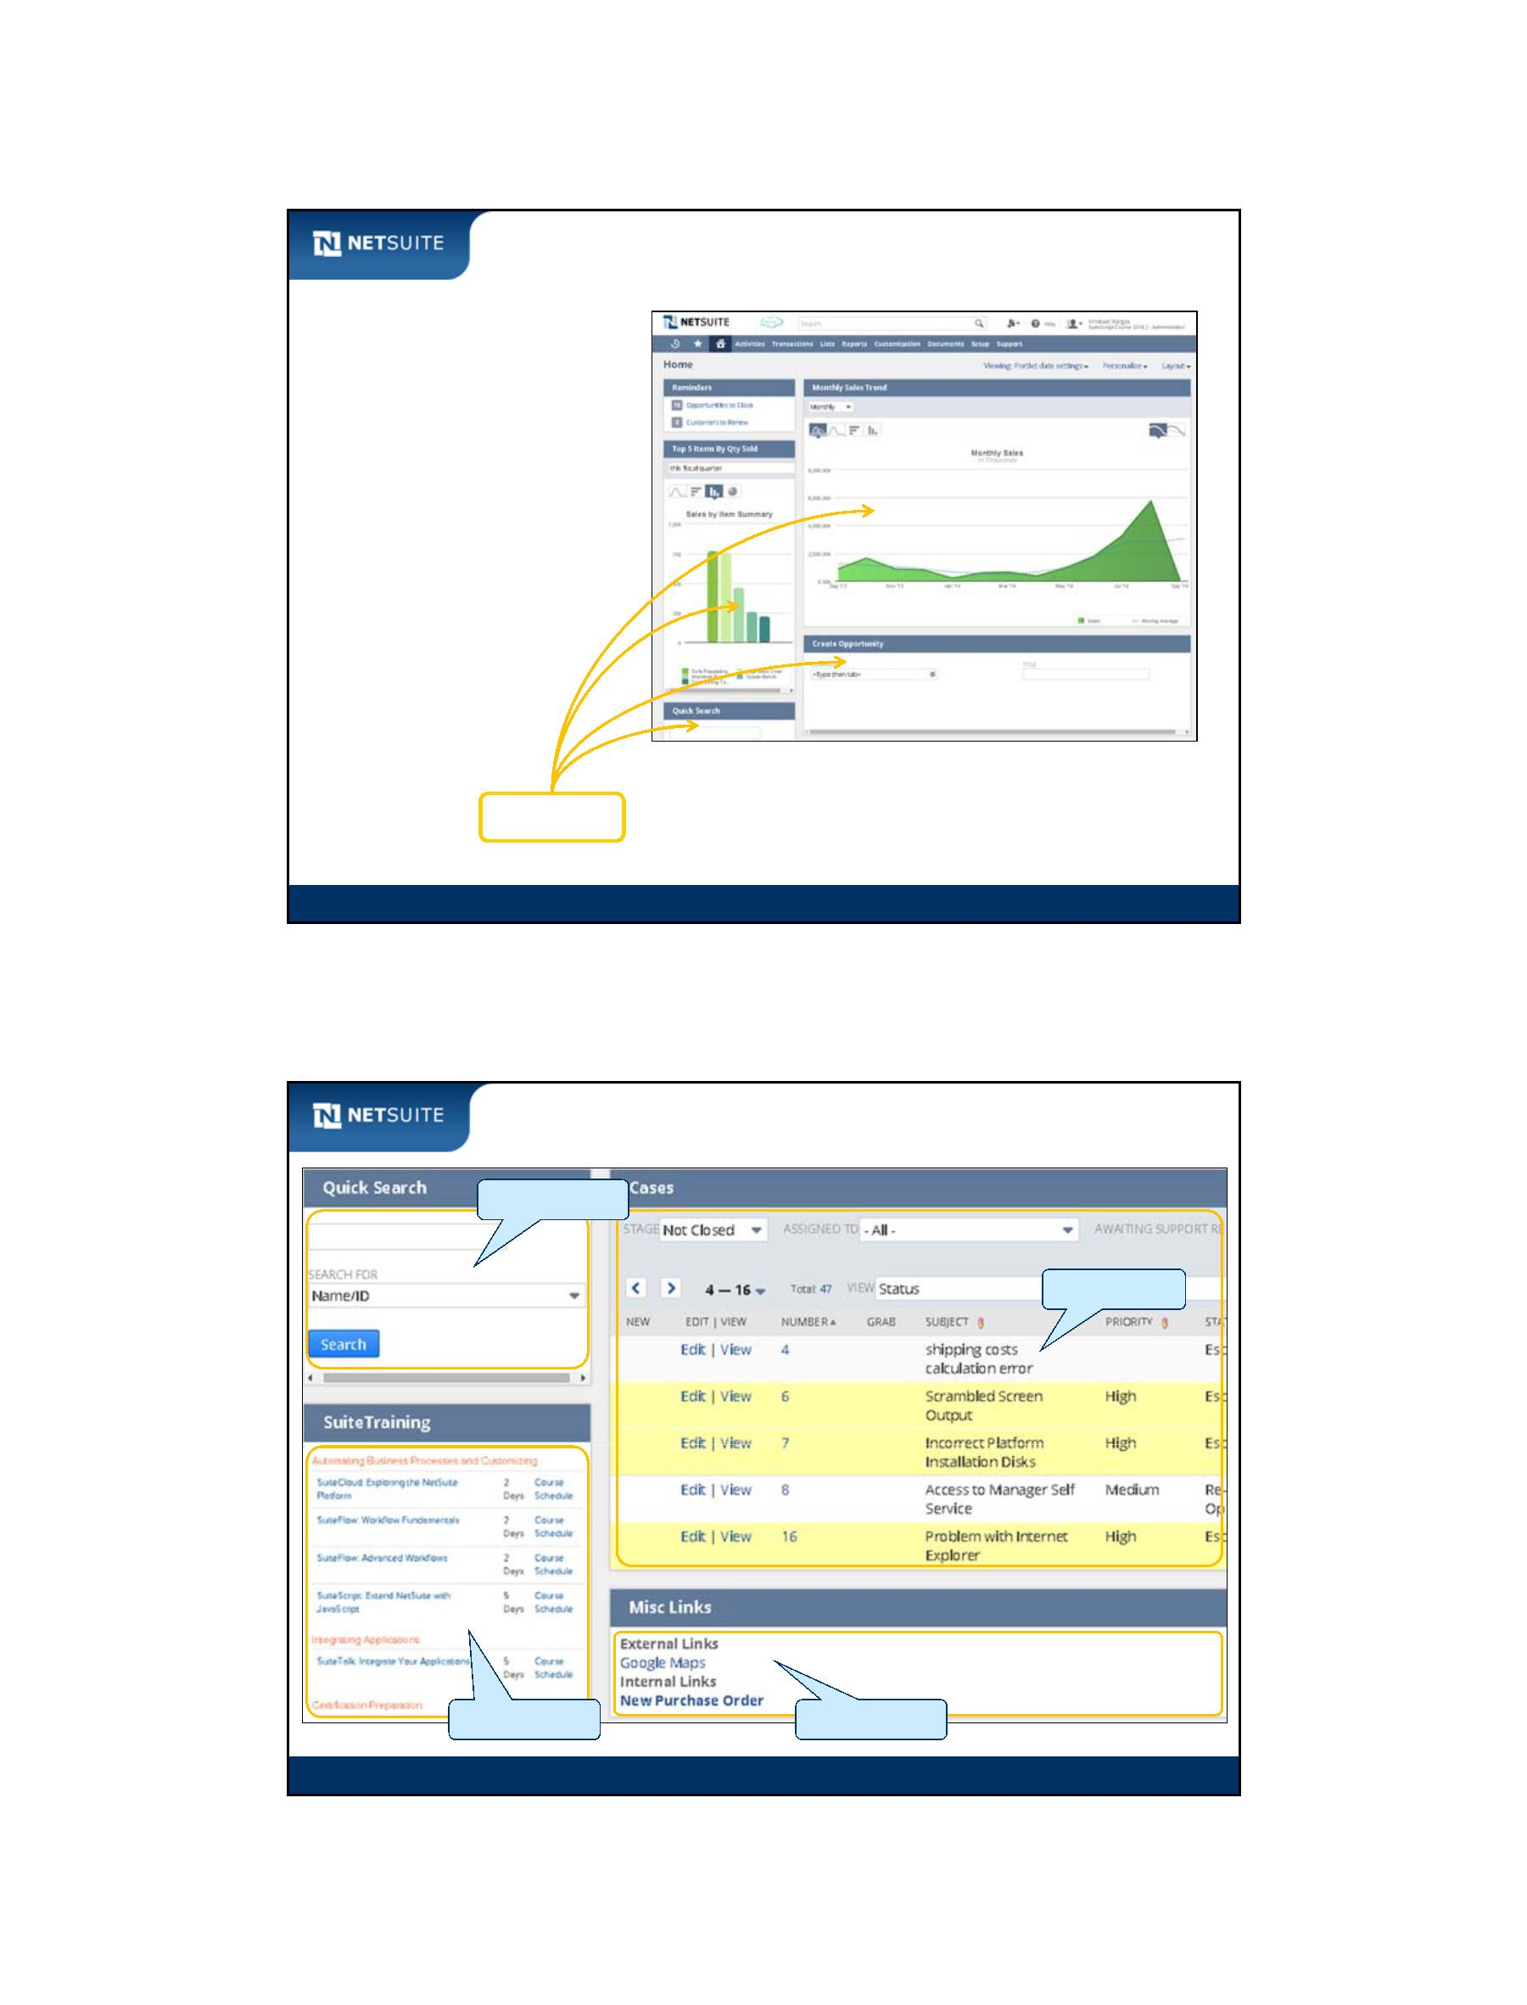

SuiteScript

Form Portlets

Optional Module: Portlet Scripts

5

List Portlets

Optional Module: Portlet Scripts

6

Module 18: Portlet Scripts - 3

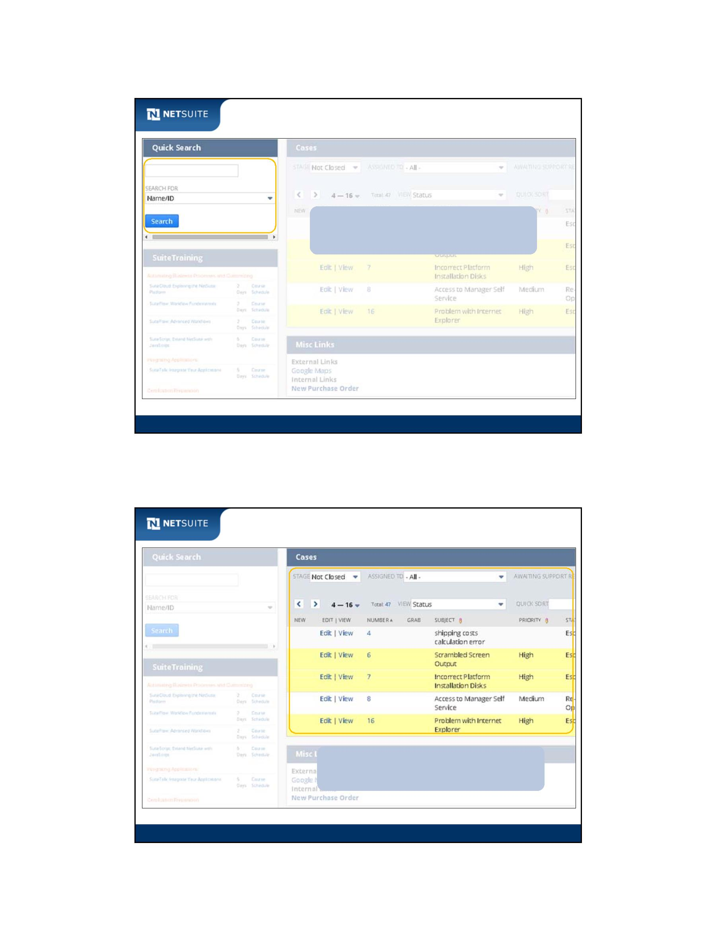

SuiteScript

HTML Portlets

HTML Portlets are custom portlets for

adding HTML‐based widgets.

Optional Module: Portlet Scripts

7

Link Portlets

Link Portlets are for displaying rows of simple

formatted content, like links and RSS content.

Optional Module: Portlet Scripts

8

Module 18: Portlet Scripts - 4

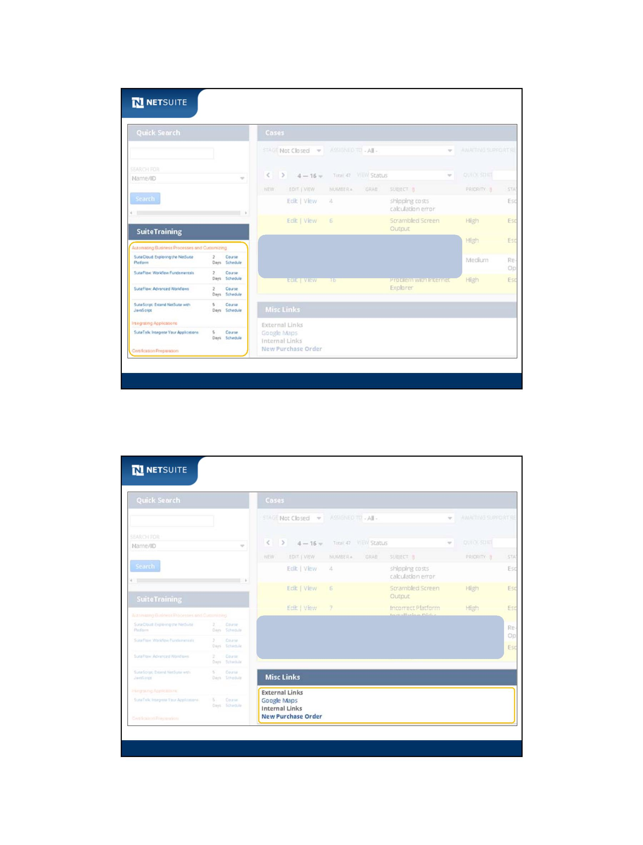

SuiteScript

Walk Through: Building a Links Portlet

Scenario:

Build a links style portlet containing:

– a link to a Google map (external link)

– a link to a new purchase order form (internal link)

Skills Covered:

Define a portlet script function

Work with the nlobjPortlet object

Configure a portlet on the Home dashboard

Please refer to the Exercise Guide

for the instructions.

Optional Module: Portlet Scripts

9

Activity: Build out List portlet for Support Cases with

Join to Employee

Format of IDs for columns is id_joinid_display or id_display. display is used to show text of

dropdown lists. id and joinid are Search Column and Search Joins IDs. Use Help to look up

addColumn.

declare function

set portlet title

add columns

Subject,

Incident Date,

Assigned To,

employee Department

and employee Job Title;

use addColumn method

Optional Module: Portlet Scripts

10

Module 18: Portlet Scripts - 5

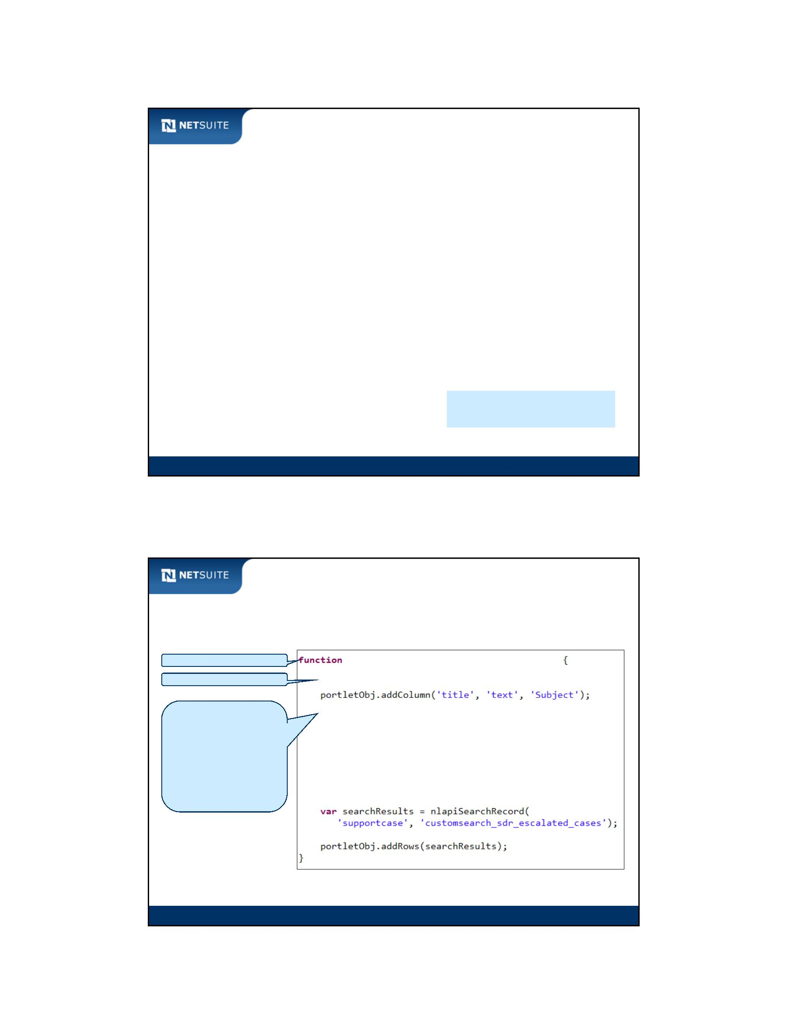

SuiteScript

Best Practices

Field IDs on a Form portlet are defined with a prefix of custpage

Prefer Form portlets over those built with custom HTML, when

applicable

Use non‐scriptable custom portlets instead of scripted ones, when

applicable

Optional Module: Portlet Scripts

11

Now It’s Your Turn

In these hands on exercises, you practice:

Building an Html portlet

Building a List portlet

Placing a portlet on the Home dashboard

Optional Module: Portlet Scripts

12

Module 18: Portlet Scripts - 6

